Title (do not change the font size or font - this also applies to the rest of the text)
John Smith¹, Petar Petrović², author names are separated by commas
Enter here the name of the institution/school where the authors work
If necessary, continue on a new line as per example
¹Address 10 pt, Italic, Centered
²Address

Add your text here, up to 2 pages long including references. When you have finished writing your paper, save the file under a new name, which contains your LastName-FirstName combination. Write the file name using the English keyboard.
Size of the page is B5 with fixed margins: up 3 cm, bottom 2.5 cm, left 2.4 cm and right 2.4 cm.

Table 1. Table caption (9 pt Times New Roman, Normal). Table text: 9 pt Times New Roman, Normal, Centered
Column header | Column header | Column header
Row header | text | text
Row header | text | text
Row header | text | text

Below is an example of formula written using Word Equation Editor. Font size should be 10 pt. To write the formula elsewhere, please select the entire row, copy and paste it at another position.
Font size should be 10 pt.

(1)

Below is an example of formula written using Math Type (formula 2). Parameters are shown on Figure 1. To write the formula elsewhere, please select the entire row, copy and paste it at another position.

(2)

Below is an example of figure inserted within the text.
To insert a new figure elsewhere, please select the entire region of the Figure with figure caption (by clicking on the cross on the left), copy and paste it at another position.

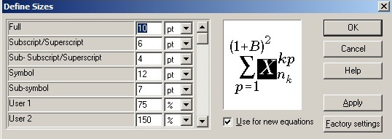
Figure 1. Settings in the Math Type

ACKNOWLEDGEMENTS
If you want to thank someone, then do so in this section. Try to keep it very short, 3-4 sentences at most.

REFERENCES
Cite the literature in the form [1] or if you cite several papers [1, 2-4]. In the bibliography, references 1 - 3 show how the journal or conference article is cited. References 4 and 5 refer to the citation of the book, and reference number 6 to the citation of the web document. Reference number 7 refers to an example of how to refer to official documents (name of the document, year of publication in parentheses, name of the newspaper and number).

- Hanif M, Sneddon P H, Al–Ahmad F M and Reid N, 2009, The perceptions, views and opinions of university students about physics learning during undergraduate laboratory work, Eur. J. Phys. 30 85–96
- Johnstone A H, Watt A and Zaman T U, 1998, The students’ attitude and cognition change to a physics laboratory, Phys. Educ. 33 pp 22–29
- McDonald D J, Dollinger R and Sarjeant W J, 1988, A method of characterizing high energy density capacitors for power conditioning systems, Proc. of the 18th IEEE Power Modulator Symp. pp 345–348
- Autor, A. A., Autor, A. B. i Autor, A. C., Book title, City of publisher: Name of publisher, year of publication, p. m-n
- M. Young, 1989, The Technical Writer’s Handbook. Mill Valley, CA: University Science
- Web document: Author, A. A. and Author, A. A. (year of publication). The title of the electronic text. Downloaded month, day, year from the site (specify the full http address)
- Rulebook on the program of all forms of work of professional associates (2012). Educational Gazette, Official Gazette of the Republic of Serbia, No. 5/2012.

