DEPOPULATION OF UPPER ENERGETIC LEVEL OF THE ARGON VUV USING LASER RADIATION
M. R. Gemišić¹⁾ and B. M. Obradović²⁾
1) Center for science, Obilicev venac 11, Belgrade
2)University of Belgrade –Faculty of Physics, Studetski trg 12, 11000 Belgrade
e-mail: mgemisic@ff.bg.ac.rs
Abstract. Reduction of Ar I 104.82 nm spectral line intensity, from the VUV part of the spectra, due to absorption of laser radiation with wavelength of 852.1433 nm is reported. This wavelength corresponds to a different transition with lower level that coincides to upper level of the transition 104. 82 nm.

1. INTRODUCTION
Paper should be up to 10 pages long, for invited lectures and up to 4 pages for contributed papers in the poster section.
The Penning discharge is used as a standard source of radiation for calibration of spectrometers in the VUV range [1]. In the argon discharge the resonant lines 104.82 nm и 106.67 nm are exited. The upper energetic level of Ar I 104.82 nm is also the upper level of Ar I 852.1443 nm line. It is possible to attain the radiation laser diode at this wavelength.

2. EXPERIMENTAL SETUP
Diagram of experimental setup is given in Fig. 1. Source of radiation is a Penning discharge with two aluminum cathodes set opposite to each other and isolated from the brass anode by ceramics. Both electrodes are water-cooled. The discharge is set in magnetic filed from a permanent magnet for discharge stabilization.

Subsection title
Laser diode (SDL 5412-H1) emits single-mode radiation of 100 mW power in the spectral range (852 ± 7) nm. In this spectral range is a strong argon line λ= 852.1443 nm, that corresponds to the transition 4s′[1/2]⁰ – 4p′[3/2]. Spectral width of laser radiation is 2·10⁻⁵ nm. The wavelength of laser radiation can be changed by change of temperature of laser diode change of current. Across the argon line wavelength is performed by changing current at constant diode temperature.
The variation of current through the laser diode is achieved by using a function generator (Kronhite). Frequency of the saw-shape signal form the generator was 500 Hz. The laser beam was focused with an aspheric lens. Signal from the photomultiplier is averaged 512 times on digital oclilospoe (Tektronix TDS 3032).2 пута. Such a large number of averaging is necessary due to the instabilities of the Penning discharge.
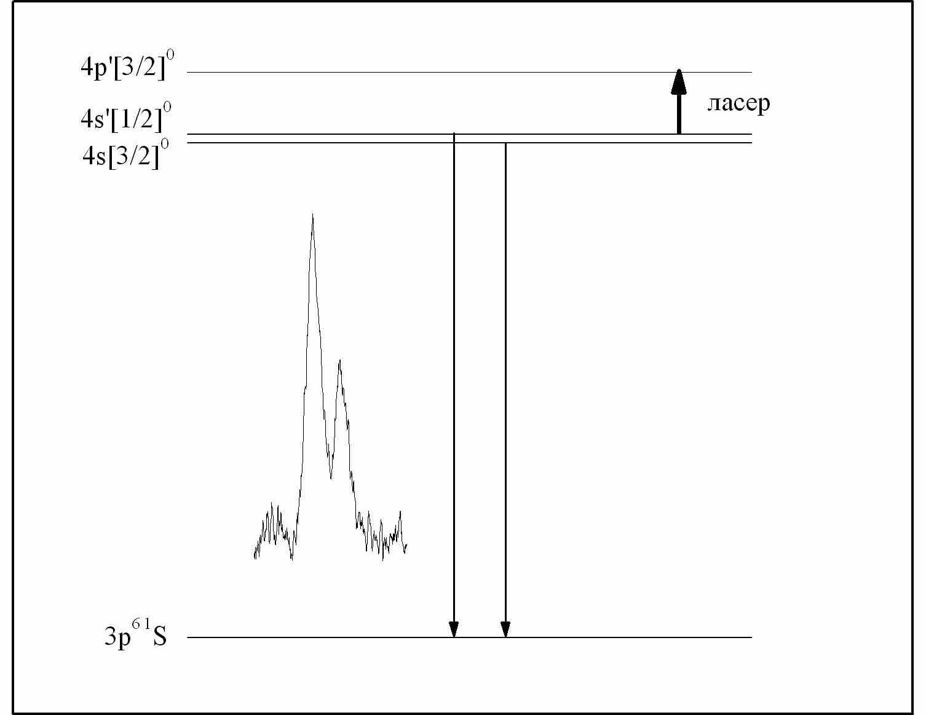

FIGURE 1. Energetic levels of lines Аr I 104.82 nm, 106.67 nm, radiation 852.1443 nm, and graphs of recorded argon lines.

TABLE . Table Caption

3. RESULTS AND DISCUSSION
In Fig. 2 a diagram of energetic levels of spectral lines of argon atom are shown. Detected argon lines in the VUV range (104.82 nm and 106.67 nm) and laser radiative excitation are also given. Spectral width (FWHM) of the argon line is 0.8 nm.
Figure 3. contains a simultaneous recording of optogalvanic effect and the effect intensity reduction of argon line 104.82 nm. The reduction of intensity is consequence of depopulation of upper energetic level induced by absorption of laser radiation.

Acknowledgement
The authors gratefully acknowledge discussions with N. Simić and S. Perić. This work within Project No. 171046 is supported by the Ministry of Science of the Republic of Serbia.

REFERENCES
[1] Wang, R. T., Classic Physiques, New York: Addison-Wesley, 1997, pp. 212-213
[2] Smith, C. D., and Jones, E. F., Phys. Rev. Lett. 35, 123-127 (1993)

