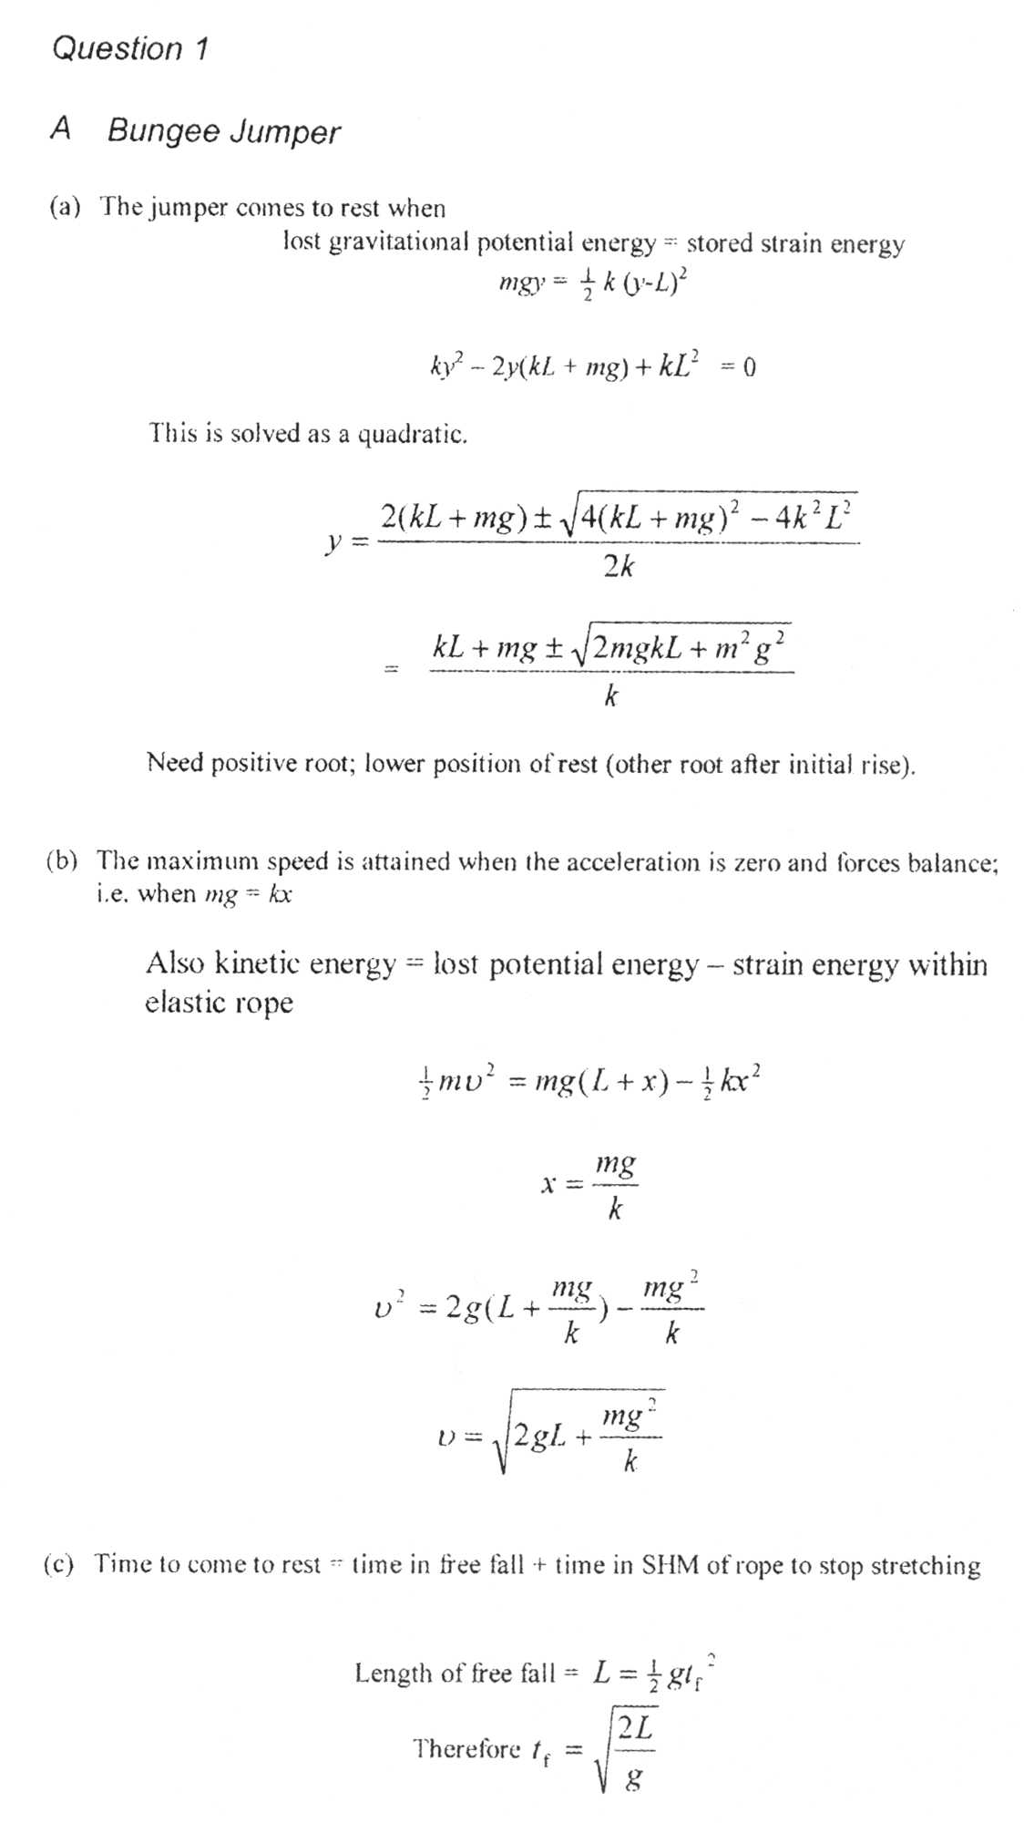
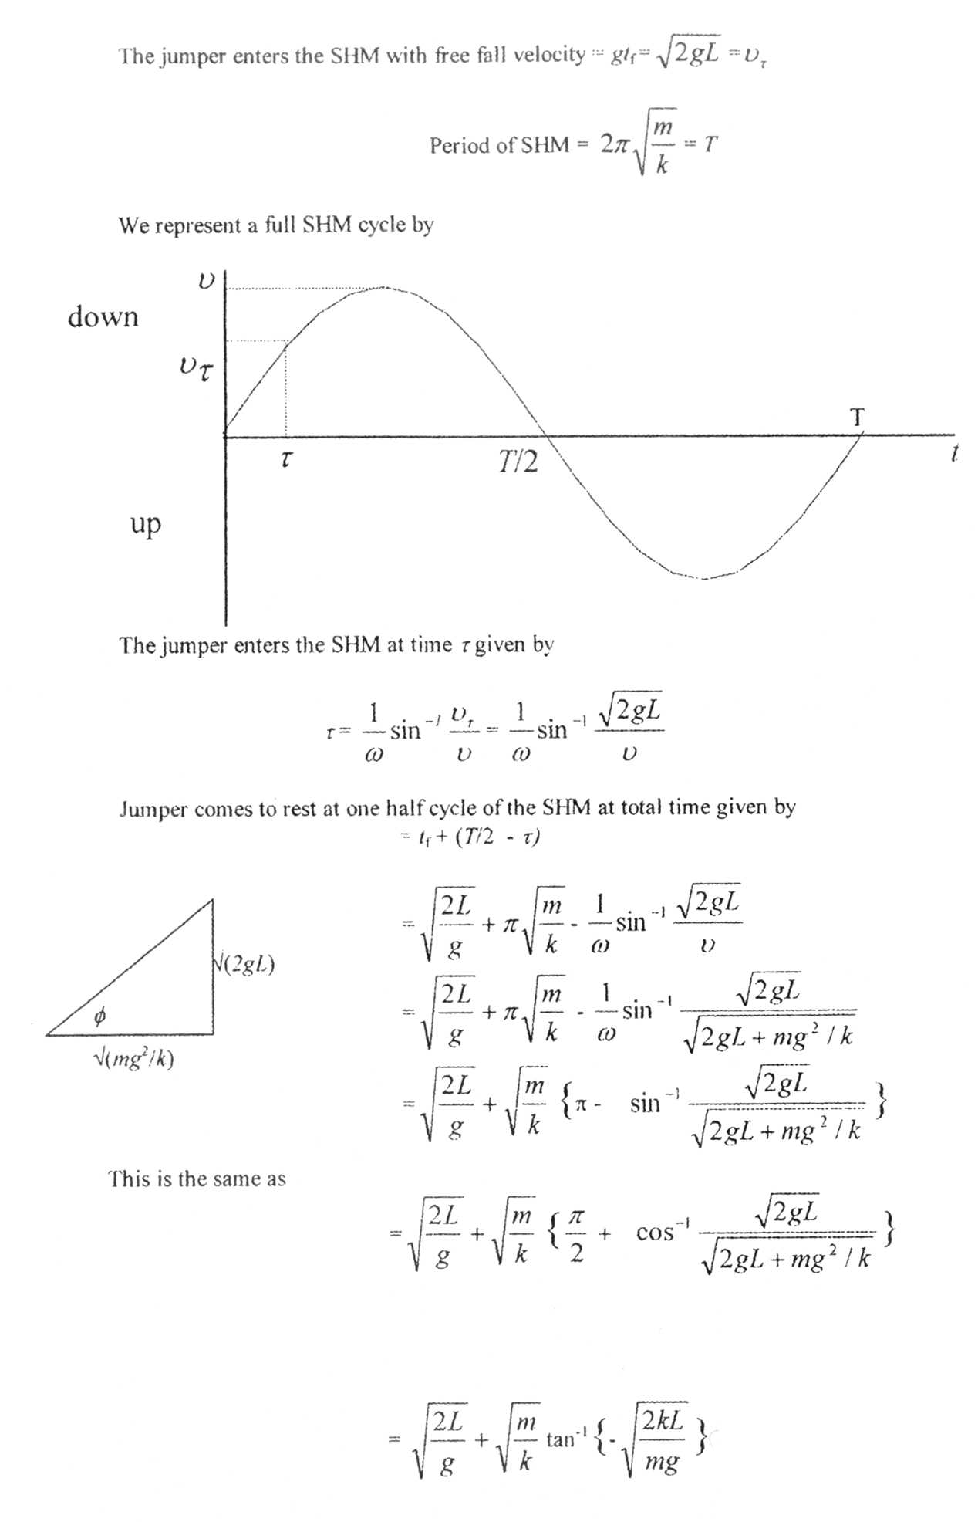
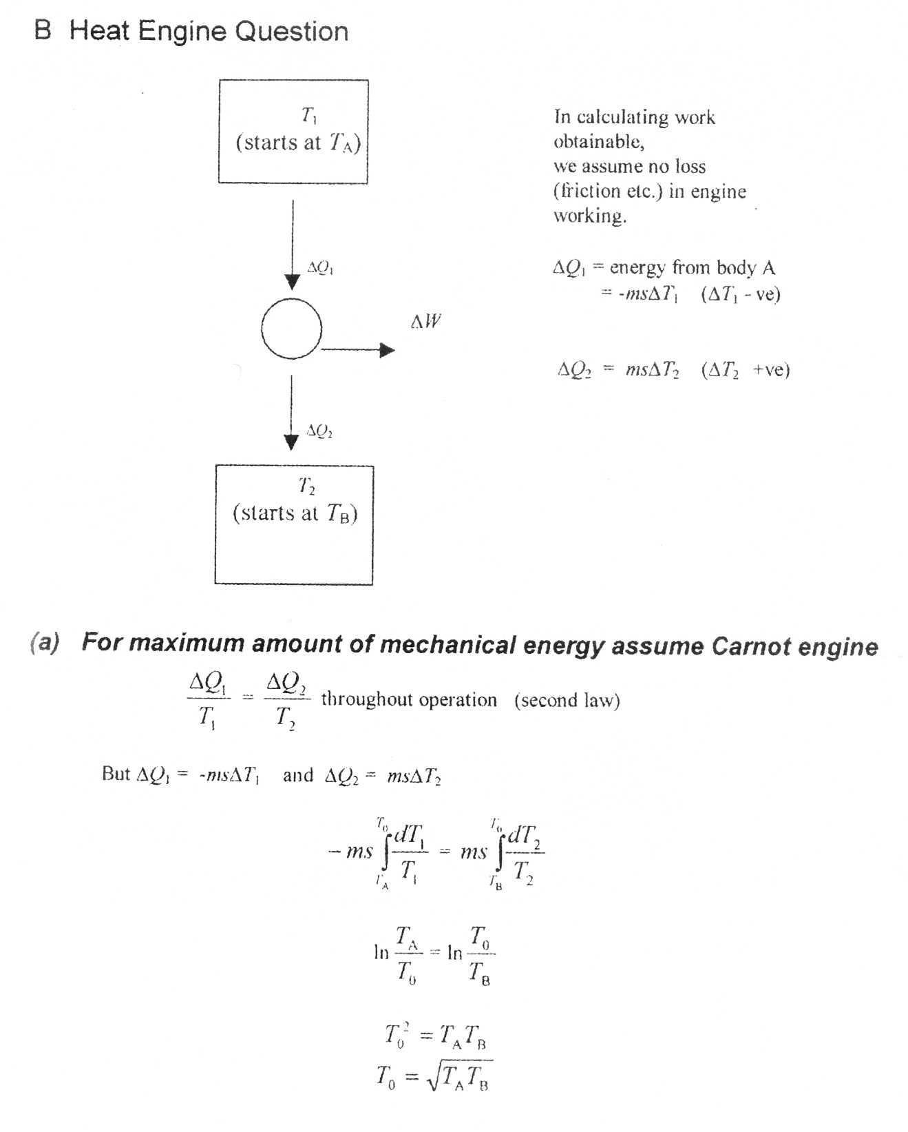

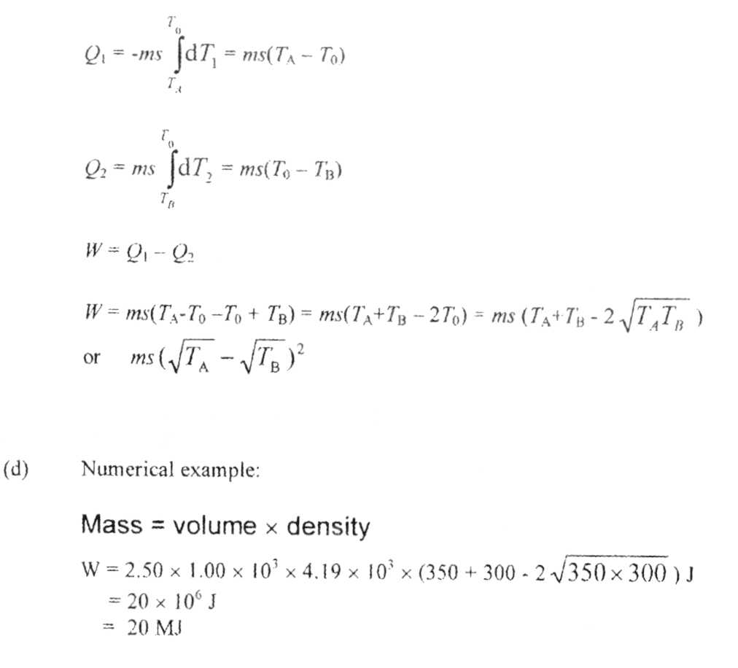

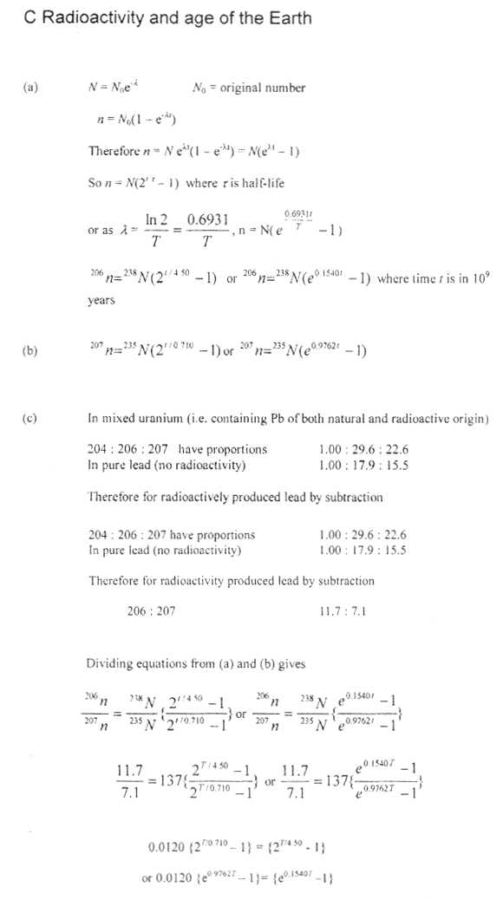
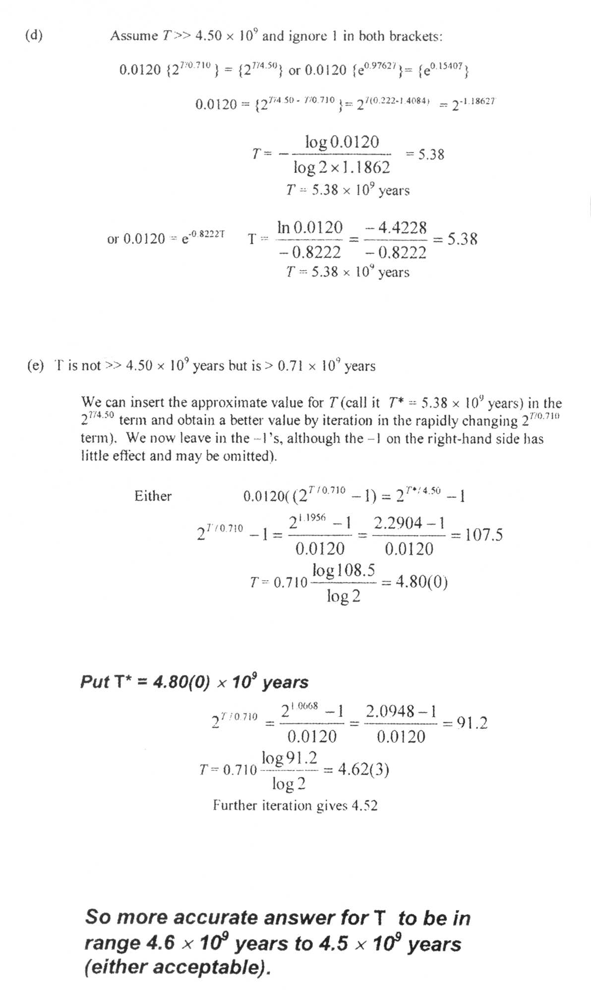
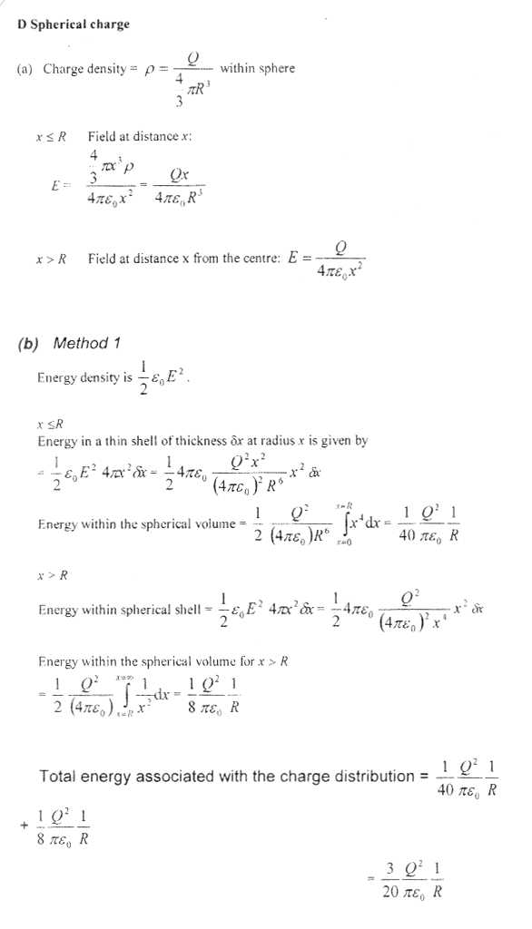
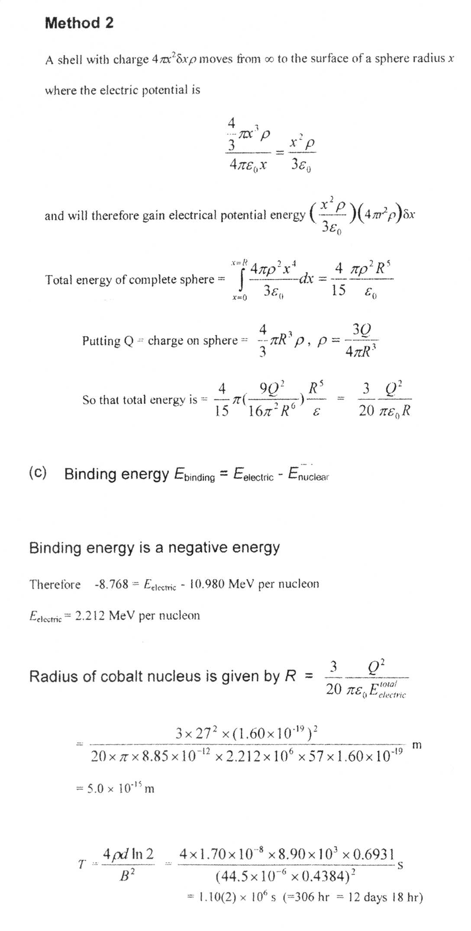
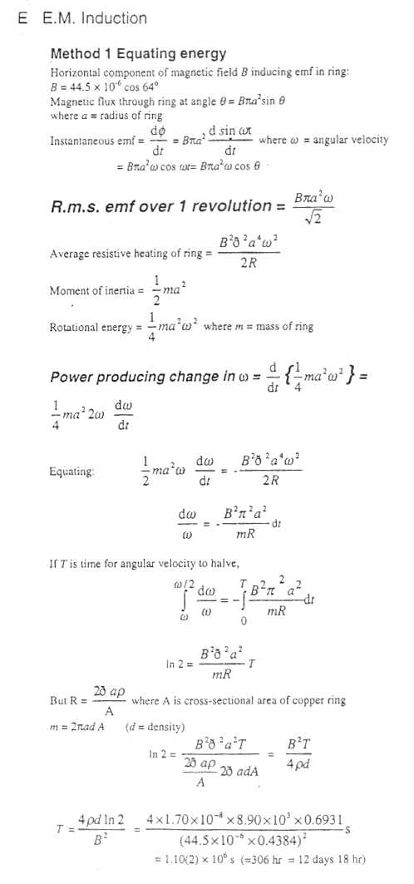
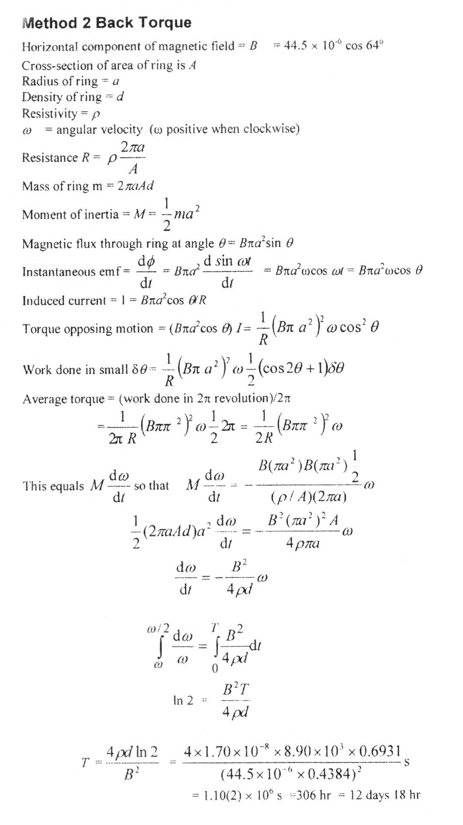
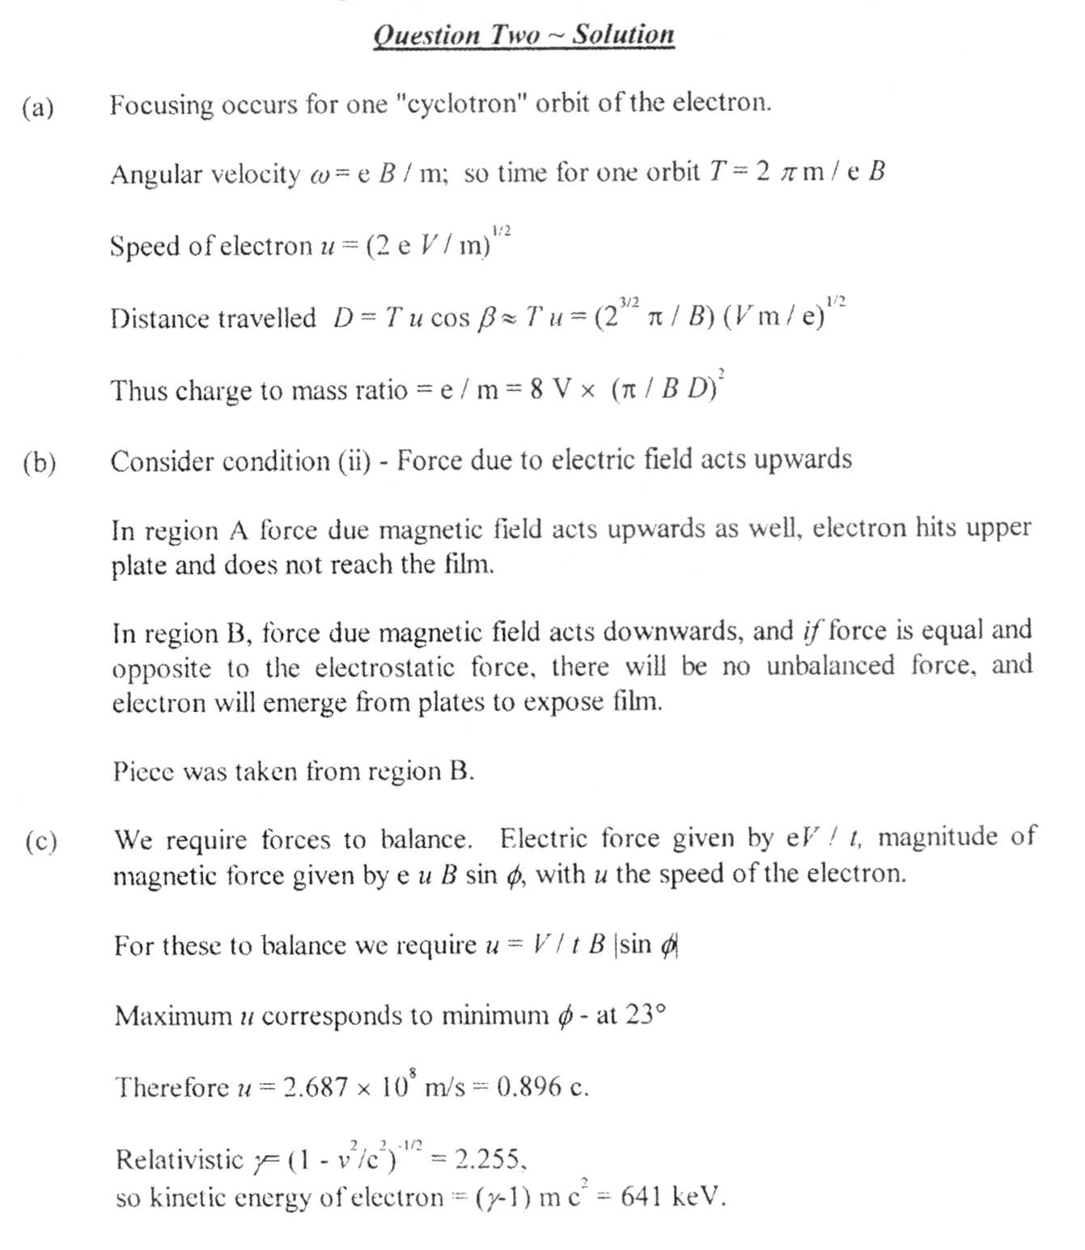

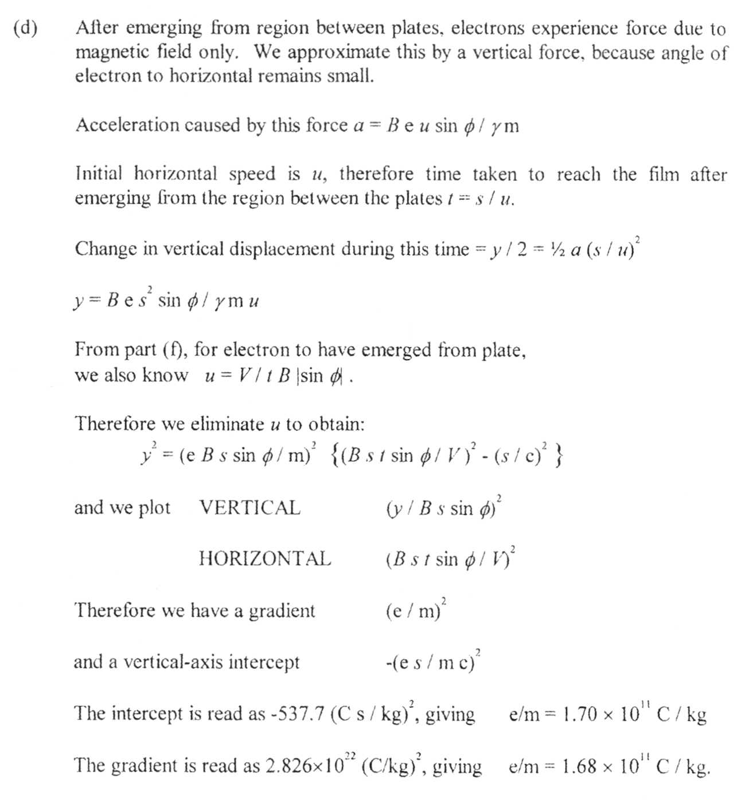

Rešenje teorijskog zadatka 3
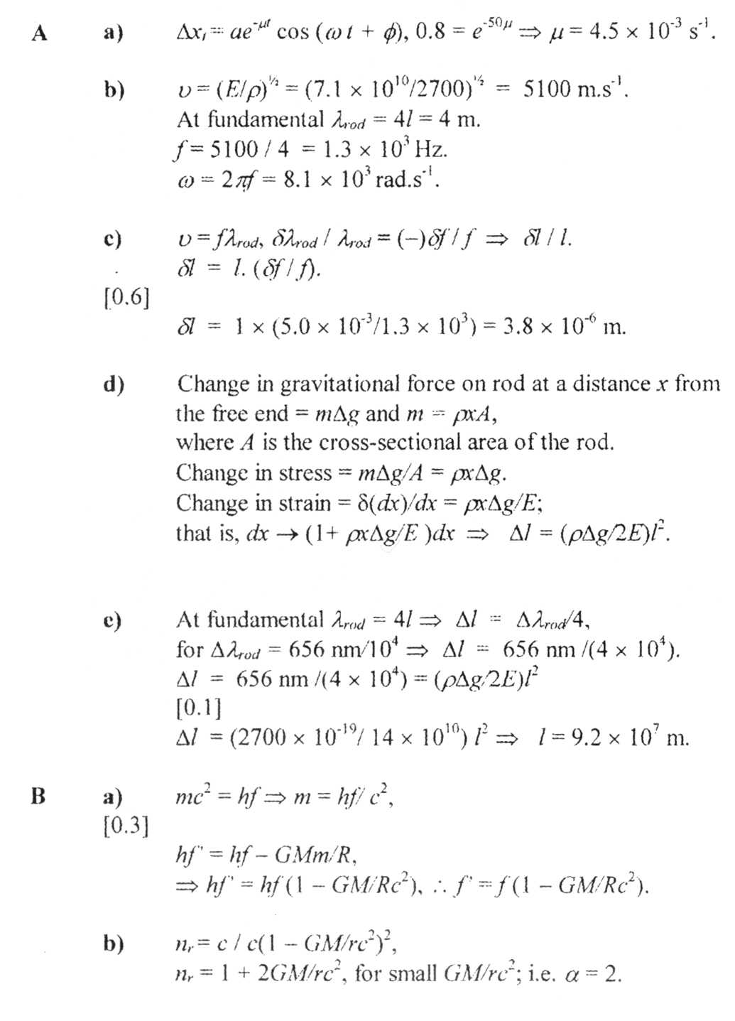

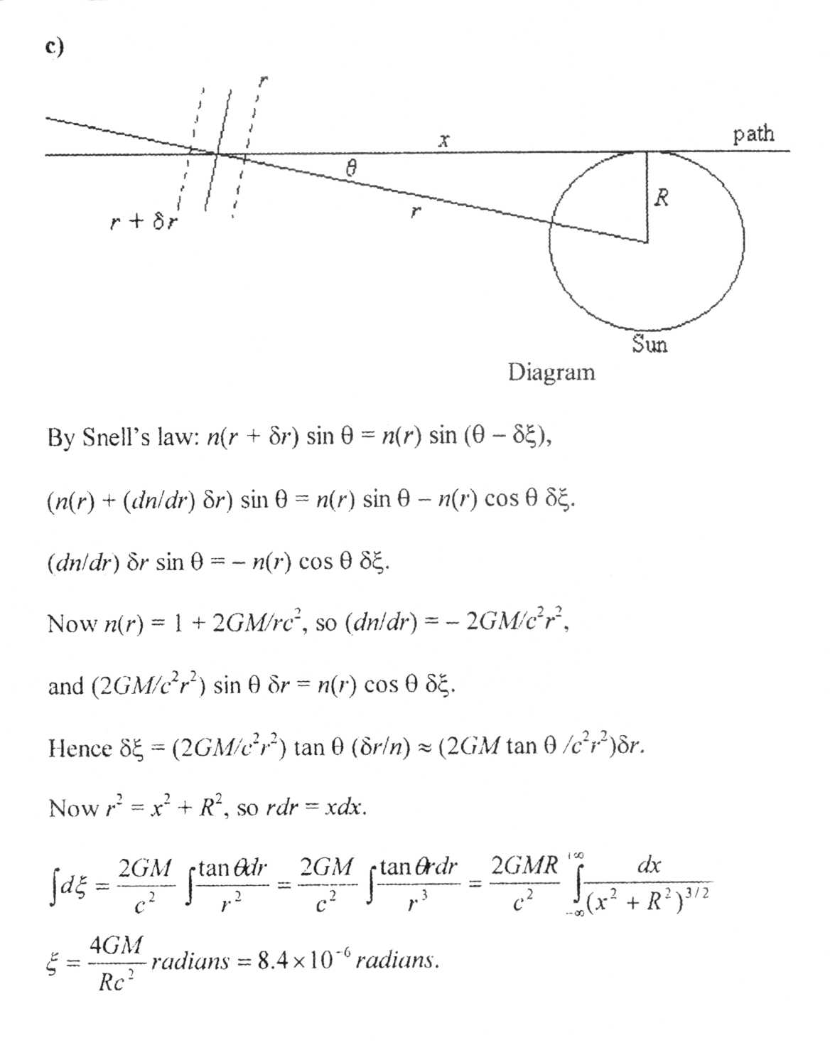

c)

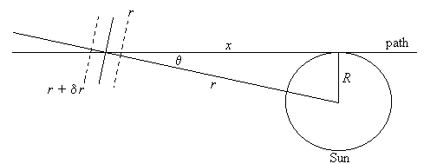

Diagram [0.2]

By Snell’s law: n(r + δr) sin θ = n(r) sin (θ − δξ), [1.0]

(n(r) + (dn/dr) δr) sin θ = n(r) sin θ − n(r) cos θ δξ. [0.4]

(dn/dr) δr sin θ = − n(r) cos θ δξ.

Now n(r) = 1 + 2GM/rc², so (dn/dr) = − 2GM/c²r², [0.3]

and (2GM/c²r²) sin θ δr = n(r) cos θ δξ.

Hence δξ = (2GM/c²r²) tan θ (δr/n) ≈ (2GM tan θ /c²r²)δr. [1.0]

Now r² = x² + R², so rdr = xdx. [0.1]
$\begin{aligned}\int{dξ=\frac{2\text{GM}}{c^{2}}\int{\frac{\text{tan}θ\text{dr}}{r^{2}}}}=\frac{2\text{GM}}{c^{2}}\int{\frac{\text{tan}θ\text{rdr}}{r^{3}}}=\frac{2\text{GMR}}{c^{2}}\int_{−∞}^{+∞}{\frac{\text{dx}}{(x^{2}+R^{2})^{3/2}}} \\ ξ=\frac{4\text{GM}}{{\text{Rc}}^{2}}\text{radians}=8\text{.}4×{\text{10}}^{−6}\text{radians}\text{.}\end{aligned}$ [0.5]

Uputstvo za bodovanje zadatka 3

Total marks = 10

A a) Δx_{t} = ae^{-μt} cos (ω t + φ), 0.8 = e^{-50μ} ⇒ μ = 4.5 × 10⁻³ s⁻¹. [0.1]

b) υ = (E/ρ)^{½} = (7.1 × 10¹⁰/2700)^{½} = 5100 m.s⁻¹.
At fundamental λ_{rod} = 4l = 4 m.
f = 5100 / 4 = 1.3 × 10³ Hz.
ω = 2πf = 8.1 × 10³ rad.s⁻¹. [0.1]

c) υ = fλ_{rod}, δλ_{rod} / λ_{rod} = (−)δf / f [0.8]
δl = l. (δf / f). [0.6]
δl = 1 × (5.0 × 10⁻³/1.3 × 10³) = 3.8 × 10⁻⁶ m. [0.1]

- Change in gravitational force on rod at a distance x from
the free end = mΔg and m = ρxA,
where A is the cross-sectional area of the rod. [0.5]
Change in stress = mΔg/A = ρxΔg. [0.5]
Change in strain = δ(dx)/dx = ρxΔg/E;
that is, dx → (1+ ρxΔg/E )dx ⇒ Δl = (ρΔg/2E)l². [0.5]

- At fundamental λ_{rod} = 4l ⇒ Δl = Δλ_{rod}/4,
for Δλ_{rod} = 656 nm/10⁴ ⇒ Δl = 656 nm /(4 × 10⁴). [0.1]
Δl = 656 nm /(4 × 10⁴) = (ρΔg/2E)l² [0.1]
Δl = (2700 × 10⁻¹⁹/ 14 × 10¹⁰) l² ⇒ l = 9.2 × 10⁷ m. [0.1]

B a) mc² = hf ⇒ m = hf/ c², [0.3]
hf’ = hf − GMm/R, [0.3]
⇒ hf’ = hf (1 − GM/Rc²), ∴ f’ = f (1 − GM/Rc²). [0.4]

b) n_{r} = c / c(1 − GM/rc²)², [1.0]
n_{r} = 1 + 2GM/rc², for small GM/rc²; i.e. α = 2. [1.0]

