Sample Solution

Part 1
a. A sketch of the experimental setup
b. Data sheet
Position (cm) | Meter reading (mA) | Position (cm) | Meter reading (mA) | Position (cm) | Meter reading (mA) | Position (cm) | Meter reading (mA)
104.0 | 0.609 | 100.9 | 1.016 | 96.0 | 0.514 | 91.0 | 0.925
103.9 | 0.817 | 100.85 | 1.060 | 95.8 | 0.098 | 90.9 | 1.094
103.8 | 0.933 | 100.8 | 1.090 | 95.6 | 0.192 | 90.8 | 1.245
103.7 | 1.016 | 100.7 | 0.994 | 95.4 | 0.669 | 90.7 | 1.291
103.6 | 1.030 | 100.6 | 0.940 | 95.3 | 0.870 | 90.6 | 1.253
103.5 | 0.977 | 100.4 | 0.673 | 95.2 | 1.009 | 90.4 | 0.978
103.4 | 0.890 | 100.2 | 0.249 | 95.1 | 1.119 | 90.2 | 0.462
103.3 | 0.738 | 100.0 | 0.074 | 95.0 | 1.138 | 90.0 | 0.045
103.2 | 0.548 | 99.8 | 0.457 | 94.9 | 1.080 | 89.8 | 0.278
103.1 | 0.310 | 99.6 | 0.883 | 94.7 | 0.781 | 89.6 | 0.809
103.0 | 0.145 | 99.4 | 1.095 | 94.5 | 0.403 | 89.5 | 1.031
102.9 | 0.076 | 99.3 | 1.111 | 94.3 | 0.044 | 89.4 | 1.235
102.8 | 0.179 | 99.2 | 1.022 | 94.1 | 0.364 | 89.3 | 1.277
102.7 | 0.392 | 99.0 | 0.787 | 93.9 | 0.860 | 89.2 | 1.298
102.6 | 0.623 | 98.8 | 0.359 | 93.7 | 1.103 | 89.1 | 1.252
102.5 | 0.786 | 98.6 | 0.079 | 93.6 | 1.160 | 89.0 | 1.133
102.4 | 0.918 | 98.4 | 0.414 | 93.5 | 1.159 | 88.8 | 0.684
102.3 | 0.988 | 98.2 | 0.864 | 93.4 | 1.083 | 88.6 | 0.123
102.2 | 1.026 | 98..0 | 1.128 | 93.2 | 0.753 | 88.5 | -0.020
102.1 | 1.006 | 97.9 | 1.183 | 93.0 | 0.331 | 88.4 | 0.123
102.0 | 0.945 | 97.8 | 1.132 | 92.8 | 0.073 | 88.2 | 0.679
101.9 | 0.747 | 97.7 | 1.015 | 92.6 | 0.515 | 88.0 | 1.116
101.8 | 0.597 | 97.5 | 0.713 | 92.4 | 0.968 | 87.9 | 1.265
101.7 | 0.363 | 97.2 | 0.090 | 92.2 | 1.217 | 87.8 | 1.339
101.6 | 0.161 | 97.0 | 0.342 | 92.15 | 1.234 | 87.7 | 1.313
101.5 | 0.055 | 96.8 | 0.714 | 92.1 | 1.230 | 87.6 | 1.190
101.4 | 0.139 | 96.6 | 1.007 | 92.0 | 1.165 | 87.4 | 0.867
101.3 | 0.357 | 96.5 | 1.087 | 91.8 | 0.871 | 87.2 | 0.316
101.2 | 0.589 | 96.4 | 1.070 | 91.6 | 0.353 | 87.1 | 0.034
101.1 | 0.781 | 96.3 | 1.018 | 91.4 | 0.018 | 87.0 | -0.018
101.0 | 0.954 | 96.2 | 0.865 | 91.2 | 0.394 | 86.9 | 0.178
104.0 | 0.609 | 100.9 | 1.016 | 96.0 | 0.514 | 91.0 | 0.925
103.9 | 0.817 | 100.8 | 1.060 | 95.8 | 0.098 | 90.9 | 1.094
103.8 | 0.933 | 100.8 | 1.090 | 95.6 | 0.192 | 90.8 | 1.245
103.7 | 1.016 | 100.7 | 0.994 | 95.4 | 0.669 | 90.7 | 1.291
103.6 | 1.030 | 100.6 | 0.940 | 95.3 | 0.870 | 90.6 | 1.253
103.5 | 0.977 | 100.4 | 0.673 | 95.2 | 1.009 | 90.4 | 0.978
103.4 | 0.890 | 100.2 | 0.249 | 95.1 | 1.119 | 90.2 | 0.462
103.3 | 0.738 | 100.0 | 0.074 | 95.0 | 1.138 | 90.0 | 0.045
103.2 | 0.548 | 99.8 | 0.457 | 94.9 | 1.080 | 89.8 | 0.278
103.1 | 0.310 | 99.6 | 0.883 | 94.7 | 0.781 | 89.6 | 0.809
103.0 | 0.145 | 99.4 | 1.095 | 94.5 | 0.403 | 89.5 | 1.031
102.9 | 0.076 | 99.3 | 1.111 | 94.3 | 0.044 | 89.4 | 1.235
102.8 | 0.179 | 99.2 | 1.022 | 94.1 | 0.364 | 89.3 | 1.277
102.7 | 0.392 | 99.0 | 0.787 | 93.9 | 0.860 | 89.2 | 1.298
102.6 | 0.623 | 98.8 | 0.359 | 93.7 | 1.103 | 89.1 | 1.252
102.5 | 0.786 | 98.6 | 0.079 | 93.6 | 1.160 | 89.0 | 1.133
102.4 | 0.918 | 98.4 | 0.414 | 93.5 | 1.159 | 88.8 | 0.684
102.3 | 0.988 | 98.2 | 0.864 | 93.4 | 1.083 | 88.6 | 0.123
102.2 | 1.026 | 98.0 | 1.128 | 93.2 | 0.753 | 88.5 | -0.020
102.1 | 1.006 | 97.9 | 1.183 | 93.0 | 0.331 | 88.4 | 0.123
102.0 | 0.945 | 97.8 | 1.132 | 92.8 | 0.073 | 88.2 | 0.679
101.9 | 0.747 | 97.7 | 1.015 | 92.6 | 0.515 | 88.0 | 1.116
101.8 | 0.597 | 97.5 | 0.713 | 92.4 | 0.968 | 87.9 | 1.265
101.7 | 0.363 | 97.2 | 0.090 | 92.2 | 1.217 | 87.8 | 1.339
101.6 | 0.161 | 97.0 | 0.342 | 92.15 | 1.234 | 87.7 | 1.313
101.5 | 0.055 | 96.8 | 0.714 | 92.1 | 1.230 | 87.6 | 1.190
101.4 | 0.139 | 96.6 | 1.007 | 92.0 | 1.165 | 87.4 | 0.867
101.3 | 0.357 | 96.5 | 1.087 | 91.8 | 0.871 | 87.2 | 0.316
101.2 | 0.589 | 96.4 | 1.070 | 91.6 | 0.353 | 87.1 | 0.034
101.1 | 0.781 | 96.3 | 1.018 | 91.4 | 0.018 | 87.0 | -0.018
101.0 | 0.954 | 96.2 | 0.865 | 91.2 | 0.394 | 86.9 | 0.178

From the graph, the positions of the first maximum point and 12th maximum point are measured at 87.8 cm and 103.6 cm.
The wavelength is calculated by
$\frac{λ}{2}=\frac{\text{103}\text{.}6−\text{87}\text{.}8}{\text{11}}$cm
2 marks
Thus,  = 2.87 cm.

Error analysis (not required)
$λ=\frac{2}{\text{11}}d$, Δd = 0.05 x2 cm = 0.1 cm.
$\left|Δλ\right|=\left|\frac{2}{\text{11}}Δd\right|=\frac{2}{\text{11}}×0\text{.}\text{10}=0\text{.}\text{018}\overset{}{}\text{cm}<0\text{.}\text{02}\overset{}{}\text{cm}$

Part 2

(a) Deduction of interference conditions
Assume that the thickness of the film is t and refractive index n. Let $θ_{1}$ be the incident angle and $θ_{2}$ the refracted angle. The difference of the optical paths $ΔL$ is:

$$ΔL=2(\text{nt}\text{/cos}θ_{2}−t\text{tan}θ_{2}\text{sin}θ_{1})$$
Law of refraction:
$$\text{sin}θ_{1}=n\text{sin}θ_{2}$$

Thus
$$ΔL=2t\sqrt{{n^{2}−{\text{sin}}^{2}θ}_{1}}$$

Considering there is 180 deg ( $λ/2$) phase shift at the air- thin film interface for the reflected beam, we have interference conditions:

$2t\sqrt{{n^{2}−{\text{sin}}^{2}θ}_{\text{min}}}=mλ (m=1, 2, 3,\text{.}\text{.}\text{.})$ for the destructive peak
and $2t\sqrt{{n^{2}−{\text{sin}}^{2}θ}_{\text{max}}}=(m±\frac{1}{2})λ$ for the constructive peak
1 mark
If thickness t and wave length  are known, one can determine the refractive index of the thin film from I - θ ₁spectrum (I is the intensity of the interfered beam).

(b) A sketch of the experimental setup
1 mark

(The sketch should include the transmitter, lens, receiver and the thin film, goniometer and the direction of angle measurement) Student should the Labels mentioned on Page 2.

(c) Data Set
X: θ₁ / degree | Y: Meter reading S/mA
40.0 | 0.309
41.0 | 0.270
42.0 | 0.226
43.0 | 0.196
44.0 | 0.164
45.0 | 0.114
46.0 | 0.063
47.0 | 0.036
48.0 | 0.022
49.0 | 0.039
50.0 | 0.066
51.0 | 0.135
52.0 | 0.215
53.0 | 0.262
54.0 | 0.321
55.0 | 0.391
56.0 | 0.454
57.0 | 0.511
58.0 | 0.566
59.0 | 0.622
60.0 | 0.664
61.0 | 0.691
62.0 | 0.722
63.0 | 0.754
64.0 | 0.796
65.0 | 0.831
66.0 | 0.836
67.0 | 0.860
68.0 | 0.904
69.0 | 0.970
70.0 | 1.022
71.0 | 1.018
72.0 | 0.926
73.0 | 0.800  0.5 marks
74.0 | 0.770
75.0 | 0.915
Uncertainty: angle ${Δθ}_{1}=±0\text{.}5^{o}$, current: ±0.001 mA
0.9 marks
0.6 marks
From the data, $θ_{\text{min}}$ and $θ_{\text{max}}$can be found at 48º and 70.5º respectively.
To calculate the refractive index, the following equations are used:
$2t\sqrt{n^{2}−{\text{sin}}^{2}{\text{48}}^{o}}=mλ (m=1, 2, 3,\text{.}\text{.}\text{.})$ (1)
and $2t\sqrt{n^{2}−{\text{sin}}^{2}\text{70}\text{.}5^{o}}=(m−\frac{1}{2})λ$ (2)
In this experiment, t = 5.28 cm,  = 2.85cm (measured using other method).
Solving the simultaneous equations (1) and (2), we get
$$m=\frac{{\text{sin}}^{2}\text{70}\text{.}5^{o}−{\text{sin}}^{2}{\text{48}}^{o}}{(\frac{λ}{2t})^{2}}+0\text{.}\text{25}$$
1 mark
m = 4.83 m = 5
Substituting m = 5 in (1), we get n = 1.54
0.5 marks
Substituting m = 5 in (2), we get n = 1.54

Error analysis:
$n=\sqrt{{\text{sin}}^{2}θ+(\frac{mλ}{2t})^{2}}$
$\begin{aligned}Δn=\frac{1}{\sqrt{{\text{sin}}^{2}θ+(\frac{mλ}{2t})^{2}}}(\text{sin}2θ⋅Δθ+\frac{m^{2}λ}{2t^{2}}Δλ−\frac{m^{2}λ^{2}}{2t^{3}}Δt) \\ \frac{1}{n}(\text{sin}2θ⋅Δθ+\frac{m^{2}λ}{2t^{2}}Δλ−\frac{m^{2}λ^{2}}{2t^{3}}Δt)\end{aligned}$

If we take θ = ±0.5º = ±0.0087 rad, t = ±0.05 cm,  = ±0.02 cm
Then, when θ = 48º
$Δn=\frac{1}{1\text{.}\text{54}}(0\text{.}\text{0087}\text{sin}{\text{96}}^{o}+\frac{5^{2}×2\text{.}\text{85}}{2×5\text{.}{\text{28}}^{2}}×0\text{.}\text{01}+\frac{5^{2}×2\text{.}{\text{85}}^{2}}{2×5\text{.}{\text{28}}^{3}}×0\text{.}\text{05})≈0\text{.}\text{02}$
0.5 marks
Thus, n + n = 1.54 ±0.02

Part 3

Sample Solution

Task 1
Sketch your final experimental setup and mark all components using the labels given at page 2. In your sketch, write down the distance z (see Figure 3.2), where z is the distance from the tip of the prism to the central axis of the transmitter.

Task 2
Tabulate your data. Perform the experiment twice.

Data Set
X: d(cm) | ΔX(cm) | Set 1  S₁ (mA) | Set 2  S₂(mA) | S_{average} (mA) | ΔS(mA)# | I_{t} (mA)²* | Δ(I_{t})$ | Y: ln(I_{t} (mA) ²) | ΔY&
0.60 | 0.05 | 0.78 | 0.78 | 0.780 | 0.01 | 0.6080 | 0.016 | -0.50 | 0.03
0.70 | 0.05 | 0.68 | 0.69 | 0.685 | 0.01 | 0.4690 | 0.014 | -0.76 | 0.03
0.80 | 0.05 | 0.58 | 0.59 | 0.585 | 0.01 | 0.3420 | 0.012 | -1.07 | 0.03
0.90 | 0.05 | 0.50 | 0.51 | 0.505 | 0.01 | 0.2550 | 0.010 | -1.37 | 0.04
1.00 | 0.05 | 0.42 | 0.42 | 0.420 | 0.01 | 0.1760 | 0.008 | -1.74 | 0.05
1.10 | 0.05 | 0.36 | 0.35 | 0.355 | 0.01 | 0.1260 | 0.007 | -2.07 | 0.06
1.20 | 0.05 | 0.31 | 0.31 | 0.310 | 0.01 | 0.0961 | 0.006 | -2.34 | 0.06
1.30 | 0.05 | 0.26 | 0.25 | 0.255 | 0.01 | 0.0650 | 0.005 | -2.73 | 0.08
1.40 | 0.05 | 0.21 | 0.22 | 0.215 | 0.01 | 0.0462 | 0.004 | -3.07 | 0.09

Task 3
By plotting appropriate graphs, determine the refractive index, n₁, of the prism with error analysis. Write the refractive index n₁, and its uncertainty ∆n₁, of the prism in the answer sheet provided.

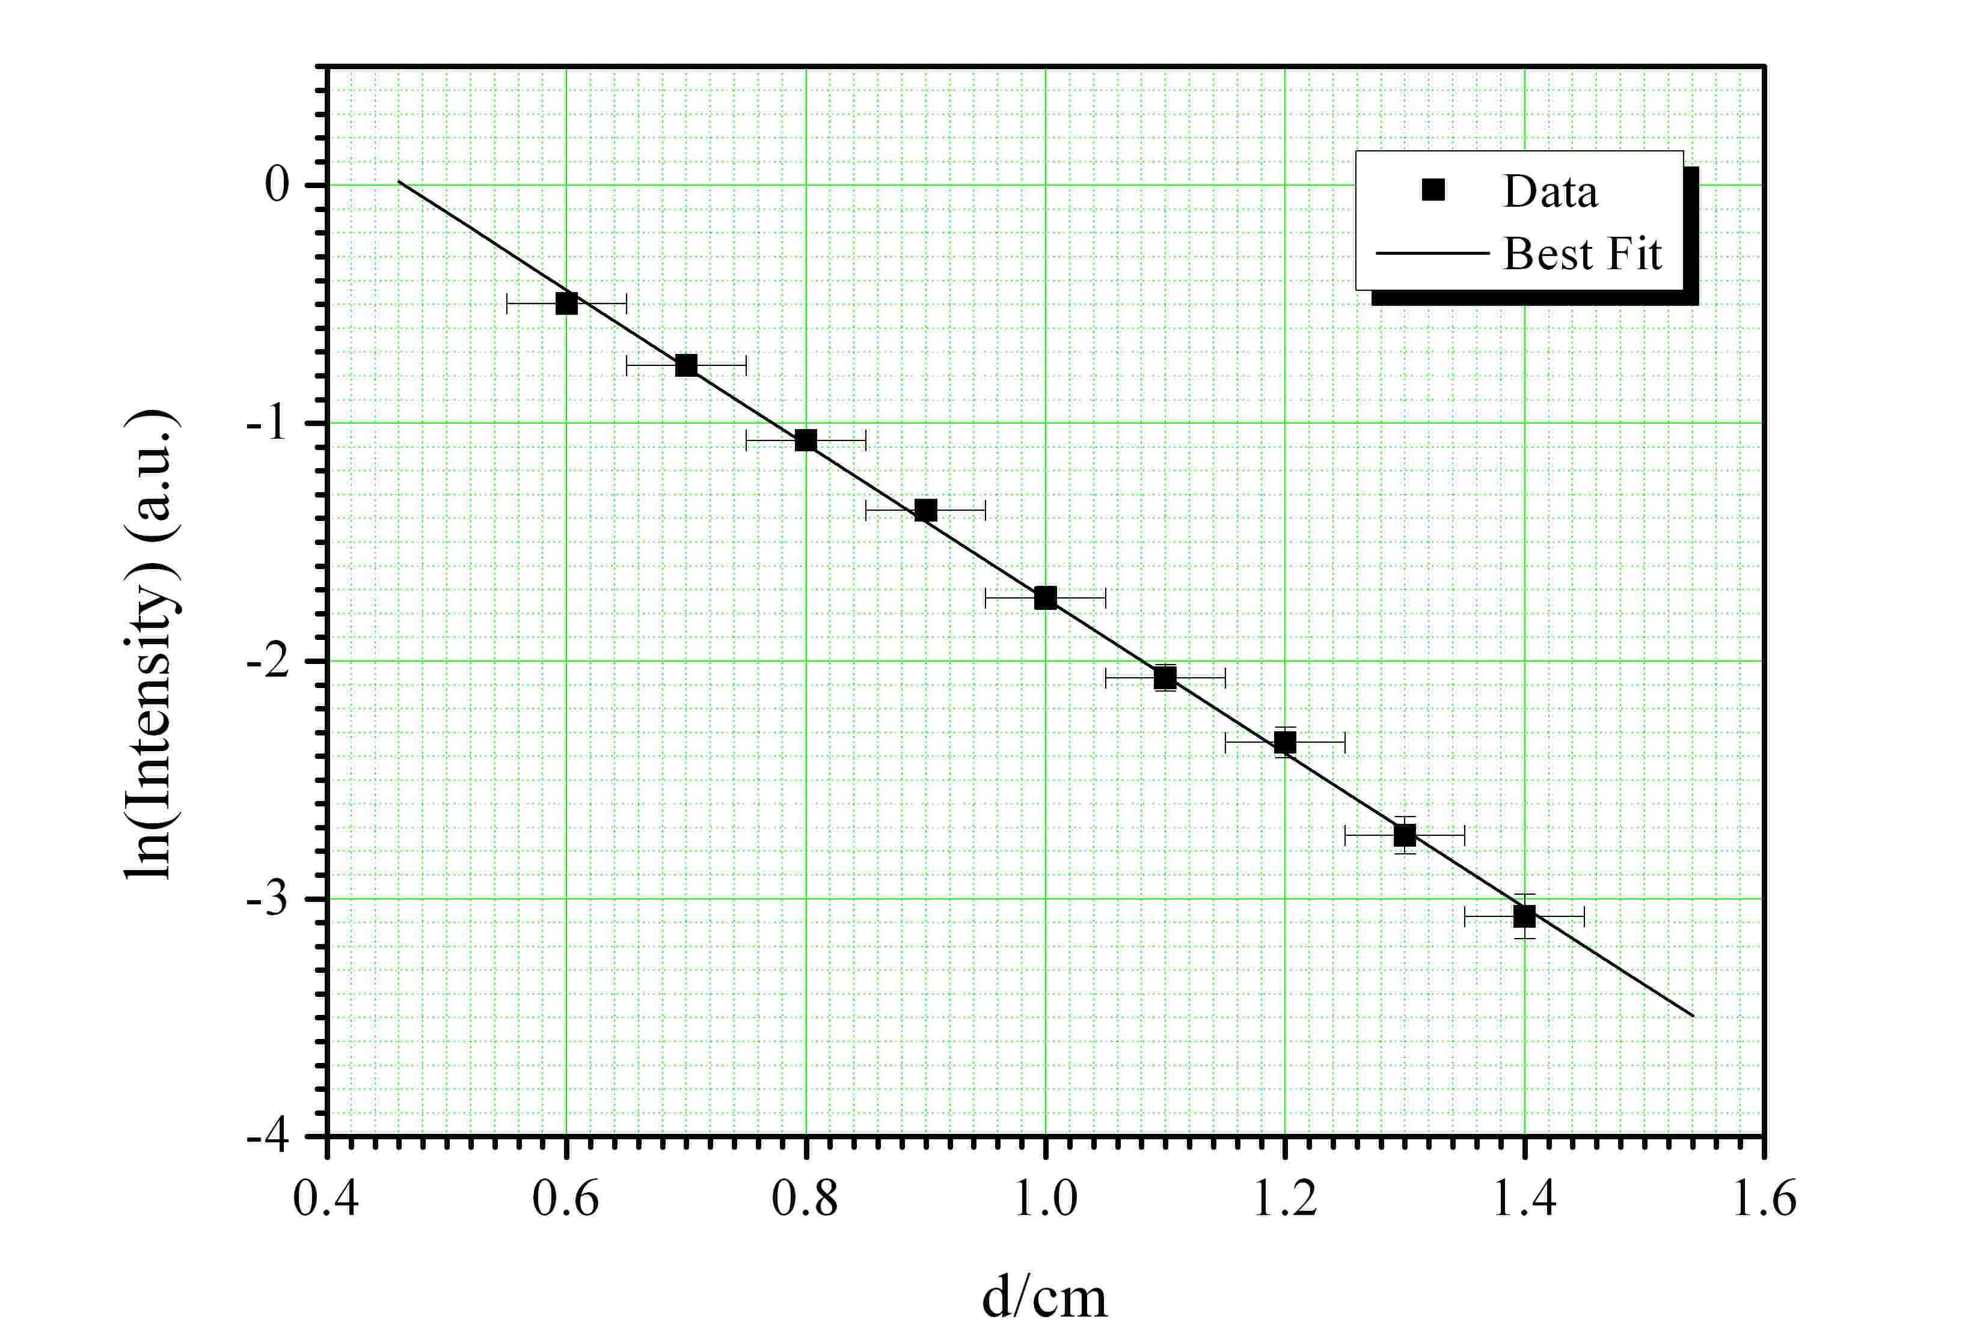

Least Square Fitting

X = d(cm) | ΔX(cm) | Y = ln(I_{t}) | ΔY | ΔY² | XY | X² | Y²
0.60 | 0.05 | -0.50 | 0.03 | 0.001 | -0.298 | 0.360 | 0.247
0.70 | 0.05 | -0.76 | 0.03 | 0.001 | -0.530 | 0.490 | 0.573
0.80 | 0.05 | -1.07 | 0.03 | 0.001 | -0.858 | 0.640 | 1.150
0.90 | 0.05 | -1.37 | 0.04 | 0.002 | -1.230 | 0.810 | 1.867
1.00 | 0.05 | -1.74 | 0.05 | 0.002 | -1.735 | 1.000 | 3.010
1.10 | 0.05 | -2.07 | 0.06 | 0.003 | -2.278 | 1.210 | 4.290
1.20 | 0.05 | -2.34 | 0.06 | 0.004 | -2.811 | 1.440 | 5.487
1.30 | 0.05 | -2.73 | 0.08 | 0.006 | -3.553 | 1.690 | 7.469
1.40 | 0.05 | -3.07 | 0.09 | 0.009 | -4.304 | 1.960 | 9.451
ΣX = |  | ΣY = | ΣΔY = | Σ(ΔY)² = | ΣXY = | ΣX² = | ΣY² =
9.00 |  | -15.648 | 0.469 | 0.029 | -17.596 | 9.600 | 33.544

From , taking natural log on both sides, we obtain:

which is of the form y = mx + c.

To calculate the gradient, the following equation was used, where N is the number of data points:

To calculate the standard deviation σ_{Y} of the individual Y data values, the following equation was used:

Hence the standard deviation in the slope can be calculated:

From the gradient:

Using:

where θ₁ = 60º, k₂ = 2π/λ ≈ 2.20 (using the wavelength determined from earlier part (using λ = (2.85 ± 0.02)cm), we obtain:

Error Analysis for refractive index of n₁

where:

Part 4

Task | Marks
1. Top-view drawing of the lattice and derivation of Bragg’s equation  - Correct drawing of the simple square lattice (0.2 marks)  - Indicating diagonal planes (0.1 mark)  - Correct labeling of a & d (0.1 +0.1 mark)  - Illustration of the optical path difference (0.2 marks)  - Derivation of Bragg’s Law (0.2 marks)  - Indicating m is an integer (0.1 mark) | 1.0
Task 1
Top-view of a simple square lattice. 0.5 marks
a
d

Figure 4.1: Schematic diagram of a simple square lattice with lattice constant a and interplaner d of the diagonal planes indicated.

Deriving Bragg's Law 0.5 marks
Conditions necessary for the observation of diffraction peaks:
- The angle of incidence = angle of scattering.
- The pathlength difference is equal to an integer number of wavelengths.
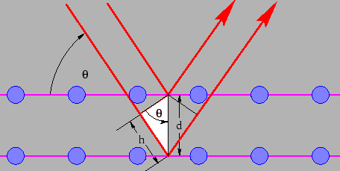
Figure 4.2: Schematic diagram for deriving Bragg's law.

h = d sinθ (1).
The path length difference is given by,
2h = 2d sinθ (2).
For diffraction to occur, the path difference must satisfy,
2 d sinθ = mλ, m = 1, 2, 3...  (3)
a
d

Fig. 4.3 Illustration of the actual lattice used in the experiment (this Figure is not required)

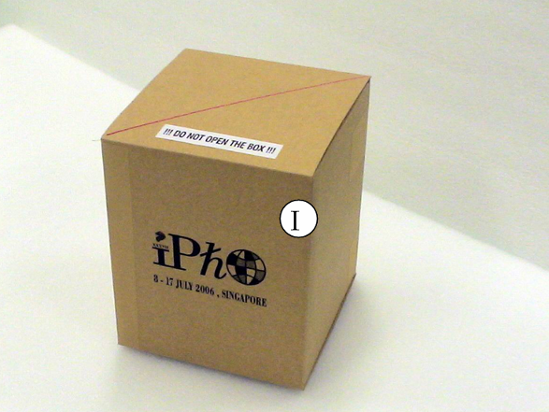
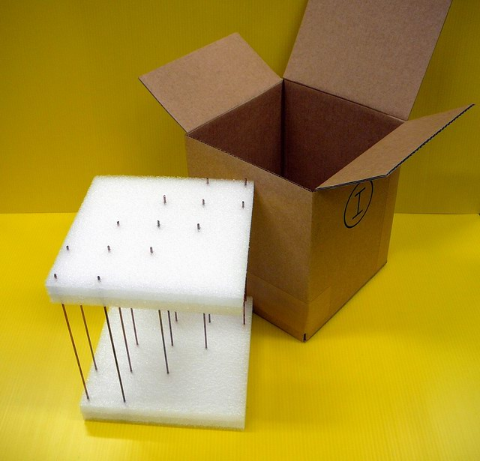

Fig. 4.4 Actual lattice used for the experiment (this Figure is not required)

Fig. 4.4 The actual lattice used in the experiment (not required)

Task 2 (a)

2(a) Experimental design + drawing  - Correct drawing of the diagram including transmitter, lens, lattice and receiver (0.6 marks)  (Deduct 0.2 marks if the components are drawn on a straight line.)  (Deduct 0.1 mark if lattice is not at center.)  (Deduct 0.1 mark for each missing component.)  - Indication of the goniometer & rotating table (0.2 marks)  - Labeling of all the 6 major components (A, B, I, J, L & N): 0.05 marks for each labeling (0.3 marks)  - Indication of θ and ζ=180°-2θ. (0.2+ 0.2 marks) | 1.5

2θ
θ
d
Plano-convex
Cylinder Lens
Transmitter A on
Holder
Lattice on
Rotating Table
Detector B on
Holder
(This Figure is not required)

ζ = 180° - 2θ
θ
Plano-cylindrical Lens on Holder
Microwave Transmitter on Holder
Lattice Box on Rotating Table
Microware Receiver on Holder
J
A
N
I
B
D
Digital Multimeter
I
L

Fig. 4.5 Sketch of the experimental set up

Task 2(a) and 2(b)

Task 2(b) Correct result & small enough interval.  - Correct unit for receiver output S: mA (0.1 mark)  - Correct significant figure for S: to 3rd decimal point  (0.1 mark)  - Correct ζ (180-2θ). (0.5 marks)  (No mark for wrong values)  - 1 degree angle interval throughout or covering at least the 22 -4 deg range (0.5 marks)  (2 deg interval: 0.3 marks; 3 deg : 0.1 mark; and 0 mark for larger interval)  - Range covering the 20-50 degree (0.2 marks)  (Range covering the 25-45 degree: 0.1 mark)  (Other range: 0 mark) | 1.4
Task 2(c) Conversion from amplitude (current) to intensity  - Calculating (Output S)² (0.3 marks)  - Label (mA)² or A.U. (0.1 mark)  (0 mark for not writing any unit)  - Using symmetry axis: (0.2 marks)  - Correct peak position within 2 deg : (0.3 marks)  within 3 deg: 0.2 marks  outside 3 deg: 0 mark  - Appropriate scale of the graph (0.1 mark)  - Correct labeling of axes with units (0.1 mark)  No mark if any label/unit missing  - Correct data plotting (0.2 marks) | 1.3

Data Set 1

*Power = 4.36 X Current²
θ/° | ζ/° | Output current S (mA) | Intensity I=S²  (mA)²
20.0 | 140.0 | 0.023 | 0.000529
21.0 | 138.0 | 0.038 | 0.001444
22.0 | 136.0 | 0.070 | 0.0049
23.0 | 134.0 | 0.109 | 0.011881
24.0 | 132.0 | 0.163 | 0.026569
25.0 | 130.0 | 0.201 | 0.040401
26.0 | 128.0 | 0.233 | 0.054289
27.0 | 126.0 | 0.275 | 0.075625
28.0 | 124.0 | 0.320 | 0.1024
29.0 | 122.0 | 0.350 | 0.1225
30.0 | 120.0 | 0.353 | 0.124609
31.0 | 118.0 | 0.358 | 0.128164
32.0 | 116.0 | 0.354 | 0.125316
33.0 | 114.0 | 0.342 | 0.116964
34.0 | 112.0 | 0.321 | 0.103041
35.0 | 110.0 | 0.303 | 0.091809
36.0 | 108.0 | 0.280 | 0.0784
37.0 | 106.0 | 0.241 | 0.058081
38.0 | 104.0 | 0.200 | 0.04
39.0 | 102.0 | 0.183 | 0.033489
40.0 | 100.0 | 0.162 | 0.026244
41.0 | 98.0 | 0.139 | 0.019321
42.0 | 96.0 | 0.120 | 0.0144
43.0 | 94.0 | 0.109 | 0.011881
44.0 | 92.0 | 0.086 | 0.007396
45.0 | 90.0 | 0.066 | 0.004356
46.0 | 88.0 | 0.067 | 0.004489
47.0 | 86.0 | 0.066 | 0.004356
48.0 | 84.0 | 0.070 | 0.0049
49.0 | 82.0 | 0.084 | 0.007056
50.0 | 80.0 | 0.080 | 0.0064

From the symmetry of the data, the peak position is determined @ θ_{max} = 31°
(The theoretical value is θ_{max} = 32°)

2(d) Determination of a & error analysis  - a – θ relation (expression) (0.2 marks)  - a value: prior to error correction (0.4 marks)  3.55 – 4.10 cm: 0.4 marks  3.40 – 3.54 or 4.11 - 4.20: 0.2 marks  Other values: 0 mark  - Error estimate Δa (0.2 marks) | 0.8 marks

From eq 3 and let m = 1,

$2d\text{sin}θ_{\text{max}}=λ$ (4)

From Fig. 4.3,

$a=\sqrt{2}d$ (5)

Combine eqs (4) and (5), we obtain,

$a=\frac{λ}{\sqrt{2}\text{sin}θ_{\text{max}}}=\frac{2\text{.}\text{85}\text{cm}}{\sqrt{2}\text{sin}{\text{31}}^{o}}=3\text{.}\text{913}\text{cm}$ (Actual value a = 3.80 cm)

The value 3.55 is derived from: $a=\frac{λ}{\sqrt{2}\text{sin}θ_{\text{max}}}=\frac{2\text{.}\text{83}\text{cm}}{\sqrt{2}\text{sin}{\text{34}}^{o}}=3\text{.}\text{58}\text{cm}$

where 2.83 cm and 34 deg are the min and max allowed values for wavelength and peak position.

Similarly:

The value 4.10 is derived from: $a=\frac{λ}{\sqrt{2}\text{sin}θ_{\text{max}}}=\frac{2\text{.}\text{87}\text{cm}}{\sqrt{2}\text{sin}{\text{30}}^{o}}=4\text{.}\text{06}\text{cm}$
The value 3.55 is derived from: $a=\frac{λ}{\sqrt{2}\text{sin}θ_{\text{max}}}=\frac{2\text{.}\text{83}\text{cm}}{\sqrt{2}\text{sin}{\text{34}}^{o}}=3\text{.}\text{58}\text{cm}$

The value 3.40 is derived from: $a=\frac{λ}{\sqrt{2}\text{sin}θ_{\text{max}}}=\frac{2\text{.}\text{83}\text{cm}}{\sqrt{2}\text{sin}{\text{35}}^{o}}=3\text{.}\text{49}\text{cm}$
The value 4.20 is derived from: $a=\frac{λ}{\sqrt{2}\text{sin}θ_{\text{max}}}=\frac{2\text{.}\text{87}\text{cm}}{\sqrt{2}\text{sin}{\text{29}}^{o}}=4\text{.}\text{18}\text{cm}$

Error analysis:

Known uncertainties:

∆λ = 0.02 cm;
∆θ = 0.5 deg = 0.014 rad. (uncertainty in determining θ from graph).

From: $a=\frac{λ}{\sqrt{2}\text{sin}θ_{\text{max}}}$
$$\begin{aligned}Δa=\frac{Δλ}{\sqrt{2}\text{sin}θ_{\text{max}}}−\frac{λ}{\sqrt{2}(\text{sin}θ_{\text{max}})^{2}}\frac{d}{dθ}(\text{sin}θ_{\text{max}})Δθ \\ a(\frac{Δλ}{λ}−\frac{1}{\text{sin}θ_{\text{max}}}\frac{d}{dθ}(\text{sin}θ_{\text{max}})Δθ) \\ a(\frac{Δλ}{λ}−\text{cot}θ_{\text{max}}Δθ) \\ 3\text{.}\text{80}(\frac{0\text{.}\text{02}}{2\text{.}\text{85}}−\text{cot}(\text{32}°)×(−0\text{.}\text{014}))\text{cm} \\ 0\text{.}\text{112}\text{cm}≈0\text{.}1\end{aligned}$$

Hence:

a ± ∆a = 3.913 ± 0.112
≈ 3.9 ± 0.1 cm

# ΔS = 0.01 mA (for each set of current measurements)
* S² proportional to the intensity, I_{t}
$ Δ(S²) = ΔI_{t} = 2 S × ΔS
& ΔY = Δ(lnI_{t}) = Δ(I_{t})/I_{t}

