
4th INTERNATIONAL JUNIOR SCIENCE OLYMPIAD
THEORETICAL COMPETITION
December 6, 2007
Read carefully the following instructions:
- The time available is 3 hours.
- The total number of the problems is 3. Check that you have a complete set of the test problems and the answer sheets.
- Use only the pen provided.
- Write down your name, code, country, and signature in the first page of your answer sheet. Write down your name and code in the other pages of your answer sheet.
- Read carefully each problem and write the correct answer in the answer sheet.
- All competitors are not allowed to bring any stationary and tools provided from outside. After completing your answers, all of the question and answer sheets should be put neatly on your desk.
- Point rules : According with each question marking.
4th INTERNATIONAL JUNIOR SCIENCE OLYMPIAD
THEORETICAL COMPETITION
December 6, 2007
EXAMINATION RULES
- All competitors must be present at the front of examination room ten minutes before the examination starts.
- No competitors are allowed to bring any tools except his/her personal medicine or any personal medical equipment.
- Each competitor has to sit according to his or her designated desk.
- Before the examination starts, each competitor has to check the stationary and any tools (pen, ruler, calculator) provided by the organizer.
- Each competitor has to check the question and answer sheets. Raise your hand, if you find any missing sheets. Start after the bell.
- During the examination, competitors are not allowed to leave the examination room except for emergency case and for that the examination supervisor will accompany them.
- The competitors are not allowed to bother other competitor and disturb the examination. In case any assistance is needed, a competitor may raise his/her hand and the nearest supervisor will come to help.
- There will be no question or discussion about the examination problems. The competitor must stay at their desk until the time allocated for the examination is over, although he/she has finished the examination earlier or does not want to continue working.
- At the end of the examination time there will be a signal (the ringing of a bell). You are not allowed to write anything on the answer sheet, after the allocated time is over. All competitors must leave the room quietly. The question and answer sheets must be put neatly on your desk.
Problem I Forces in Fluid
Theoretical Competition, 4th IJSO, Taipei, Taiwan, December 6, 2007
When an object moves through a fluid, in addition to the buoyant force, it also experiences a force due to the resistance of the fluid. This force is known as the drag force F_{D}. It is known that for objects moving with low velocities, F_{D} is proportional to the velocityof the object relative to the fluid and the linear size R of the object. Therefore, we can write F_{D} = CvR, where C is a constant that depends on properties of fluids and the geometry of the object. Using this fact and assuming the velocities involved in below are low, answer the following questions.
I-1 (1.0 point)
What is the unit of C ? (in terms of SI units：kg, s, m.)
I-2 (1.5 points)
Following problem I-1, consider a dust particle of radius, R = 3.0×10⁻⁶ m, falls in air at 20°C. The numerical value of C for this particle in the air at 20°C is 3.4×10⁻⁴ (in SI units). The density of the particle, ρ, is 2.0×10³ kg·m⁻³. Suppose that the particle can move indefinitely without being blocked by the surface of the earth. Eventually, the particle reaches the state with fixed velocity, known as the terminal speed. If the acceleration due to gravity g is fixed at the value 9.8 m·s⁻² and the buoyant force due to air can be ignored, find the terminal speed of the dust particle.
I-3 (1.0 point)
As shown schematically in Fig.I-1, centrifuges are apparatuses in which samples are being rotated rapidly to perform many tasks in biological or medical laboratories. Samples often consist of biological molecules in water. As an example, consider a sample containing proteins of density 1.3×10³ kg·m⁻³ in the water with density 1.0×10³ kg·m⁻³. Suppose that the centripetal acceleration can be considered as a constant and is 10⁵ times of g. Fig.I-2 shows how the distribution of proteins changes versus time and Fig.I-3 shows the time dependence of h. Find the terminal speed of this protein molecule in the water.
Theoretical Competition, 4th IJSO, Taipei, Taiwan, December 6, 2007

Fig.I-1
sample
sample
axis of rotation

Fig.I-2
t = 0
t
h

t (s)
h (cm)

Fig.I-3
I-4 (2.5 points)
Theoretical Competition, 4th IJSO, Taipei, Taiwan, December 6, 2007
Following problem I-3, determine the molecular mass of each protein in terms of the atomic mass unit u, 1u = 1.66×10⁻²⁷ kg. Here we assume that each protein can be regarded as a sphere with radius R = 2.5×10⁻⁶ m and the numerical value of C for this protein in water is 4.0×10⁻⁵ (in SI units).
I-5
In different pH environment, each protein may carry different net charge. This is demonstrated in Fig.I-4. Here the Isoelectric point (pI) is the pH value at which a protein carries no net electrical charge. Consider three proteins, denoted by D, E, and F, with molecular weights 60000u, 88000u, 160000u and their pIs being 5.2, 6.7, and 9.2 respectively. We will assume that the slopes of their pH values versus charges are the same. As shown schematically in Fig.I-5, a droplet that contains D, E, F, and neutral particles (denoted by N) is introduced near the center of a capillary tube that contains a solution with pH = 8.3. Electric potentials of opposite signs but of the same magnitudes are applied at the left and right electrodes of the capillary tube. It is found that right after the application of the electric potentials, the droplet and the solution move with constant velocities. Furthermore, after some period t₀, the droplet evolves into 4 bands denoted by 1, 2, 3, and 4 as shown in the lower figure in Fig.I-5. The corresponding traveling distances are denoted by d_{i} with i being equal to 1, 2, 3, or 4. We shall neglect effects due to diffusion and boundaries. The interactions between proteins and neutral particles can be also neglected. By assuming that these proteins have the same values of C and can be considered as spheres of the same density, answer the following questions:
I-5-A (1.2 points)
Let the charges that proteins D, E, and F carry in the solution be Q_{D}, Q_{E}, and Q_{F}. Order Q_{D}, Q_{E}, Q_{F}, and 0 (zero charge) according to their values.
I-5-B (2.0 points)
Identify all the bands in Fig.I-5 by mapping D, E, F, and N to 1, 2, 3, and 4.
I-5-C (0.8 point)
Express the average flow velocity of the solution in terms of t₀ and d_{i}.
Theoretical Competition, 4th IJSO, Taipei, Taiwan, December 6, 2007
Net charge of a protein
0
Environmental pH

Isoelectric point

Fig.I-4

1
2
3
4

Fig.I-5
Problem II Chemistry of Carbon dioxide
Theoretical Competition, 4th IJSO, Taipei, Taiwan, December 6, 2007
Carbon dioxide (CO₂) is involved in several important biological and environmental processes. CO₂ is used in photosynthesis to make glucose (C₆H₁₂O₆) and O₂. The energy required to produce 1 mol of glucose is 2800 kJ. It is estimated that the net average amount of CO₂ fixed by photosynthesis on the landmass of the Earth is 370 g per square meter per year. All the carbon atoms produced are converted into glucose. CO₂ is also the final oxidation product of all carbon-based fuels; its increase in the atmosphere is causing global warming. The metabolism of glucose yields CO₂(g) and H₂O(l) as the final products. Heat released in the process is converted to useful work with about 70% efficiency. The excess CO₂ produced by the metabolic processes in a human body is exhaled. The expired air normally contains 30.0 mmHg of CO₂ at 37°C. A simple test for CO₂ in the breath is carried out by blowing the expired air into a limewater (a saturated solution of Ca(OH)₂) to turn it milky. A very useful property of CO₂ is its ability to react with potassium superoxide (KO₂) to generate O₂ which can be used in oxygen masks. Based on the above information, answer the following questions.

II-1 (0.5 point)
Write down the balanced chemical equation for the photosynthesis of glucose from CO₂ and H₂O.
II-2 (2.0 points)
The sun supplies about 1.0 kJ of energy per second per square meter of land on the Earth’s surface. What percentage of this energy is used to produce glucose?
II-3 (1.5 points)
Calculate the mass of glucose metabolized by a 60 kg person in climbing a mountain with an elevation gain of 1000 m by assuming that the energy consumed in the climbing is five times of the mechanical energy required for lifting a 60 kg object by 1000 m and the energy is supplied solely from the metabolism of glucose.
II-4 (0.5 point)
Write down the balanced chemical equation for the reaction of KO₂ and CO₂ to form K₂CO₃ and O₂.

Theoretical Competition, 4th IJSO, Taipei, Taiwan, December 6, 2007
II-5 (1.5 points)
Find the mass of CO₂ in 1 L of the expired air from the human body.
II-6 (1.5 points)
If a firefighter wearing a KO₂ oxygen mask exhales 400 L of air per hour, find the mass of O₂ that can be supplied by the oxygen mask per hour for the firefighter. Assume that the reaction is instant and complete.
II-7 (0.5 point)
Write down the balanced chemical equation for the test of CO₂(g) with limewater.
II-8 (0.5 point)
What is the total number of electrons in a molecule of C₆H₁₂O₆?
II-9 (1.5 points)
An element usually has several isotopes with different natural abundances. For carbon atoms, 98.9% are C-12 and 1.1% are C-13. Nearly all hydrogen is H-1 and oxygen is O-16. Estimate the relative abundance of molar mass 181 (¹³C¹²C₅H₁₂O₆) to 180 (¹²C₆H₁₂O₆) for a sample of glucose.
Problem III
Theoretical Competition, 4th IJSO, Taipei, Taiwan, December 6, 2007
III-1 Plant Physiology
A student added 20 cm³ of 5 mM KHCO₃ solution and 5 drops of universal pH indicator into a 250 cm³ conical flask (Fig.III-1). He cut the ends of leaves underwater and transferred the cut-ends to a small glass vial with sufficient water for the cut-ends to be immersed. He then tied a thread around the glass vial, lowered the vial into the conical flask, and sealed the flask with a bung and parafilm. After these preparations, he started the following experiments.
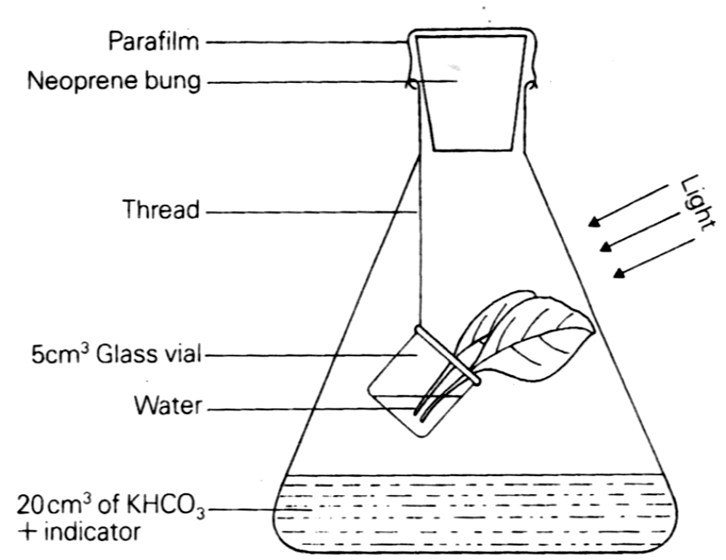
Conical flask
Fig.III-1

For the following questions, please select the corresponding number of the right answer from Table III-1 and fill it in the corresponding space in the answer sheet. Each item in the table may be selected more than once or may not be selected at all. (each answer 0.3 point; total 4.2 points)
Table III-1
1: increased | 2: decreased | 3: remained the same | 4: photosynthesis
5: respiration | 6: transpiration | 7: O₂ | 8: CO₂
9: K⁺ | 10: HCO₃⁻ | 11: OH⁻ | 12: H⁺

Theoretical Competition, 4th IJSO, Taipei, Taiwan, December 6, 2007
III-1-A
He placed the flask 30 cm from a 60 W tungsten lamp and turned on the lamp for 90 minutes. During the 90 minutes, he found the pH value of the solution in the flask a . The reason is that the leaves largely carried out the process of b , which consumed c , and caused the ions of d and e in the solution to have f .
III-1-B
He turned off the lamp and left the flask in the dark for 60 minutes. During the 60 minutes, he found the pH value of the solution in the flask a . The reason is that the leaves underwent the process of b , which released c , and caused the ions of d and e in the solution to have f .
III-1-C
He changed the solution of KHCO₃ to 20 cm³ of 5mM NaOH, replaced the leaves with fresh ones, resealed the flask, and then turned on the lamp for 30 minutes. During the 30 minutes, he found that first the process of a__ in leaves decreased, and then the process of b in leaves decreased.
III-2 Homeostasis of blood sugar
Theoretical Competition, 4th IJSO, Taipei, Taiwan, December 6, 2007
The term homeostasis refers to the maintenance of the human body at relatively constant conditions. An example of homeostasis is the concentration of the blood sugar (mainly the blood glucose), which is regulated within a narrow range by hormones. Mr. Chen took the blood sugar test by following the procedures: He first had the supper with his regular hospital meal at 6:00 pm and fasted afterwards. Immediately after his supper, blood samples for sugar concentration tests were taken and examined at every hour for 8 hours. The results are shown in Figure III-2 in which the vertical scale is the sugar concentration in blood and the horizontal scale is the time interval in unit of hour. The data shows three phases. By the above serial blood test and physical examination, Mr. Chen’s health condition was claimed by a medical doctor to be normal and free of diabetes.
blood  sugar  conc. | 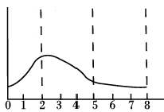  phase  1  phase  2  phase  3  Hours (after supper)
Fig.III-2
Based on the above information, answer the following questions by selecting appropriate numbers (1 to 6) from Table III-2 or letters (a to e) from Table III-3.
Table III-2: Hormones that regulate the concentration of blood sugar
1. thyroxin
2. insulin
3. adrenaline
4. glucagon
5. growth hormone
6. cortisol
Table III-3: Statements that are related to changes in blood sugar concentration.
- blood sugar coming into hepatocytes
- blood sugar coming into pancreatic cells
- glycogen decomposition coming to blood
- digested foods absorbed in intestine coming into blood
- blood sugar excreted into urine
Theoretical Competition, 4th IJSO, Taipei, Taiwan, December 6, 2007
III-2-A (0.3 point)
Which one of the statements in Table III-3 explains why the blood sugar concentration of Mr. Chen slowly increased during the phase 1 after the supper?
III-2-B
III-2-B-a (0.3 point)
Which statement in Table III-3 explains the decreasing trend in Mr. Chen’s blood sugar concentration during the phase 2?
III-2-B-b (0.3 point)
Which of the hormones in Table III-2 controls this phenomenon shown in phase 2?
III-2-C (0.3 point)
Which one of the following figures would correctly capture the change of blood sugar concentration in Mr. Chen’s body during the 6 hours after phase 3, i.e., the period during 8~14 hours after supper?

(a) |  | (b)
blood  sugar  conc. | 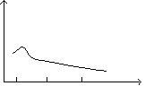  8 10 12 hr | blood  sugar  conc. | 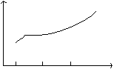  8 10 12 hr
(c) |  | (d)
blood  sugar  conc. | 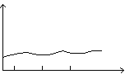 8 10 12 hr | blood  sugar  conc. | 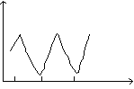 8 10 12 hr

III-2-D
Theoretical Competition, 4th IJSO, Taipei, Taiwan, December 6, 2007
III-2-D-a (0.3 point)
Which one of the hormones in Table III-2 is the most possible candidate to regulate the blood sugar concentration of Mr. Chen after phase 3 (as described in question III-2-C)?
III-2-D-b (0.3 point)
Which one of the statements in Table III-3 is related to blood sugar concentration present after phase 3 (as described in question III-2-C)?
III-2-E (0.6 point)
Mr. Wang is a mild diabetic patient. He also has his suppers with the hospital regular meal at 6:00 pm and fasts afterwards for blood test. Please predict the change of blood sugar concentration of Mr. Wang during 8 hours period after supper. For comparison, plot the curve of blood sugar concentration change for Mr. Wang on Figure III-2.
III-2-F
A test on Mr. Wang has determined that Mr. Wang’s urine contains glucose. It is known that a urine glucose molecule follows the following pathway: It is first absorbed by small intestine, and then it travels through the cardiovascular and urinary systems. Finally, it is excreted in urine. In the following passage, please fill in each blank with the number that corresponds to the appropriate term (terms numbered 1−14 in Table III-4). (each answer 0.2 point, total 2.4 points)
Table III-4
- pulmonary artery  - pulmonary vein  - left atrium  - right atrium  - left ventricle  - right ventricle  - hepatic artery  - hepatic vein  - hepatic portal vein  - kidney artery  - kidney vein  - urethra  - ureter  - bladder | A blood glucose molecule, absorbed by the villi of the small intestine, is carried by the a to the liver, transferred through the b into the inferior vena cava, and flows into the c of the heart. Then, the blood is pumped by the d to leave heart, flows into a e to delivery the blood to the lungs, and flows back to the heart through a f . Passing by the g and the h , the blood is pumped to leave the heart and flows into the aorta. When the blood flows into the kidney through a i , the blood glucose is filtrated into the kidney. Urine containing glucose not absorbed by the kidneys is sent via an j into the k for storage. Finally, the glucose molecule in urine is excreted through the l .
Theoretical Competition, 4th IJSO, Taipei, Taiwan, December 6, 2007
III-3 Pests in the rice field
For several years, Mr. Tu had continuously been applying a certain amount of X-pesticide on the field for reducing the damage of pests on rice production. For each year, he counted pests found in the rice field by numbers/m² and plotted the results shown in Figure III-3.
Fig.III-3
According to the above observation, Mr. Tu concluded that the X-pesticide was very effective in the earlier years, but, it gradually became ineffective in later years. Based on the above information, please answer the following questions.
III-3-A (0.4 point)
By examining the data shown in Fig.III-3, which year was the first year for applying X-pesticide?
III-3-B (0.3 point)
Which one of the following statements matches Mr. Tu’s conclusion?
(a) Mutations happened in Mr. Tu’s rice plants and the mutated rice plants attracted a large quantity of various other pests to come.
(b) A pesticide-resistant line was developed in the pest population, after which the number of the pesticide-resistant insects increased.
(c) Bad quality control in the production of the pesticide resulted in the ineffectiveness of the pesticide.
(d) After Mr. Wang applied X-pesticide in the field, heavy rains reduced the efficiency of the pesticide.
III-3-C (0.3 point)
Based on the study of Mr. Tu, to prolong the effectiveness of X-pesticide, which one of the following suggestions is the best?
(a) Lowering the applied dosage of X-pesticide every year
(b) Doubling the applied dosage of X-pesticide every year
(c) Alternation of high and low X-pesticide dosages on a yearly basis
(d) Alternating application of X-pesticide with another effective pesticide each year.

