Question “Pink”

1.1
Period = 3.0 days = $2\text{.}6×{\text{10}}^{5}s$.
Period = $\frac{2π}{ω}$ $⇒$ $ω=2\text{.}5×{\text{10}}^{−5} \text{rad} s^{−1}$.

1.2
Calling the minima in the diagram 1, $I_{1}/I_{0}=α=0\text{.}\text{90}$ and $I_{1}/I_{0}=β=0\text{.}\text{63}$, we have:

$$\frac{I_{0}}{I_{1}}= 1+{\left(\frac{R_{2}}{R_{1}}\right)}^{2}{\left(\frac{T_{2}}{T_{1}}\right)}^{4}=\frac{1}{α}$$
$$\frac{I_{2}}{I_{1}}= 1−{\left(\frac{R_{2}}{R_{1}}\right)}^{2}\left(1−{\left(\frac{T_{2}}{T_{1}}\right)}^{4}\right)=\frac{β}{α}$$

From above, one finds:
$\frac{R_{1}}{R_{2}}=\sqrt{\frac{α}{1−β}} ⇒ \frac{R_{1}}{R_{2}}=1\text{.}6$ and $\frac{T_{1}}{T_{2}}=\sqrt[4]{\frac{1−β}{1−α}} ⇒ \frac{T_{1}}{T_{2}}=1\text{.}4$

2.1)
Doppler-Shift formula:
$\frac{Δλ}{λ_{0}}≃\frac{v}{c}$ (or equivalent relation)

Maximum and minimum wavelengths: $λ_{1\text{,max}}=\text{5897}\text{.}7$Å , $λ_{1\text{,min}}=\text{5894}\text{.}1$ Å
$λ_{2\text{,max}}=\text{5899}\text{.}0$Å , $λ_{2\text{,min}}=\text{5892}\text{.}8$ Å

Difference between maximum and minimum wavelengths:
${Δλ}_{1}=3\text{.}6$ Å , ${Δλ}_{2}=6\text{.}2$ Å

Using the Doppler relation and noting that the shift is due to twice the orbital speed:
$v_{1}=c\frac{{Δλ}_{1}}{2λ_{0}}$ $=9\text{.}2×{\text{10}}^{4}$ m/s
$v_{2}=c\frac{{Δλ}_{2}}{2λ_{0}}$ $=1\text{.}6×{\text{10}}^{5}$ m/s

2.2) As the center of mass is not moving with respect to us:

$\frac{m_{1}}{m_{2}}=\frac{v_{2}}{v_{1}}$ = $1\text{.}7$

2.3)

Writing $r_{i}=\frac{v_{i}}{ω}$ for $i=1 ,2$ , we have

$r_{1}=3\text{.}8×{\text{10}}^{9}$m, $r_{2}=6\text{.}5×{\text{10}}^{9}$m

2.4)

$r=r_{1}+r_{2}=1\text{.}0×{\text{10}}^{\text{10}}$m

3.1)

The gravitational force is equal to mass times the centrifugal acceleration

$$G\frac{m_{1}m_{2}}{r^{2}}=m_{1}\frac{v_{1^{2}}}{r_{1}}=m_{2}\frac{v_{2^{2}}}{r_{2}}$$
Therefore,

$\begin{aligned}\left\{m_{1}=\frac{r^{2} v_{2^{2}}}{G r_{2}} | \right.\end{aligned}$ $⇒$ $\begin{aligned}\left\{m_{1}=6×{\text{10}}^{\text{30}}\text{kg} | \right.\end{aligned}$

4.1) As it is clear from the diagram, with one significant digit, $α=4$.

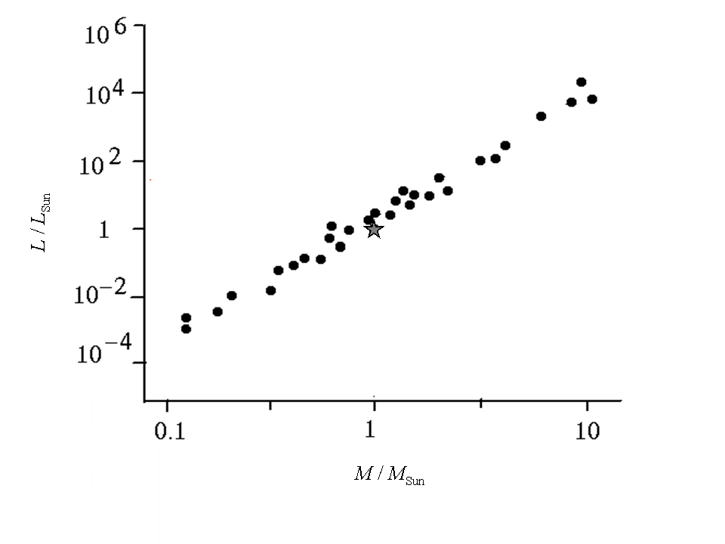

4.2)
As we have found in the previous section: $L_{i}=L_{\text{Sun}}{\left(\frac{M_{i}}{M_{\text{Sun}}}\right)}^{4}$
So,
$L_{1}=5×{\text{10}}^{\text{28}}\text{Watt}$
$L_{2}=6×{\text{10}}^{\text{27}}\text{Watt}$

4.3) The total power of the system is distributed on a sphere with radius $d$ to produce$I_{0}$, that is:
$I_{0}=\frac{L_{1}+L_{2}}{4 π d^{2}}$ $⇒ d=\sqrt{\frac{L_{1}+L_{2}}{4 π I_{0}}}$=$1×{\text{10}}^{\text{18}}$m
= 100 ly.

4.4) $θ≃\text{tan} θ=\frac{r}{d}$= $1×{\text{10}}^{−8}$rad.

4.5)
A typical optical wavelength is $λ_{0}$. Using uncertainty relation:
$D=\frac{d λ_{0}}{r_{\text{tot}}}$ = 50 m.

