EXAMINATION RULES
- All competitors must be present at the front of examination room ten minutes before the examination starts.
- No competitors are allowed to bring any tools except his/her personal medicine or any personal medical equipment.
- Each competitor has to sit according to his or her designated desk.
- Before the examination starts, each competitor has to check the stationary and any tools (pen, ruler, calculator) provided by the organizer.
- Each competitor has to check the question and answer sheets. Raise your hand, if you find any missing sheets. Start after the bell rings.
- During the examination, competitors are not allowed to leave the examination room except for emergency case and for that the examination supervisor will accompany them.
- The competitors are not allowed to bother other competitor and disturb the examination. In case any assistance is needed, a competitor may raise his/her hand and the nearest supervisor will come to help.
- There will be no question or discussion about the examination problems. The competitor must stay at their desk until the time allocated for the examination is over, although he/she has finished the examination earlier or does not want to continue working.
- At the end of the examination time there will be a signal (the ringing of a bell). You are not allowed to write anything on the answer sheet, after the allocated time is over. All competitors must leave the room quietly. The question and answer sheets must be put neatly on your desk.
Read the following instructions carefully:
- While you are in the laboratory, you should wear safety spectacles at all times.
- Eating of any kind of food is strictly prohibited in the laboratory. If necessary, you may ask Lab Assistant and take a snack break nearby the laboratory.
- Participants are expected to work safely, to behave socially and to keep equipment and work environment clean. When carrying out discussions with your teammates, keep your voice low.
- Do not leave the examination room until you have permission to do so. Ask Lab Assistant if you need to use the bathroom.
- Work may only begin when the start signal is given.
- You have 3 hours and 30 minutes to complete the experimental tasks, and record your results on the answer sheets. There will be a pre-warning 30 minutes before the end of your time. You must stop your work immediately after the stop command is given. A delay in doing this by 5 minutes will lead to zero points for the task.
- Be sure that your team has a complete set of the experimental examination (3 copies) and 5 types (one for each experiment) of answer sheets (1 white copy for workout and 1 yellow copy for submission). Submit only the yellow answer sheets.
- Use only the pen and calculator provided.
- Team code and student codes must be written on every page of the final answer sheets. Each team member must sign on the front page of the final answer sheets.
- All results must be written in the designated boxes on the answer sheets. Data written elsewhere will not be graded.
- After completing the task, put all the equipments back to its original place.
- After the stop command is given, put ONLY the final answer sheets (one copy) on top of the envelope on the desk. Wait for the Lab Assistant to check and collect it. You can take the other papers with you.

Taste of Azerbaijan

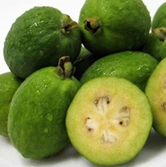 | 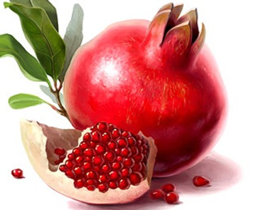
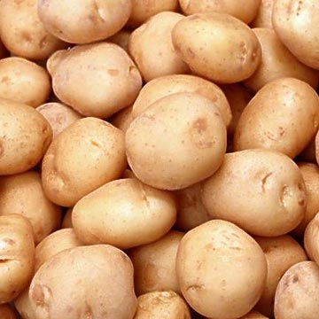 | 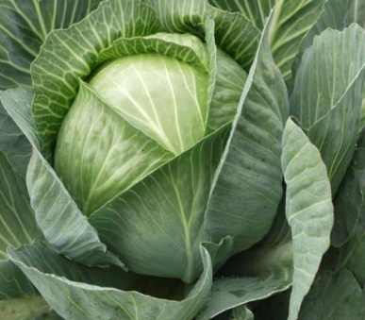

Feijoa (also known as feykhoa in native language) is very valuable and healthy fruit, mainly growth in the south subtopic regions of Azerbaijan. Feykhoa is used as decorative plant in most countries, but in Azerbaijan it is used as agricultural plant. Feykhoa contains up to 6.9% of sugar, carotene etc. During clinical experiments it was discovered that feykhoa and its juice is very good for treatment of several diseases.
Feykhoa is widely used in national cuisine of Azerbaijan. It is very popular to prepare compote, jam and candies from feykhoa in Azerbaijan. Azerbaijan is also main exporter of this fruit to the world market.
Pomegranate is a real freshfruit with a sour-sweet taste.There are 400 to 700 tiny seeds covered with semitransparent,smooth and light red colored flesh in one main fruit .The seeds in the fruit are divided to segments by thin, milky-colored membranes.38% to 63% of the fruit is juice.
There are a lot of pomegranate gardens in Azerbaijan. Especially Goychay region is very popular for its pomegranates. This is only place in the world where the region celebrates “Pomegranate Day”. There are about 35 types of pomegranate in Azerbaijan. The local product “NarSharab” – sour sauce, which is made from pomegranate juice very popular in the world.
Part I: Determination of the amount of peroxidase in plant samples and the effect of pH on enzymatic reactions

Introduction
Complex biochemical reactions occur in living cells of plants and animals. These processes are regulated by protein substances – enzymes- which catalyse biochemical reactions in living cells. Enzymes accelerate the reaction rate, but do not take part in the reaction itself. Complicated, sensitive and accurate laboratory test assays are required for the investigation of enzymes. However, some biochemical processes related to enzymes can be seen visually with the naked eye. The aim of this part (I) of the experiment is to determine the presence of the enzyme – peroxidase - within feykhoa, potato and cabbage.
Peroxidase is an oxidizing enzyme found in most living tissues. Peroxidase uses peroxide for oxidation reactions. There are some substances which are slowly oxidized without enzymes, but the presence of enzymes accelerates the biochemical reactions several thousand times. During oxidation of some organic substances, like hydroquinone, different coloured products are formed.
No colour change indicates that there is no peroxidase enzyme in a sample. Any immediate colour change (10-40 seconds) means that the enzyme is acting. The depth of colour indicates the level of enzyme activity.
Colour numbering:
1 – Brown, 2 – Pink, 3 – Orange, 4 – Red, 5 – Green, 6 – Blue, 7 – No colour change

Experiment I: Peroxidase determination
Equipment required | Quantity
Test tube rack | 1
Plastic wash bottle 500 mL | 1
Graduated cylinder-100 mL | 1
Spatula | 1
Water bath | 1
CD-marker. | 1
Test tubes | 8
Beakers | 5
Automatic pipette with many tips | 1
Tissue papers | 1 box
Stopwatch | 1
Trash can | 1
Chemicals required | Quantity
3% hydrogen peroxide solution | 100 mL
Hydroquinone | 5g
Distilled water | 500 mL
Feykhoa juice | 200 mL
Potato juice | 200 mL
Cabbage juice | 200 mL

Plug in and turn on the water bath – ensure it is heating to boiling point.
Procedure for serial dilutions:

- Take 10 mL of each juice (feykhoa, potato and cabbage) using the automatic pipette and place in separate beakers (See Appendix 1 for the automatic pipette usage instructions).
- Dilute cabbage 5 times, by adding 40mL of water using the measuring cylinder.
- Dilute potato 5 times, by adding 40mL of water using the measuring cylinder.
- Dilute feykhoa 5 times by adding 40mL of water using the measuring cylinder.
- If more distilled water is required, ask the lab assistants.
- Place 8 clean, labeled test-tubes in a test tube rack and arrange as shown below.

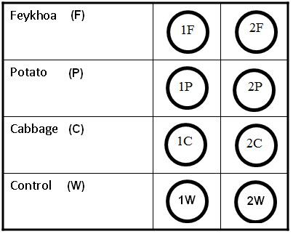
Peroxidase assay:

- Adjust the automatic pipette to 1 mL.
- Add to each of the two tubes in the first row, 1 mL of the diluted feykhoa solution.
- Add to each tube of the two tubes in the second row 1 mL of the diluted potato solution.
- Add to each tube of the two tubes in the third row 1 mL of the diluted cabbage solution.
- Add to each tube of the two tubes in the fourth row 1 mL of water.
- Keep these dilutions for use in later experiments.
- Ensure the tubes are labeled correctly according to the pictures above.
- Place 2F, 2P, 2C and 2W tubes in the hot water bath for 10 minutes.
- Take the tubes out of the water bath and then cool these tubes for 10 minutes to reach approximately room temperature. Add to all 8 tubes a small quantity of hydroquinone using the spatula tip.
- Note the initial colour(s).
- Add to all tubes 1 mL of the hydrogen peroxide solution, and shake each tube.
- Note the final colour(s) after 2 minutes.
Questions for Experiment I (6.5 points)

I – 1. Fill in the table on the answer sheet with the colour(s) and numbers. (2.5 points)

I – 2. Which of the investigated vegetables/fruit contain peroxidase? (1.5 points)

I – 3. Do you observe any colour change in the control tubes after 15 min? (0.5 points)

I – 4. How does boiling affect peroxidase? (1.0 points)

I – 5. How and why will the colour immediately (10-40 seconds) change if only hydroquinone without hydrogen peroxide is added to diluted juice of cabbage? (1.0 points)

After experiment, drain off test tubes into trash can and rinse all the tubes and put them into equipment box.
Experiment II: Determination of optimum pH of enzymatic reaction
Equipment required | Quantity
Test tube rack | 1
CD-marker. | 1
Test tubes | 10
pH-meter | 1
Spatula | 1
Automatic pipette with many tips | 1
Tissue papers | 1 box
Chemicals required | Quantity
0.05 mol/L hydrochloric acid solution (HCl) | 350 mL
0.1 mol/L sodium hydroxide solution (NaOH) | 100 mL
3% hydrogen peroxide solution | 100 mL
Hydroquinone | 5 g
Buffer solution | 1 plastic can
Diluted Cabbage juice from part 1

The pH of a medium plays an important role in enzymatic reactions. Each enzyme has an optimal pH range, where enzymatic reactions occur at the maximum rate.

Procedure: Prepare and test a range of solutions with different pH’s:

The task is to identify the optimal pH range of peroxidase from cabbage.
- Label 10 test tubes from 1 to 10.
- Adjust the automatic pipette (use a new tip) to 4 mL then measure 4 mL of diluted cabbage juice (you prepared when you carried out the 1st experiment) into each test tube.
- Then use the solutions of HCl (0.05 M), NaOH (0.1 M) to produce solutions of different pH’s as described below:
- Add 3 mL 0.05 M hydrochloric acid to the 1st tube
- Add 1.5 mL 0.05 M hydrochloric acid to the 2nd tube
- Add 0.75 mL 0.05 M hydrochloric acid to the 3rd tube
- Add 0.3 mL 0.05 M hydrochloric acid to the 4th tube
- Add nothing to the 5th tube
  - Change the automatic pipette tip with a clean one and continue the experiment.
- Add 0.2 mL 0.1M sodium hydroxide solution to the 6th tube
- Add 0.4 mL 0.1M sodium hydroxide solution to the 7th tube
- Add 1 mL 0.1 M sodium hydroxide solution to the 8th tube
- Add 2 mL 0.1 M sodium hydroxide solution to the 9th tube
- Add 3 mL 0.1 M sodium hydroxide solution to the 10th tube
- Check the pH meter. (See Appendix 2 for the pH meter usage instructions). Measure and record the pH reading of the provided buffer solution.
- Measure and record the pH of solutions in tubes 1 to 10 using the pH meter. Keep the pH meter in the test tube until stable values are shown. Rinse pH meter with distilled water after each use.
- As in previous experiments, add a small quantity of hydroquinone using the spatula tip to each tube and shake them.
- Record the colour changes of each test tube.
- Adjust the automatic pipette to 1mL and with a new tip, measure 1 mL hydrogen peroxide into each tube.
- Record the colour changes of each test tube after 2 min.
Questions for Experiment II (7 points)

*Note: Neglect the overall volume of the solutions in the test tubes.

II – 1. Record the pH reading for buffer solution. Fill in the chart with the recorded pH of the solutions in tubes 1 to 10 given on the answer sheet. (3.0 points)

II – 2. Identify the range of optimal pH for the action of peroxidase enzyme. (2.0 points)

II – 3. Identify the tube in which the peroxidase enzyme is the most active. (1.5 points)

II – 4. According to the experimental results, predict which substances of the following would inhibit peroxidase activity: oxalic acid, ammonium hydroxide, sodium carbonate, acetic acid? (0.5 points)
Part II: Determination of Vitamin C concentration in cabbage solution by titration
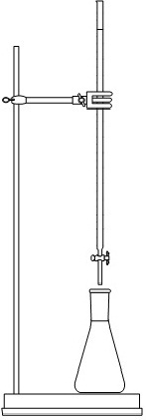
Introduction
This method determines the vitamin C (Molecular Formula: C₆H₈O₆, Relative Molecular Mass: 176.2) concentration in a solution, by a redox titration with potassium iodate, in the presence of potassium iodide. Vitamin C, more properly called ascorbic acid, is an essential antioxidant needed by the human body.
When iodate ions (IO₃⁻) are added to an acidic solution containing iodide ions (I⁻), an oxidation-reduction reaction occurs. The iodate ions are reduced to form iodine, whilst the iodide ions are oxidized to form iodine. Combining these half-equations demonstrates the reaction between iodate and iodide ions.
The iodine formed by this reaction oxidises the ascorbic acid to dehydroascorbic acid as the iodine is reduced to iodide ions:
Ascorbic acid + I₂ → 2I⁻ + dehydroascorbic acid+2H⁺
In this reaction, the iodine formed is immediately reduced to iodide, as long as there is any ascorbic acid present. Once all the ascorbic acid has been oxidized, the excess iodine is free to react with the starch indicator, forming the permanent dark-blue starch-iodine complex. This is the end point of the titration.
Experiment III: Determination of vitamin C
Equipment required | Quantity
Burette and stand | 1
Automatic pipette with tips | 1
Erlenmeyer (conical) flask 250 mL | 1
Measuring cylinder 100 mL | 1
Chemicals required | Quantity
0.002 mol/L Potassium iodate (KIO₃) | 100 mL
0.1 mol/L Potassium iodide (KI) | 100 mL
0.05 mol/L hydrochloric acid (HCl) | 350 mL
0.5% starch solution | 20 mL
Original undiluted Cabbage juice | 190 mL

Titration procedure:
- Pour the 0.002 mol/L potassium iodate (KIO₃) solution into a burette with the help of the funnel.
- Pipette 30 mL of the original (undiluted) cabbage juice into a 250 mL Erlenmeyer flask (the max capacity of automatic pipette is 5 mL, so you can regulate the automatic pipette display to 5 mL and use the pipette 6 times for taking a 30 mL sample. You might choose to measure and take the volume of the solutions using the measuring cylinder).
- Add 20 mL of distilled water, 30 mL of 0.1 mol/L potassium iodide, 100 mL of 0.05 mol/L hydrochloric acid (HCl) and 1 mL of starch indicator solution. Record the initial volume of the burette and titrate the sample with the 0.002 mol/ L potassium iodate solution. Shake the flask carefully, not to spill the solution. The end point of the titration is the first permanent trace of a dark blue color due to the starch-iodine complex. Record the final volume of the burette.
- Repeat the titration with further aliquots of the sample solution until you obtain consistent results.
Questions for Experiment III (11.5 points)

III – 1. Write down the reduction half equation in an acidic medium for iodate ions and the oxidation half-equation for iodide ions. (1.0 points)

III – 2. Combine the half-equations and write the overall equation between iodate and iodide ions.
RAISE YOUR HAND TO CALL A LAB ASSISTANT TO GET THE PAPER SIGNED. THE LAB ASSISTANT WILL PROVIDE THE OVERALL EQUATION AFTER THE LAB ASSISTANT CHECKS YOUR ANSWER (0.5 points)

III – 3. Fill in the table for titration steps on the answer sheet. (3.5 points)

III – 4. Calculate the moles of iodate that reacted, forming iodine. (1.5 points)

III – 5. Using the equation for the reaction between the iodate ions and iodide ions, calculate the moles of iodine formed. (2.0 points)

III – 6. From the titration equation determine the moles of ascorbic acid in the cabbage juice. (1.5 points)

III – 7. Calculate the concentration in mol/L, of ascorbic acid in the cabbage juice. (1.0 points)

III – 8. Determine the mass of ascorbic acid in the 30 mL of cabbage juice sample. (0.5 points)
Part III: Determination of Physical Properties of Chosen Fruit Juices
Introduction
As we know, in many plants water is the most abundant substance in their contents. Different properties (taste, color, etc.) that the fruit juices have, are mainly due to their composition, i.e. relative amount of different acids besides the highly abundant water.
As a result of such acids, the physical properties of a juice will differ from one fruit to another, and some information about the contents can be obtained by studying these properties. Density of the juice is one of these properties and strongly depends on the content of the juice. In this part of the experiment, you will be first asked to measure the density of the juices of two chosen fruit; pomegranate and feykhoa. The second task in this part of the experiment is to find the resistivity of the juices mentioned above.
Experiment IV: Density measurements
Equipment required | Quantity
Aquarium with water | 1
Scaled test tube (readings in ml) | 1
Microspatula | 1
Automatic pipette with tips | 1
Pipette | 1
Chemicals required | Quantity
Pomegranate juice | 50 ml
Feykhoa juice | 50 ml
Distilled water | 100 ml

Information
The density of a substance is defined in terms of its mass and volume with a relationship. No balance is given in this experiment to measure the mass of the liquid, so the density of each juice has to be measured indirectly.
In this experiment, you have to incorporate your knowledge of buoyancy force, with basic experimental skills to measure the density. The buoyancy force is an upward force that an object immersed in a liquid of density ρ experiences. The force equals the weight of the liquid displaced by the object.

Procedure
Every group is supplied with an aquarium (tank) filled with water and a test tube. The test tube to be used for these measurements is different than those used in previous experiments. The test tube used in chemistry and biology are not scaled completely. Use the test tube that is scaled up to the top.
Pour 4.0 ml distilled water into the test tube and let it float. (Do not use the water in the aquarium to fill the test tubes. Use the pipette to pour the liquids but ignore the readings on the pipette). The density of distilled water is and is independent of temperature. Record the corresponding depth that the tube sinks (also measured in units of volume as read from the test tube). Repeat this measurement for 4.6 ml and 5.2 ml of distilled water in the test tubes. These recorded values for the depths serve as reference measurements.
Now pour a volume of pomegranate juice into the test tube in a way that the tube sinks to the same depth as that of the measurement with 4.0 ml of distilled water. Record the value of volume of juice. Repeat this procedure for the depths corresponding to a volume of 4.6 ml and 5.2 ml of distilled water. Repeat these three measurements for the feykhoa juice.
While trying to use the juices, you may observe that its surface is covered with fleshy part of the fruit. To make the juice more homogeneous use the microspatula provided and stir the juice.
When too little fluid is inside the test tube, it sinks due to the imperfect balance and when too much fluid is inside the test tube, it sinks due to excessive weight. A test tube full of juice that sunk will cause juice to be mixed with the water and further experiments will lack accuracy.
When you switch from one juice to another, wash the test tube and clean it thoroughly, such that the further experiments are reliable.
Questions for Experiment IV (8 points)

IV – 1. Record the data for the sunken depth and fluid volumes for distilled water, pomegranate juice and the feykhoa juice. Copy the data into the tables provided in the answer sheet. (1.5 points for each fluid)

IV – 2. Use the balance of the forces to show how you would determine the densities of the juices. Write down an appropriate equation. Copy the important steps into the answer sheet. (1.5 points)

IV – 3. From the data, calculate the density of the pomegranate juice and the feykhoa juice and compute their averages. Copy your answers into the corresponding boxes in the answer sheet. (1.0 points for each juice)
Experiment V: Resistivity measurements
Equipment required | Quantity
Voltameter | 1
Power source | 1
Multimeter | 1
Microspatula | 1
Funnel | 1
Ruler | 1
Cables | 10
Automatic pipette with tips | 1
Pipette | 1
Chemicals required | Quantity
Pomegranate juice | 250 ml
Feykhoa juice | 250 ml

Information:
In this experiment, the task is to find the resistivity of the previous juices with the apparatus provided above. Resistance of a substance is defined as. Here is the resistivity, L is the length and A is the cross-sectional area of the resistor. When a resistor connected to a power source, the current that passes through it is related to the potential difference between its ends through the relation.
Here our resistor is a fluid and to measure its resistance it is poured into a container called a voltameter. With this voltameter, power source and a voltmeter your first task is to measure the resistance of a fluid and then the resistivity of this fluid.
Voltameter – The voltameter used in these experiments is a jar to hold the juices. The juice to be studied has to be poured to this jar up to a few centimeters high. The cover of the voltameter has plates attached to it, to which the potential difference will be applied. Assume the current flows directly between the two plates only. If you see that the plates are loose, make sure that the plates are parallel to each other and tighten the bolts firmly.
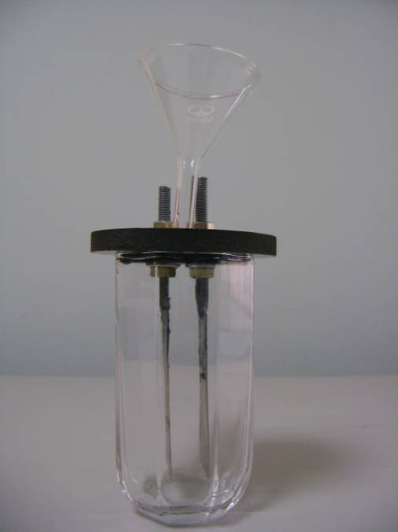
A mark exists on the plates. Adjust the level of juices to this mark. Initial pouring is a crude adjustment and once the plates and the cover are inserted the level can be adjusted with a funnel.
A hole exists on the cover to insert the funnel. Place the funnel here and add more juice until you reach the mark.

Power source – Power source HY1503D will be used in this experiment to supply the power to the plates of the voltameter. The power source has a built in Ammeter. Make sure that the current knob (top knob) is fully turned in the clockwise direction and leave it in this position during the whole experiment. Before you turn on the power source make sure that the voltage knob (bottom knob) is not turned at all, i.e. cannot turn in counter-clockwise direction any more.
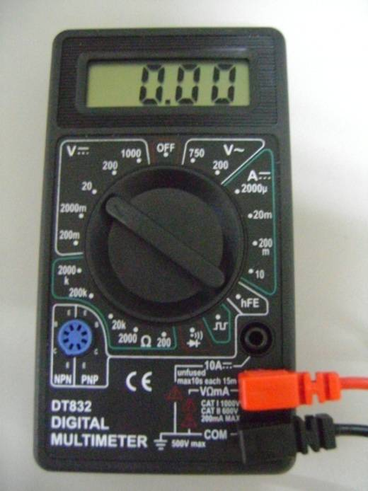
The display on the power source indicates the potential difference between its ends and the current that passes through it. A multimeter is supplied to measure the potential difference between the ends of the voltameter.

Multimeter – A multimeter is given to each group to measure the voltage. Connect the cables to COM and VΩmA ports and dial the knob to DC voltage 20V.

With the apparatus listed above and with the aid of the descriptions construct a circuit where you can measure the potential difference between the ends of the voltameter and current passing through the voltameter. Record the current vs. voltage up to 15V for at least 10 different voltages.
There is no need to hurry during the measurements because rushing may reduce the performance of the measurements. Nevertheless, if the measurement takes too long the current will cause electrolysis, heating, breakdown of components of juice and etc, which will affect the measurements. Therefore, plan to finish your measurement within two minutes once the power is turned on.
To measure the resistivity you need the distance between the electrodes and the effective area of the electrodes. Effective area is the area that is inside the juice. Measure these distances with the ruler provided.
Questions for Experiment V (7 points)

V – 1. In the answer sheet draw the circuit that will be used to get the current vs. voltage characteristics. (0.5 points)

V – 2. Measure the distance between the plates and their effective area. Copy your data into the appropriate boxes in the answer sheet. (0.5 points)

V – 3. Copy the data obtained for current vs. voltage measurements to the appropriate table and plot an appropriate graph on the graph sheets provided for both juices. (1.5 points for each juice)

V – 4. From the graph determine the effective resistance of the juices. (1.0 points for each juice)

V – 5. Calculate the resistivity of both juices. (0.5 points for each juice)
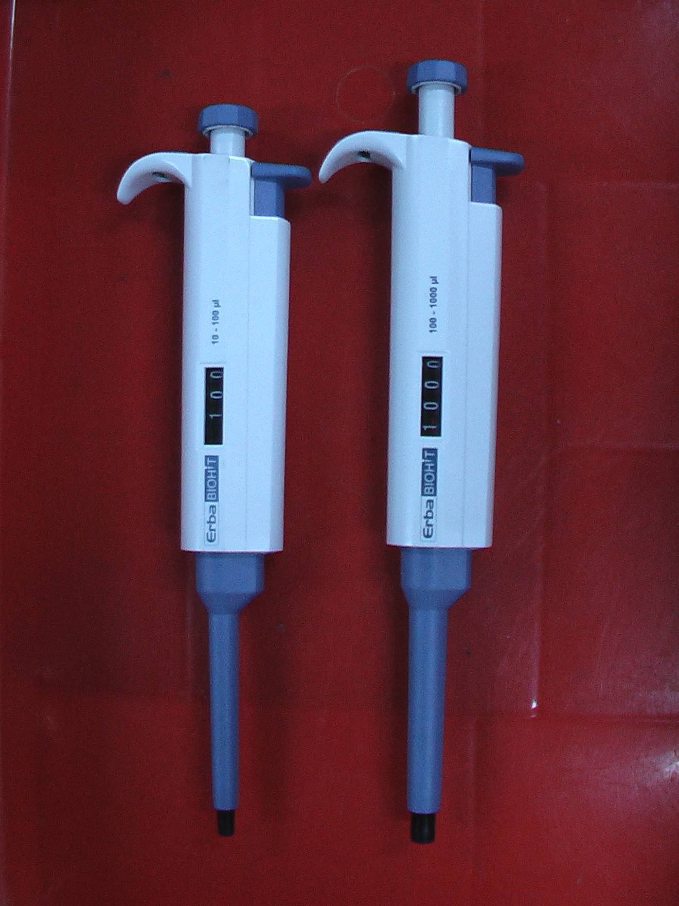
APPENDIX 1: Automatic pipette usage instructions
Tip-ejector
Plunger
Display
Tip-holder

Adjustment method:
Turn the plunger (Figure 1) to set the value to the desired volume, which can be seen in the display.

Remember that each micropipette has a fixed range of volumes as indicated on the pipette. DO NOT CROSS THE LIMITS OF THIS RANGE.

Usage method:
Secure the pipette tip to the tip holder (Figure 1). Gently push down the plunger to the first stop, hold, and dip the tip into the solution vertically to a depth of 2 - 4 mm. Release the plunger slowly and make it return to the original position. Remove the pipette from the liquid and transfer the contents to the desired tube. Keep the pipette vertically while the liquid is inside the tip. Make sure that the tip is close to the inner wall of the tube. Push the plunger to the first stop and then push further to discharge the solution completely from the tip. Remove the pipette from the tube. Eject the used tip into the discard container by pressing the tip-ejector.
APPENDIX 2: pH meter usage instructions
- Take out cup of pH meter as shown in Picture 1
- Pull down the tip of pH meter as shown in Picture 2
- Press on/off button to switch on or off the pH meter
- While measuring the pH reading of solution wait to the recording is stable
- Rinse with distilled water and dry with tissue the pH meter after every using
- Please switch off the pH meter and close the cup and put it back into the box

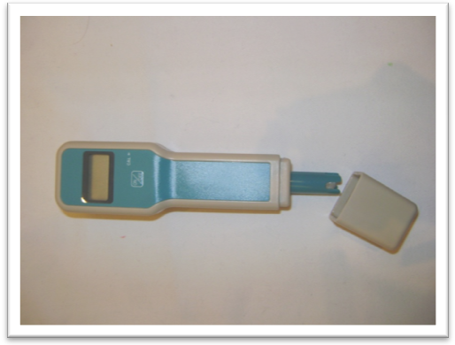
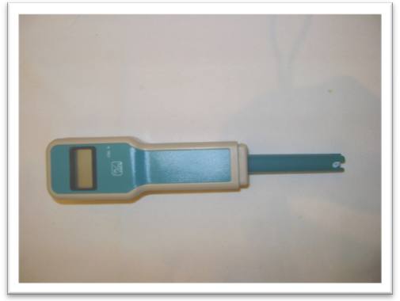
Picture-1 Picture-2

