EXAMINATION RULES
- All competitors must be present at the front of examination room ten minutes before the examination starts.
- No competitors are allowed to bring any tools except his/her personal medicine or any personal medical equipment.
- Each competitor has to sit according to his or her designated desk.
- Before the examination starts, each competitor has to check the stationary and any tools (pen, ruler, calculator) provided by the organizer.
- Each competitor has to check the question and answer sheets. Raise your hand, if you find any missing sheets. Start after the bell rings.
- During the examination, competitors are not allowed to leave the examination room except for emergency case and for that the examination supervisor will accompany them.
- The competitors are not allowed to bother other competitor and disturb the examination. In case any assistance is needed, a competitor may raise his/her hand and the nearest supervisor will come to help.
- There will be no question or discussion about the examination problems. The competitor must stay at their desk until the time allocated for the examination is over, although he/she has finished the examination earlier or does not want to continue working.
- At the end of the examination time there will be a signal (the ringing of a bell). You are not allowed to write anything on the answer sheet, after the allocated time is over. All competitors must leave the room quietly. The question and answer sheets must be put neatly on your desk.

Read the following instructions carefully:
- The time available is 3 hours.
- The total number of the questions is 3. Check that you have a complete set of theoretical questions and the answer sheet.
- Use only the pen provided.
- Write down your name, code, country and signature in the first page of your answer sheet. You will only need to write down your name and code in the next pages of your answer sheet.
- Read carefully each problem and write the correct answer in the answer sheet.
- All competitors are not allowed to bring any stationary and tools provided from outside. After completing your answers, all of the question and answer sheets should be put neatly on your desk.
- Grading rules: According with each question marking.
Problem I: Oil Extraction
Azerbaijan – “The Land of Fire” is famous for its oil reserves. Obtaining oil is a multi-phase process. In the initial phase, the deposit structure is determined with the help of geological exploration methods. Then the number, position and depth of oil-wells matching the oil deposit’s structure are determined. Oil-wells are supposed to be drilled in such a way that as much oil as possible gushes by itself due to the oil deposit’s natural pressure. When the pressure of the oil deposit decreases, getting oil from the other wells is assisted by forcing water into the deposit.

The deposit structure in Absheron peninsula is such that to force of oil out of the oil-well J is spent per cubic meter of water forced into the deposit. Because this process requires extra expenses, the oil cost increases and the deposit’s operation profitability coefficient () decreases.is defined as the ratio of the energy () obtained to the energy spent on the oil and gas extracted from the deposit. The specific energyfor “Azeri Light” oil is and gas is .

The defined structure according to the geological exploration results of the oil deposit is shown in Figure I – 2. Oil and gas inside the deposit is in the form of a sphere with a fixed radius. The initial pressure of gas inside the deposit is equal to the pressure of soil between the ground level and the top of the deposit surface. The dependency graph of energy spent on drilling of each meter vs. depth of the well is given in Figure I – 3. Answer the following questions regarding the position and depth of the wells..
Useful information:
You need to know the followings regarding the drilling of the well:
- The wells are drilled vertically only.
- If you drill through the gas, the gas will escape.
- The pipes cannot be extended into the oil and gas.
The density of water: 1000
The density of “Azeri Light” oil:. The oil is incompressible
The volume of a sphere : ; take
The volume of a sphere segment (Figure I – 1) : , where is the height of the segment
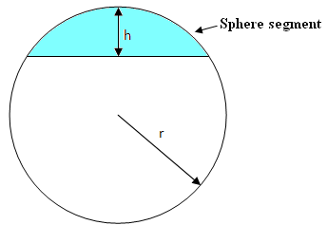
Figure I – 1
Ideal gas equation is , where is the gas constant, take ; is the pressure of the gas; is the volume of the gas; is the mass of the gas; is the molar mass of the gas (The molar mass of the natural gas is ); and is the temperature of the gas. In every condition, the temperature is
The density of soil:
The atmospheric pressure is not taken into account. Take
The diameter of the drilled well is negligible
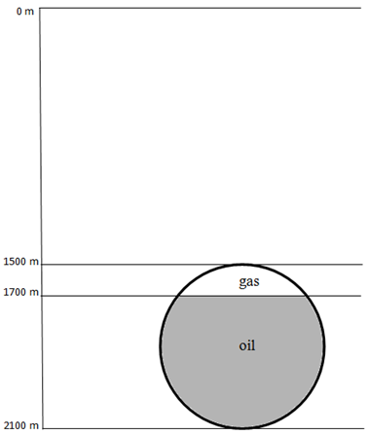
soil
Figure I – 2.
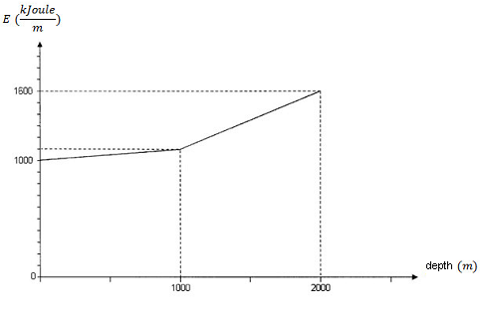
Figure I – 3.
I – 1 (1.0 points)
What is the initial pressure of gas inside the deposit?
I – 2 (1.0 points)
Calculate the masses of gas and oil inside the deposit.
I – 3 (1.0 points)
Where should the well be drilled such that the maximum amount of oil gushes by itself due to the gas pressure? Indicate the position on the figure shown in the answer sheet. Moreover, justify your finding by calculations.
I – 4 (0.5 points)
What is the maximum amount (mass) of oil that gushes?
I – 5 (2.0 points)
Find the deposit’s according to the gush oil method.
I – 6 (1.0 points)
After the oil gush process stops, what is the depth of the additional well that needs to be drilled in order to obtain the remaining oil and gas left inside the deposit.
Indicate the position of this additional well on the figure shown in the answer sheet. The existing well can be used to pump in the water.
I – 7 (1.5 points)
Estimate the energy spent in forcing water into the well in order to obtain all of the remaining oil and gas left inside the deposit.
I – 8 (2.0 points)
Calculate the total for such a deposit according to the defined extraction strategy above.
Problem II: Metal Corrosion
In the previous problem, the drilling and production issues of the oil industry were discussed. To implement these operations safely, the integrity management of used equipment is required. Lack of integrity management can cause major accidents, harm to people and the environment. Corrosion (oxidation of metal) of metallic equipment – pipelines, tanks, vessels and pumps; is the main problem of integrity management. Corrosion induced by bacteria (sulphate reducing bacteria – SRB) is widely observed in systems containing water and called microbiological corrosion. SRB induce corrosion in anaerobic conditions. The microbiological corrosion of steel based on iron occurs as described in the reactions below:
In facilities of the oil industry, samples are taken (in anaerobic condition) for bacterial and chemical analysis to control microbiological corrosion. For monitoring microbiological corrosion in Azeri-Chirag-Guneshli oilfield located in Caspian Sea, two water samples were taken from two different offshore oil platforms: the first sample from Azeri and the second one from Chirag oilfield. It was identified that the initial amount ofin Azeri and Chirag samples wasand, respectively.
Then two experiments were done by using these samples. In the first experiment, from the first sample (Azeri) andfrom the second sample (Chirag) were taken and mixed in a flask containing iron nail with the mass of. The mixture in a flask was kept under anaerobic conditions friendly for bacterial growth. Black precipitation started to increase gradually in a flask, and after 30 days, the amount of precipitate was. Moreover, in the second experiment, from the first sample andfrom the second sample were taken, mixed in a flask, and kept (under same condition) under anaerobic condition with an iron nail inside. However, in this case, after 30 days, the amount of precipitate was.

The amount of accumulated precipitate was controlled during the experiments and kinetic graphs were obtained (see Figure II – 1). The concentration of SRB cells also were increased during the experiments together with black precipitate accumulation. Kinetics graphs shown in Figure II – 2 describe the SRB cell growth in two flasks with mixtures of samples.
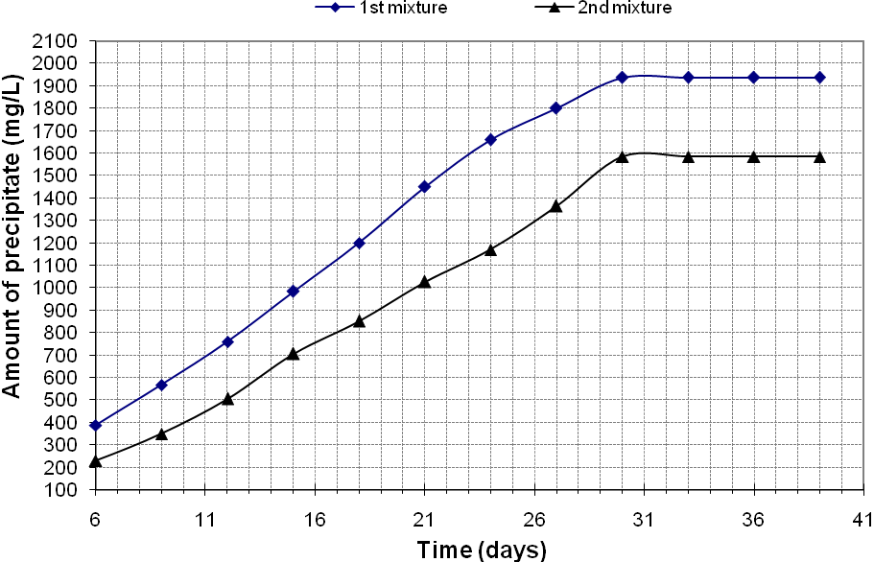
Figure II – 1.
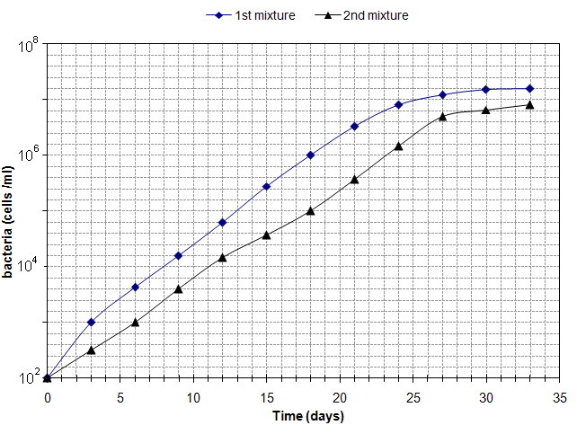
Figure II – 2.

II – 1 (0.4 points)
Write down the overall oxidation – reduction reaction of iron induced by SRB cells.
II – 2 (1.1 points)
Find the amount () ofin the first and second mixtures at initial time (, as soon as the samples were mixed), before the oxidation – reduction reactions started.
II – 3 (0.3 points)
Write down the formula of precipitate formed in the flasks during the experiments.
II – 4 (1.2 points)
Find the concentration () ofin the first and second mixtures at initial time (, as soon as the samples were mixed), before the oxidation – reduction reactions started.
II – 5 (2.0 points)
Find the concentration () ofin samples taken from Azeri and Chirag platforms. Assume that all ofin mixtures was reduced during 30 days.
II – 6 (1.0 points)
Calculate the mass percentage of iron nail lost as a result of corrosion in each mixture.
II – 7 (0.8 points)
Calculate the average corrosion rate of nail () (year is equal to 365 days) in each mixture based on data for 30 days..
II – 8 (0.5 points)
Why is the concentration of black precipitate stable after 30 days in Figure II – 1? Choose the correct reason and write down in the answer sheet.

a) Iron nail andwas in excess level | c)was consumed
b)inhibited the corrosion reaction | d) Iron nail fully reacted

II – 9 (2.2 points)
Use the graphs shown in both figures (Figure II – 1 and II – 2) to identify the concentration () of bacterial cells in both mixtures; and the precipitate amount () in the second mixture, when the amount of black precipitate in the first mixture is.
II – 10 (0.5 points)
How would the accumulated amount of black precipitate change at the end of 30 days, if a big nail withweightmass is used instead ofnail? Choose one of the answers below:
- will increase 5 times; b) will decrease 5 times; c) no change;
- will increase 2 times; e) will decrease 2 times;
Problem III: Embryonic Development of Human
Fertilization takes place in the oviduct. The resulting zygote then starts to divide. The third division is completed at about 72 hours after fertilization. At this stage a process called compaction occurs. About 7 days after fertilization, the embryo has over 100 cells arranged around a central cavity (1). This is an embryonic stage known as the blastocyst.
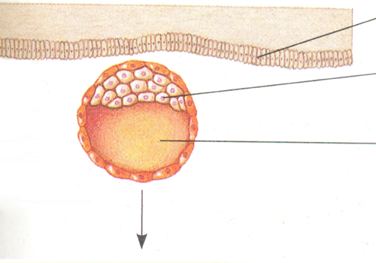 | I
 | II
 | III
Figure III – 1.

The inner cell mass (2) of the blastocyst forms a flat disc with an upper layer of cells, the epiblast (3), and a lower layer, the hypoblast (4).The outer epithelium surrounding the cavity of the blastocyst is the trophoblast (5).
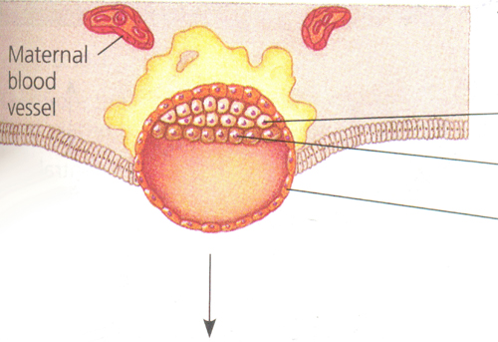 | IV
 | V
 | VI
Figure III – 2.

The trophoblast along with the mesoderm (6), will form some internal organs. The embryo will develop from epiblast cells, while the hypoblast will form the yolk sac (7).
At the blastocyst stage, it begins to implant into the endometrium (8) of the uterus. After the implantation, the trophoblast thickens and extends fingerlike projections into the surrounding maternal tissue. Then it gives rise to the chorion (9) and continues to expand in the endometrium. The epiblast forms the amnion (10), surrounding a fluid-filled amniotic cavity (11). Mesodermal cells are also derived from the epiblast.

VII
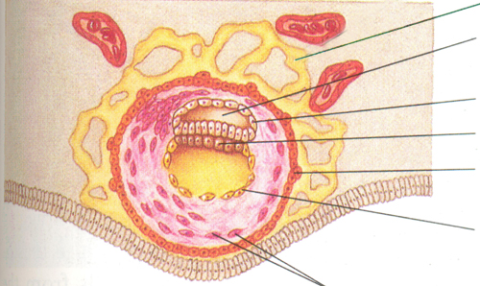 |  | VIII
 |  | IX
 |  | V
 |  | VI
 |  | X
 | XI
Figure III – 3.

III – 1 (2.2 points)
Using the information above, match the structures given in the text with the correct labels shown in the illustrations (Figure III – 1, III – 2, and III – 3).
III – 2 (0.8 points)
a) Which one of the labeled parts of the embryo develops into the placenta?
b) To detect hereditary disorders a special technique is used in which a fluid is obtained from the sac surrounding the fetus. Choose the correct label in the Figure III – 3 indicating the part from which the sample is taken for this analysis.
III – 3 (1.0 points)
Research has shown that a certain chemical, secreted by the trophoblast, lowers the human immune function. Which of the events listed below is prevented by this function of the trophoblast?

a. Invasion of fetal blood by mother’s antigens
b. Infection of an embryo with a virus
c. Rejection of an embryo
d. Blockage of the trophoblast development by endometrium

III – 4 (0.5 points)
Calculate the number of cells in the embryo at the time when compaction occurs.
III – 5 (0.9 points)
The nervous system is one of the first organ systems formed during embryonic development. The anterior part of the neural tube develops into the brain. Different parts of the brain control different body functions.
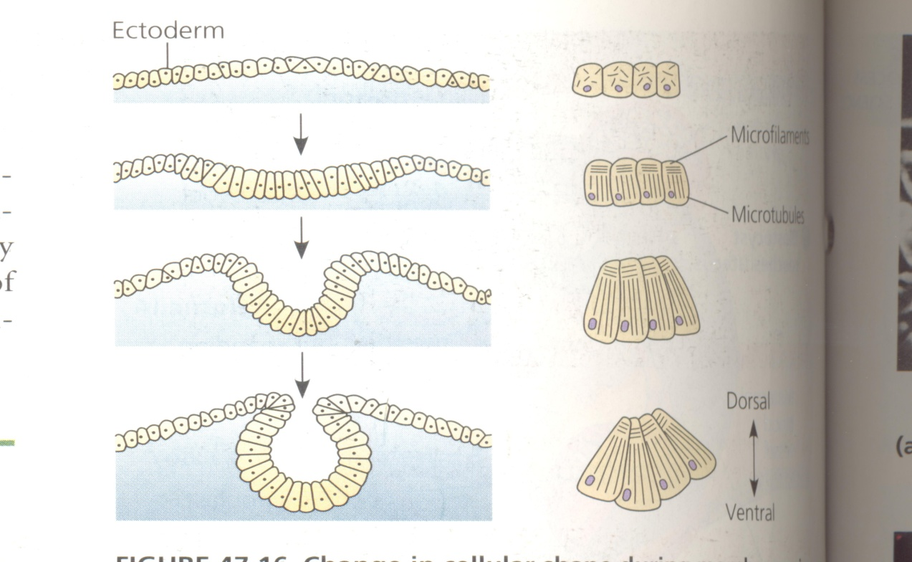
Match the event (A), the cellular process (B) and the subcellular structure (C) responsible for the changes given on the Figure III – 4. (i.e. I-a-1) .

Figure III – 4.
A. I. Implantation of an embryo to endometrium
II. Organogenesis
III. Formation of neural tube
IV. Formation of amniotic sac

B. a. Cellular respiration
b. Change in cell shape
c. Cell destruction
C. 1. Contractile vacuole
2. Mitochondrion
3. Cell skeleton
4. Cell wall

In humans, two clusters of neurons in the hypothalamus – the suprachiazmatic nuclei (SCN) receive nerve signals directly from the retina and have a connection with the pineal gland. The SCN and pineal gland probably interact to form the biological clock.
The SCN tells the pineal gland when to produce melatonin, a sleep – promoting hormone. Melatonin is a hormone made from the amino acid tryptophan. When received in food, tryptophan is converted into serotonin, and serotonin into melatonin, with specific enzymes controlling these conversions. Two of these enzymes are shown in the Figure III – 5.

Tryptophan

Tryptophan hydroxylase

Serotonin

N-acetyltransferase

Melatonin
Figure III – 5.
The activity of enzymes controlling conversion of serotonin into melatonin is inhibited by light. It was shown that light, especially with wavelength 450-500 nm (Figure III – 6), suppresses melatonin production. During the daytime serotonin accumulates in the pineal gland.
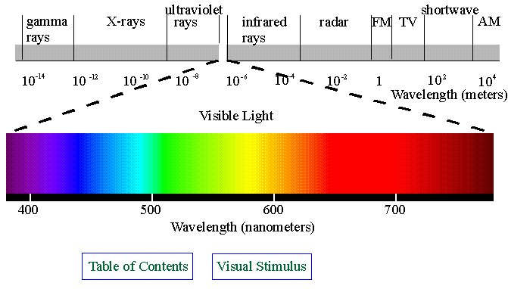

Figure III – 6. The visible part of spectrum
III – 6 (0.4 points)
Mr. Huseynli, aged 75, suffers from insomnia (sleep disorder). Levels of melatonin in his blood and in the blood of a 30 year – old healthy man were measured. Which of the curves in the Figure III – 7 shows the level of melatonin in the blood of Mr. Huseynli? Choose the corresponding curve.
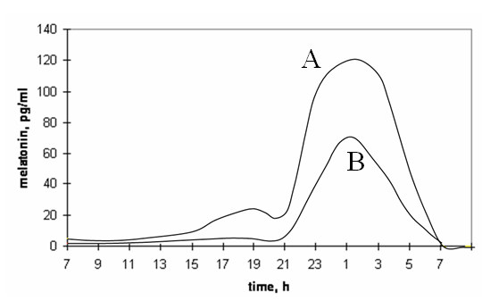
Figure III – 7.
III – 7 (1.0 points)
Eye glasses blocking which color of light would you advise Mr. Huseynli, who has to adjust himself to an earlier bedtime and overcome his sleep problems, to wear?
- Green
- Blue
- Yellow
- Red
- Orange
III – 8 (0.6 points)
Which of the enzymes is involved in the production of serotonin? Choose the corresponding curve.
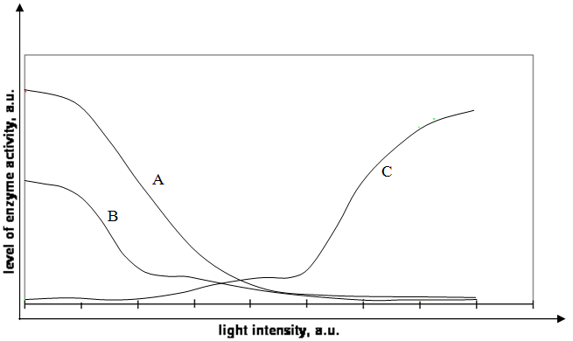
Figure III – 8.
III – 9 (1.5 points)
What do you suggest happens to the activity of N-acetyltransferase during the following time periods?
1. from 19:00 to 23:00,
2. from 23:00 to 02:00,
3. from 02:00 to 07:00.
Put X in appropriate boxes in the answer sheet:

a. increases b. decreases c. stays relatively the same
III – 10 (1.2 points)
What is the most probable explanation for the pineal gland to be called a ’third eye’ in fish, amphibians, reptiles and birds? Choose the right answer.
a. Light can pass through the thin part of the skull of these animals and is detected by the pineal gland.
b. Pineal gland is very big.
c. Pineal gland is situated between the eyes.
d. Nerve impulses from the eyes go directly to the pineal gland.

