Country:
Signature:

Problem I: Oil Extraction

I – 1 (1.0 points). The initial pressure of the gas in the deposit:

The pressure at the top of the deposit is found from the relationship

P_{s}=ρ_{s}×g×h (0.7 points )
P_{i} =3000×10×1500=45×10⁶ Pa (0.3 points)

I – 2a (0.5 points). Mass of the gas in the deposit: | I – 2b (0.5 points). Mass of the oil in the deposit:
The equation of state for the gas  PV=m/μ RT => $m=\frac{\text{PVμ}}{\text{RT}}$ (0.1 points)  Here we need the volume of the gas to calculate its mass. From the equation for a sphere segment  $V=\frac{1}{3}×π×h^{2}×(3R−h)$=  $$\frac{1}{3}×3×{\text{200}}^{2}×(3×\text{300}−\text{200})=\text{28}×{\text{10}}^{6}m^{3}$$  (0.2 points)  Substituting the data  M_{g}=45×10⁶×28×10⁶×0.016/(8×300)=84×10⁸ kg (0.2 points)  is the amount of the gas in the deposit. | To obtain the volume of oil, we need to subtract the volume of gas from the total volume of the sphere. Here we obtain the volume of the oil to be  $$V_{o}=\frac{4}{3}×π×R^{3}−V_{q}=\text{80}×{\text{10}}^{6}m^{3}$$  (0.3 points)  The mass of the oil will be  M_{o}=ρ_{o}×V_{o}=800×80×10⁶=64×10⁹ kg  (0.2 points)
I – 3a (0.5 points). Indicate the position of the well:
The well has to be drilled as shown in the figure such that the amount of gushed oil is maximum.
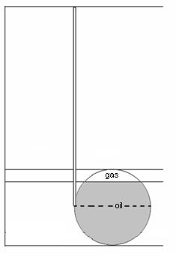
I – 3b (0.5 points). The justification of the finding.
To confirm if the point does give the maximum gushed oil rate, we have to check that when the gas has expanded, its pressure is still sufficient to pump the oil out.
First lets find the final pressure of the gas upon expansion. Taking the temperature to be constant
P₁V₁=P₂V₂
P₁=45×10⁶ Pa
V₁=2$8×{\text{10}}^{6}m^{3}$
V₂=$\frac{2}{3}{πR}^{3}=\frac{2}{3}$×3×300³=54×10⁶ m³ => P₂=P₁V₁/V₂=$\frac{\text{45}×{\text{10}}^{6}×\text{28}×{\text{10}}^{6}}{\text{54}×{\text{10}}^{6}}$=233.310⁵ Pa

The hydrostatic pressure of the oil in the well can be found from the equation
P_{o}=ρ_{o}×g×h =800×10×1800=144×10⁵ Pa

It is seen that P_{o} < P₂ , which means that chosen point will result in a successful oil gush.

I – 4 (0.5 points). The maximum amount (mass) of oil that gushes:
The gas can expand until occupying the half of the volume of the deposit. The maximum amount of oil that will be pumped up during this process is
V_{max}= $\frac{2}{3}{πR}^{3}−\frac{1}{3}{πh}^{2}(3R−h)=\text{26}×{\text{10}}^{6}m^{3}$ (0.3 points)
M_{max}= V_{max}×ρ_{o}=26×10⁶×800=208×10⁸ kg (0.2 points)

I – 5 (2.0 points).The of the oil gush method:

To calculate the OPC we need to evaluate the amount of work necessary to drill the well first. Since the depth of the well is h=1800m, we can find the amount of work done from the following diagram.
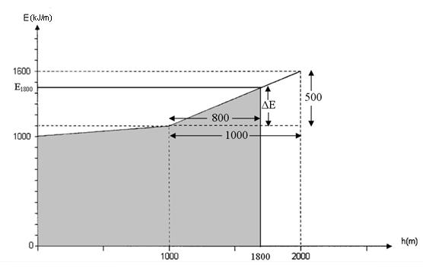
From the similarity of the triangles $\frac{ΔE}{\text{500}}=\frac{\text{800}}{\text{1000}}$ => ΔE=400 kJ/m (0.4 points)
E₁₈₀₀=1100 + ΔE=1500 kJ/m (0.2 points)
The amount of energy necessary to drill this well will then be

W_{1t}=$\frac{\text{1000}+\text{1100}}{2}×\text{1000}+\frac{\text{1100}+\text{1500}}{2}×\text{800}=$209×10⁴ kJ=209×10⁷ J (0.5 points)
And the amount of energy that will be obtained from the gush oil is equal to
E_{o}=EE_{o}×m_{o}=45×10⁶×208×10⁸=936×10¹⁵ J (0.4 points)
OPC=$\frac{E_{p}}{E_{1_{t}}}=$$\frac{\text{936}×{\text{10}}^{\text{15}}}{\text{209}×{\text{10}}^{7}}=$4.48×10⁸ (0.5 points)
I – 6 (1.0 points). Indicate the position of the second well:

To extract all the oil and gas a second well has to be drilled down to the topmost point of the deposit. Water will be pumped in from he first well and oil will be obtained from the second one. The depth of this second well has to be1500m.
I – 7 (1.5 points). The work done to pump the water:
No energy will be spent on water pumping until the oil reaches the bottom of the well. Once the oil starts to be pumped through the well, energy has to be spent to expel all the oil from the deposit. The volume of the water that will expel the oil from the deposit is then equal to the volume of the oil left.
V= $\frac{2}{3}{πR}^{3}=\text{54}×{\text{10}}^{6}m^{3}$ (1.0 points)
To pump this amount of water, work of

V×E_{water} =54×10⁶×100=54×10⁸ J has to be done. (0.5 points)
I – 8 (2.0 points). The total: 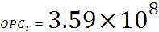
To compute the total OPC we need to calculate the energy obtained from all the oil and petrol and the work done to drill the two wells. Lets calculate the amout of work done to drill the second well with the help of the following diagram.
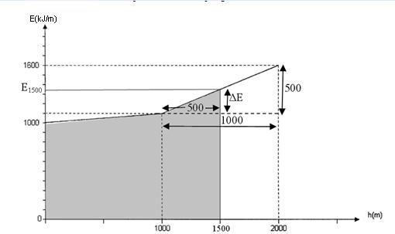
Again from the similarity of the triangles
$\frac{ΔE}{\text{500}}=\frac{\text{500}}{\text{1000}}$ => ΔE=250 kJ/m
E₁₅₀₀=1100 + ΔE=1350 kJ/m (0.4 points)
The amount of work needed to drill the second well is
W_{2t}=$\frac{\text{1000}+\text{1100}}{2}×\text{1000}+\frac{\text{1100}+\text{1350}}{2}×\text{500}=$166.25×10⁴ kJ=166.25×10⁷ J

(0.4 points)

The total energy obtain from the oil is
E_{ot}=EE_{o}×m_{ot}=45×10⁶×64×10⁹=288×10¹⁶ J (0.2 points)

And the total energy obtained from the gas is
E_{g}=EE_{g}×m_{g}=48×10⁶×84×10⁸=40.32×10¹⁶ J (0.2 points)

The total energy obtained from the resources
E_{t}= E_{ot}+E_{g}=288×10¹⁶+40.32×10¹⁶=328.32×10¹⁶ J (0.2 points)

The total work done
E_{r}= W_{1t}+ W_{2t}+ W=166.25×10⁷+209×10⁷+54×10⁸=915.25×10⁷ J (0.2 points)
And the total OPC is
OPC=$\frac{E_{t}}{E}$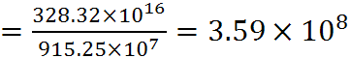 (0.4 points)

Problem II: Metal Corrosion

II – 1 (0.4 points). The oxidation – reduction of iron induced by SRB cells
Fe + H₂SO₄ + 3H₂ → FeS + 4H₂O

II – 2a (0.55 points). The amount () ofin the first mixture = 51mg/L
1st mixture: 45 x 0.04 + 55 x 0.06 = 1.8 + 3.3 = 5.1 mg (0.50 points);
5.1mg /100ml = 51mg/L (0.05 points)

II – 2b (0.55 points). The amount () ofin the second mixture = 49 mg/L
2nd mixture: 45 x 0.06 + 55 x 0.04 = 2.7 + 2.2 = 4.9 mg (0.50 points);
4.9mg/100ml = 49 mg/L (0.05 points)

II – 3 (0.3 points). The formula of precipitate
FeS

II – 4a (0.6 points). The concentration () ofin the first mixture
0.021 mol/L
II – 4b (0.6 points). The concentration () ofin the second mixture
0.017 mol/L
I mixture: 5.1 mg (FeS) = 0.0051 g; 0.1936 – 0.0051 = 0.1885 g = 0.0021 mol FeS (0.4 points)
II mixture: 4.9 mg (FeS) = 0.0049 g; 0.1584 – 0.0049 = 0.1535g = 0.0017 mol FeS (0.4 points)

I mixture: 0.021 mol/L (0.2 points)
II mixture: 0.017 mol/L (0.2 points)

II – 5a (1.0 points). The concentration () ofin an original sample taken from Azeri oilfield
0.009 mol/L
II – 5b (1.0 points). The concentration () ofin an original sample taken from Chirag oilfield
0.029 mol/L
A x 0.04 + B x 0.06 = 0.0021 (0.8 points)
A x 0.06 + B x 0.04 = 0.0017 (0.8 points)

A = 0.009 mol/L H₂SO₄ in 1st sample (Azeri) (0.2 points)
B = 0.029 mol/L H₂SO₄ in 2nd sample (Chirag) (0.2 points)

II – 6a (0.5 points). The mass percentage of iron nail lost in the first mixture
5.99%
II – 6b (0.5 points). The mass percentage of iron nail lost in the second mixture
4.76%
I mixture: 0.1885 g FeS contains 0.1176 g (Fe²⁺); 0.1176/2 x 100 = 5.99% (0.5 points)

II mixture: 0.1535 g FeS contains 0.0952 g (Fe²⁺); 0.0952/2 x 100 = 4.76% (0.5 points)

II – 7a (0.4 points). The average corrosion rate () in the first mixture
1434 mg/year
II – 7b (0.4 points). The average corrosion rate () in the second mixture
1160 mg/year
0.1176 g / 30 days = 1434 mg/y (0.4 points)
0.0952 g / 30 days = 1160 mg/y (0.4 points).

II – 8 (0.5 points). Write down the correct reason C
The answer is c) was consumed

II – 9a (0.6 points). The concentration () of bacterial cells in the first mixture
From second figure on 18th day concentration of bacteria:
1st mixture 10⁶ bacteria cells/ml

II – 9b (0.6 points). The concentration () of bacterial cells in the second mixture
2nd mixture 10⁵ bacteria cells/ml
II – 9c (1.0 points). The precipitate amount () in the second mixture 850 mg/L
0.12g/100ml= 1200 mg/L, from first figure it was reached in 1 st flask on 18th day. (0.5 points)
From first figure on 18th day precipitation concentration in 2nd glass was 850 mg/L. (0.5 points)

II – 10 (0.5 points). Write down the correct answer C
The answer is c) no change

Problem III: Embryonic Development of Human

III – 1 (11x0.2 points). Match the structures given in the text with the correct labels shown in the figures. Write only the corresponding roman numerals
Number in text | 1 | 2 | 3 | 4 | 5 | 6 | 7 | 8 | 9 | 10 | 11
Roman numeral in the figure | III | II | IV | V | VI | XI | X | I | VII | IX | VIII

III – 2a (0.4 points). Write down the correct label
VII
III – 2b (0.4 points). Write down the correct label
VIII

III – 3 (1.0 points). Put X in appropriate box
a | b | x | d

III – 4 (0.5 points). The number of the cells in the embryo
8 CELLS
3 DƏFƏ BÖLÜNMƏ BAŞ VERMİŞ VƏ ZİQOTDAN 8 HÜCEYRƏ ƏMƏLƏ GƏLMİŞ

III – 5 (3x0.3 points). Match the following. Write only the corresponding numbers or letters
Event | Cellular process | Subcellular structure
III | B | 3

III – 6 (0.3 points). Put X in appropriate box
A | x

III – 7 (1.0 points). Put X in appropriate box
a | x |  | c | d |  | e
III – 8 (0.6 points). Put X in appropriate box
A |  | B |  |  | x
III – 9 (1.5 points). Put X in appropriate boxes
 | increases | decreases | stays the same
1 | x
2 |  |  | x
3 |  | x

III – 10 (1.2 points). Choose the right answer. Put X in appropriate box
x | b | c | d

