EXAMINATION RULES
- All competitors must be present at the front of examination room ten minutes before the examination starts.
- No competitors are allowed to bring any tools except his/her personal medicine or any personal medical equipment.
- Each competitor has to sit according to his or her designated desk.
- Before the examination starts, each competitor has to check the stationary and any tools (pen, ruler, calculator) provided by the organizer.
- Each competitor has to check the question and answer sheets. Raise your hand, if you find any missing sheets. Start after the bell rings.
- During the examination, competitors are not allowed to leave the examination room except for emergency case and for that the examination supervisor will accompany them.
- The competitors are not allowed to bother other competitor and disturb the examination. In case any assistance is needed, a competitor may raise his/her hand and the nearest supervisor will come to help.
- There will be no question or discussion about the examination problems. The competitor must stay at their desk until the time allocated for the examination is over, although he/she has finished the examination earlier or does not want to continue working.
- At the end of the examination time there will be a signal (the ringing of a bell). You are not allowed to write anything on the answer sheet, after the allocated time is over. All competitors must leave the room quietly. The question and answer sheets must be put neatly on your desk.

Read the following instructions carefully:
- The time available is 3 hours.
- The total number of the questions is 30. Check that you have a complete set of the test questions and the answer sheet.
- Use only the pen provided.
- Write down your name, code, country and signature in your answer sheet.
- Read carefully each problem and choose your correct answer by crossing one of the capital letters in your answer sheet. There is only one right answer for each problem.
Example:
1 | A | B | C | D
- If you want to change your answer, you have to circle the first answer and then cross a new letter as your correct answer. You are only allowed to make one correction.
Example:
1 | A | B | C | D
A is the first answer and D is the corrected answer
- All competitors are not allowed to bring any stationary and tools provided from outside. After completing your answers, all of the question and answer sheets should be put neatly on your desk.
- Grading rules:
- Correct answer : + 1.00 point
- Wrong answer : : - 0.25 point
- No answer : 0 point

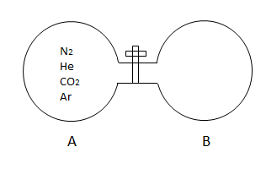
1. There is a mixture of equal moles of andgases in the container A. Initially, the container B is in the state of vacuum. If the stopcock/valve/tap is opened what will be the relationship between the amounts of gases in the container B before equilibrium is reached? {Relative molar mass of the gases are}

(A)
(B)
(C)
(D)

2. Ammonia, and react to form solid ammonium chloride,
Two cylinders that have diameters of with length of at are connected by a stopcock/valve/tap. One of the cylinders contains of and the other contains of. If the stopcock/valve/tap is opened what will the final pressure of the system be after the reaction is complete? {Neglect the volume of stopcock/valve/tap and formed. The volume of a cylinder is; the area of a circle is; the height of a cylinder is;; Relative atomic masses are ; )}

(A) 1.22 atm (B) 2.38 atm (C) 3.382 atm (D) 6.8 atm

3. Increasing application of implantable devices such as cardiac pacemaker for clinical and investigative purposes has prompted the development of vivo biological power sources. In this process a zinc and platinum electrode is implanted into the body tissues. It causes the formation of a “biogalvanic cell”. If a current ofis drawn from the cell, how often will azinc electrode need replacing? {Relative atomic mass ofis; Faraday constant}

(A) 26.3 hours (B) 52.8 hours (C) 128.6 hours (D) 1060.3 hours

4. aqueous solution of an unknown salt shows a precipitate when treated with barium nitrate solution and turns a phenolphthalein solution pink. The unknown substance could be:

(A) (B) (C) (D)

5. We can classify substances according to the conductivity of their solutions. Strong electrolytes (1) conduct electric current very well. The substances that conduct electric current poorly are called weak electrolytes (2); the non – electrolytes (3) do not conduct current at all.
Which of the following matching is correct? (Hint: the strength of an electrolyte is directly proportional to its ability to separate into ions, but not to its ability to dissolve)

(A) I – 2, II – 2, III – 1, IV – 3 (B) I – 3, II – 2, III – 1, IV – 2
(C) I – 2, II – 3, III – 3, IV – 2 (D) I – 2, II – 3, III – 1, IV – 2

6. Sodium fluoride is widely used in toothpaste industry. A chemist working for a toothpaste firm wishes to prepare of a aqueous solution of sodium fluoride. How many grams of should be needed? {Relative atomic masses are}

(A) 0.14 grams (B) 0.26 grams (C) 0.42 grams (D) 1.57 grams

7. When the atoms are arranged in order of increasing size, what is the correct order?

(A) (B)
(C) (D)

8. Which of the following two properties best describe non – metals?

(A) Low ionization energy and good electrical conductivity.
(B) High ionization energy and poor electrical conductivity.
(C) Low ionization energy and poor electrical conductivity.
(D) High ionization energy and good electrical conductivity.

9. ofis dissolved in water and the sulfate ion precipitated as. The mass of pure, dryobtained is. What is? Relative atomic masses;
A) 0.5 B) 1 C) 2 D) 5

10. The heat of combustion of fructose is. If a fresh apple weighing is of fructose by mass, what calorific content does the fructose contribute to the apple? {Relative atomic masses are}
(A) 38.5 kcal (B) 53.3 kcal (C) 161.2 kcal (D) 226.8 kcal

11. A ring of radius R, made of material with resistivity ρ, is connected to the circuit shown in the picture on the right. Point A is fixed. However, point B could be moved so that the angle α changes. The power source and the ammeter are working ideally. Which graph shows how the ammeter reading varies with the changing angle α? |  | 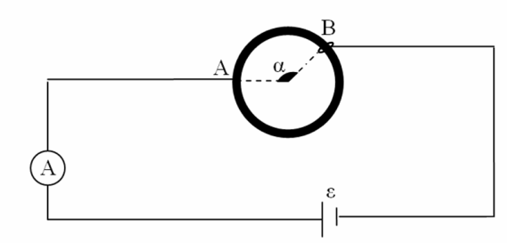
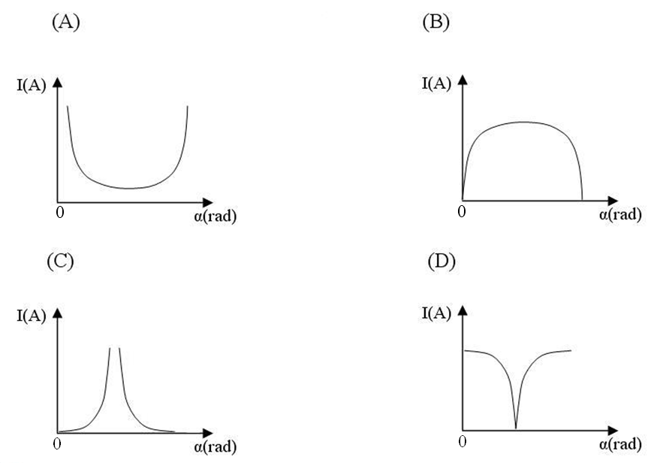
12. Two objects have equal masses and the ratio of their specific heat capacities is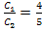. A heater can raise the temperature of the first object by in. How long will it take the same heater to raise the temperature of the second object by . (Heat loss is negligible)

- 45 min | - 60 min |  | - 75 min | - 90 min

 | 13. An object with an initial velocity speeds up with an acceleration a, traveling a distance, then it slows down with a deceleration a, and stops after traveling an additional distance. If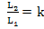, then what is the maximum velocity of the object during its travel?
 |  |  |  | - 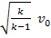 |  |  |  |  |  |  |  | - 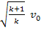
 | 14. What path does a ray take before leaving the triangular prism that has a refraction index of, if it travels from air to the surface of the prism with the angle of incidence? |  |  |  |  |  |  |  | 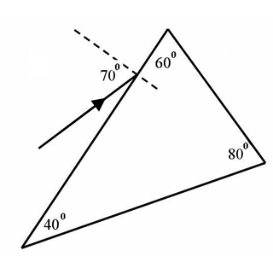
 | 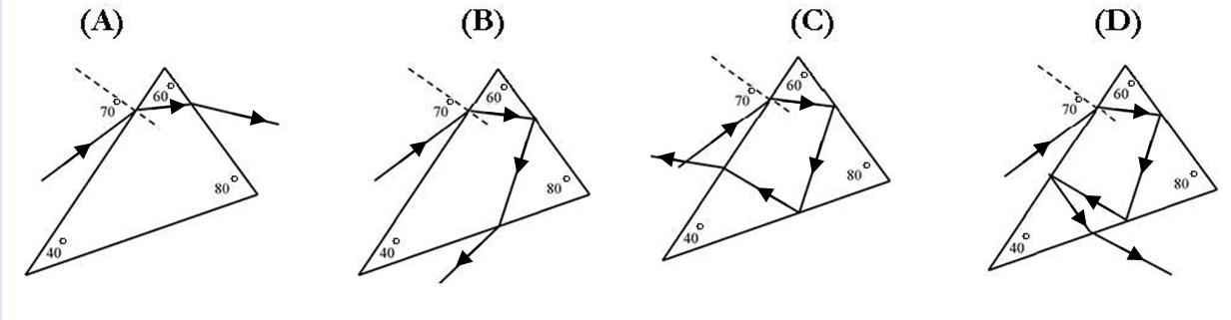
 | 15. The object shown in Figure 1 slips down the inclined planes AB and BC which have the friction coefficient of. The velocity vs. time graph is shown in Figure 2. Which of the following is the angle of the inclined plane BC to the horizontal surface? () |  |  |  | 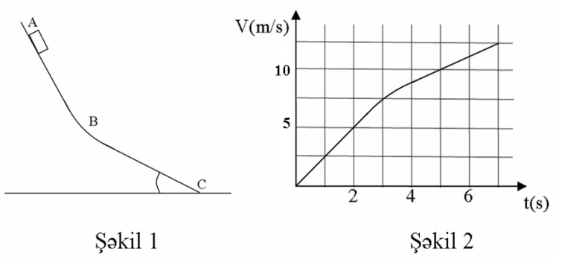  Figure 1.  Figure 2.
 | - 34.3 | - 31.4 |  |  |  | - 30.8 |  |  |  | - 28.6
16. In which case, will different seasons not be observed on a planet?

(A) When the spin axis of the planet is perpendicular to the orbital plane
(B) When the spin axis of the planet makes an obtuse angle with its orbital plane
(C) When the spin axis of the planet is parallel to the orbital plane
(D) When the planet is following an elliptic orbit

17. A boy and a cart are moving in the same direction, with the boy going twice as fast as the cart. When he gets into the cart, the speed of the cart increases by. Find the ratio of mass of cart to mass of boy.

18. A student made some measurements on the electrical circuit with the help of the battery (1), resistance box (2), switch (3), ammeter (4), and voltmeter (5). According to the indicators shown in the picture below, determine the electromotive force of the battery. The readings of the voltmeter and the ammeter are in volts and amperes respectively. The voltmeter and the ammeter are working ideally.
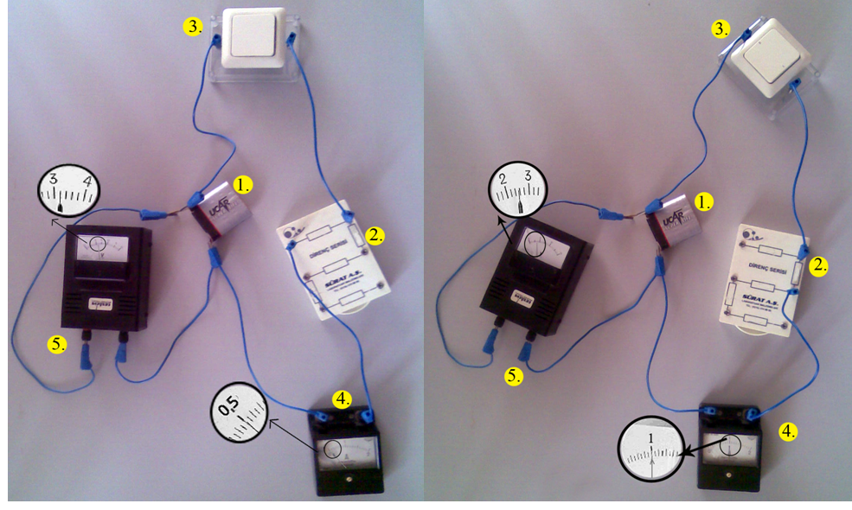

19. A ball is moving at a speed and collides elastically with a large truck moving at a speed, in the opposite direction. What is the speed of the ball after collision? (All speeds are relative to the ground)

20. When the pentagonal plate PQRST is hanging from the point X it balances as shown in Figure 1. When hanging from Y it balances as shown in Figure 2. The plate is now hung, from points P, Q, R, S, and T. Which of the following answers is correct? (The sections are of the square form)
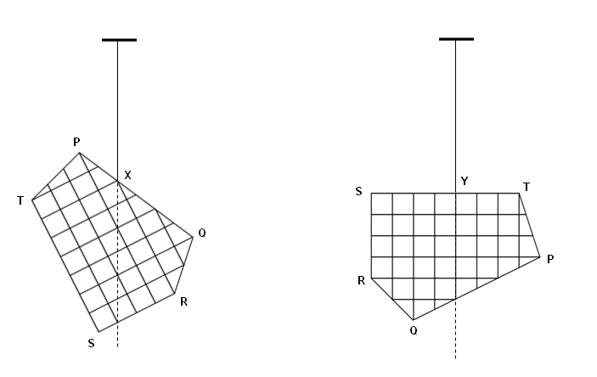
Figure 1 Figure 2

 | When the gravitational potential energy is minimum |  | When the gravitational potential energy is maximum
 | T |  | R
 | Q |  | S
 | S |  | Q
 | R |  | T

21. Human chorionic gonadotropin hormone (hCG) is injected into the blood of a mouse. Antibodies are produced in the mouse blood in response to this substance. What can the serum from this mouse blood be used for?

(A) Treatment of infertility
(B) Pregnancy test
(C) Prevention of fertilization
(D) Paternity test

22. Freshwater and marine fish face different osmotic problems. As a consequence, they have various features enabling them to survive in their habitats. Some of these features are listed below:
1. Active tubular reabsorption of
2. Reduced glomerulus size
3. Active secretion of through gills
4. Osmotic movement of water through gills into the blood
Which of these are adaptations of marine fish to their environments?

(A) 1, 2 (B) 1, 3 (C) 2, 3 (D) 2, 4

23. Some people might believe that above a certain critical population density, the human population must become vegetarian. Which of the following is more likely to be true?

(A) Taking into account trophic efficiency it would enable supporting greater number of people.
(B) Eating too much meat is not healthy.
(C) Plant food contains all nutrients needed for human organism.
(D) It would help to increase biodiversity.

24. The graph below shows the processes which take place after HIV gets into the human blood.

X. The immune reaction of the body prevents massive invasion of blood by HIV, but the virus continues reproducing in the lymphatic tissue
Y. The number of HIV passing from the lymph to the blood increases, as a consequence the number of helper T-cells drops
Z. An extensive loss of humoral and cell mediated immunity is observed


X
Y
Z
1 2 3 4 5 6 7 8 9 10Years after infection
1
3
2

Determine what is represented by the curves 1,2 and 3:
 | 1 |  | 2 |  | 3
(A) |  | T-cells concentration |  | Relative HIV concentration |  | Relative amount of antibodies
(B) |  | T-cells concentration |  | Relative amount of antibodies |  | Relative HIV concentration
(C) |  | Weakening of immune response |  | Increase in T-cells concentration |  | Recovering from disease
(D) |  | Relative amount of antibodies |  | T-cells concentration |  | Relative HIV concentration

25. Human beings, as they grow old, may have problems with their eyes. One of them involves the cornea, and can develop due to the decreased transparency of this eye layer. This problem can successfully be solved through transplantation operation. Which of the following statements makes this operation more likely to be successful comparing to other transplantation operations?

(A) Cornea is an eye layer situated in the frontal part of the eye.
(B) Cornea is not in direct contact with light-sensitive cells.
(C) With age the role of cornea in an eye is minimized.
(D) There are no blood vessels in the cornea.

26. Which letter(s) represents omnivores in the food web below?
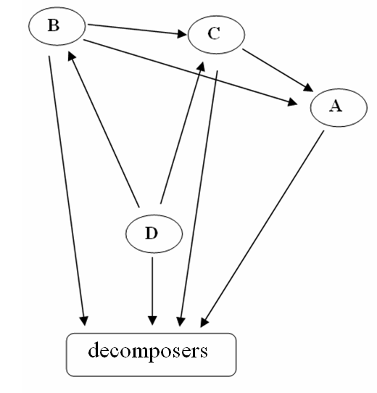
(A) A and B
(B) C
(C) D
(D) B

27. A student needs a blood transfusion after an accident. Consider the blood test results below and find out the probability that the student will receive a successful blood transfusion, if anti-B antibodies are detected in the blood of the donor’s monozygotic twin.
Donor’s parent | 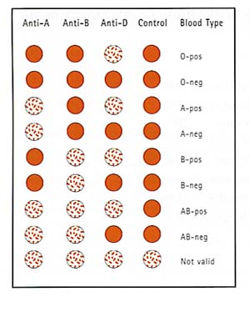
Student’s father
Student’s mother

(A) 0 (B) 1/4 (C) 1/2 (D) 3/4
28.
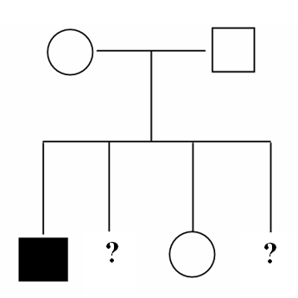

Pedigree manifests the inheritance of an autosomal recessive disease. What is the probability that the second child is a normal boy and the fourth is a sick girl?

(A) 3/256 (B) 1/8 (C) 3/64 (D) 9/64
29. In eukaryotic cells, the DNA molecules have nucleotide sequences called telomeres at their ends, which don’t contain genes. These telomeres protect the genes near the ends of DNA molecules from being eroded, because linear chromosomal DNA gets shorter after each round of replication. An enzyme telomerase catalyses the lengthening of telomeres. In what type of cells do you expect the activity of telomerase will be the highest?

(A) Specialized cells
(B) Germ cells which produce gametes
(C) Actively respiring cells
(D) Ageing cells

30. It is known that trypsin catalyses hydrolysis of peptide bonds formed by carboxyl groups of amino acids lysine – and arginine – , pepsin catalyses hydrolysis of peptide bonds formed by amine groups of aromatic amino acids (phenylalanine – and tyrosine – ) and chymotrypsin catalyses hydrolysis of peptide bonds formed by carboxyl groups of these aromatic amino acids. Taking this into account, find out what will be formed from polypeptide in the stomach and followed by the small intestine?
 | Stomach | Small intestine
(A)
(B)
(C)
(D)

