Multiple Choice Questions
Answer Key
11. Since the total resistance of the ring is R, the resistance of an arc spanning the angle α is$R_{1}=\frac{Rα}{2π}$. Similarly the resistance of the second arc will be$R_{2}=\frac{R\left(2π−α\right)}{2π}$. The two resistors are connected in parallel, thus the total resistance is $R=$$\frac{R_{1}R_{2}}{R_{1}+R_{2}}$=$\frac{Rα\left(2π−α\right)}{4π^{2}}$.
The current measured by the ammeter will be $I=\frac{ε}{R}$ =$\frac{4{\text{επ}}^{2}}{Rα\left(2π−α\right)}$ .
The graph at choice A corresponds to this equation.
Correct answer : (A)

12. The heat delivered by the heater will be solely used to increase the temperature of the objects. For the first object ${\text{Pt}}_{1}={\text{mc}}_{1}ΔT$ and similarly for the second one ${\text{Pt}}_{2}={\text{mc}}_{2}3ΔT$. From these equations we obtain that $t_{2}=\frac{3c_{2}t_{1}}{c_{1}}$= 75 mins

Correct answer :(С)

13. The motion of the object is described in the diagram below.

$υ_{o}$ $υ_{1}$ $υ$=0 m/s
L₁ L₂

Object will acquire the maximum velocity just before it starts to decelerate. The relationship between maximum and initial velocity can be obtained from the kinematic relation $υ_{1^{2}}=υ_{0^{2}}+2{\text{aL}}_{1}$. Afterwards the object will decelerate to stop $υ_{1^{2}}=2{\text{aL}}_{2}$. Combining the two equations the acceleration can be written in terms of the initial velocity and the mentioned distances $a=\frac{υ_{0^{2}}}{2\left(L_{1}−L_{2}\right)}$.
The maximum velocity is obtained from the last two equations to be

Correct answer: (B)

14. The critical angle for this material is $β={\text{sin}}^{=1}\left(\frac{1}{n}\right)=\text{23}\text{.}{\text{58}}^{0}$

The light will undergo total internal reflection as long as the angle is greater than this. The initial angle of refraction is calculated from the Snell’s law
$1×\text{sin}\text{70}=2\text{.}5×\text{sin}α$ $⇒α=\text{22}\text{.}{\text{08}}^{0}$
The light path inside the prism is described in the diagram below. The light will make 3 total internal reflections. At the 4th incidence, the angle will be less than the critical angle and the light will be able to escape the prism.
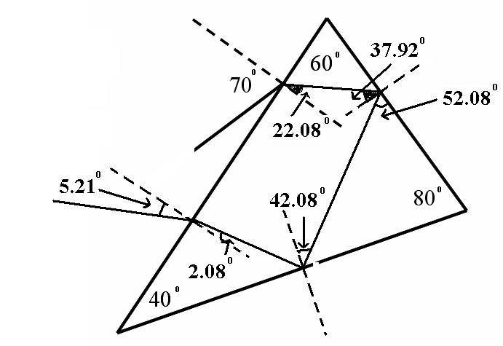
Correct answer :(С)

15. The acceleration of the object is computed from the given graph to be
a =$\frac{Δυ}{Δt}=1\text{.}\text{25}\frac{m}{s^{2}}$
From the Newton’s second law the equation for the acceleration is deduced to be $a=g(\text{sin}α−f\text{cos}α)$. Substituting the value of the acceleration found from the graph we obtain the angle of inclination to be $α=\text{28}\text{.}6^{0}$.
Correct answer:(D)

16.
Correct answer: (A)

17. The problem is similar to a collision problem where we can write the conservation of momentum $m×2υ+M×υ=\left(m+M\right)×1\text{.}2υ$. The relationship between the masses of the cart and the child will then be$M=4m$
Correct answer: (B)

18. The readings of the ammeters and the voltmeters in the two configurations are
$\begin{aligned}I_{1}=0\text{.}5A \\ I_{2}=1\text{.}0A\end{aligned}$ $\begin{aligned}V_{1}=3\text{.}2V \\ V_{2}=2\text{.}6V\end{aligned}$
For the circuit being studied, relationship between the readings of the ammeters and the voltmeters is
$\begin{aligned}V=ε−I_{1}r \\ V_{2}=ε−I_{2}r\end{aligned}$
Canceling the internal resistance of the battery from the equations we end up with
$\frac{ε−V}{ε−V_{2}}=\frac{I_{1}}{I_{2}}$
From here the EMF of the battery is calculated to be $ε=3\text{.}8$ Volt.
Correct answer : (C)

19.

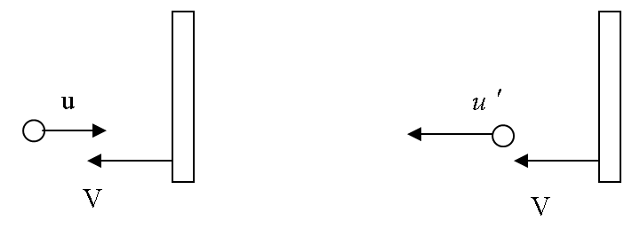

Before collision After collision

Velocity of ball relative to the large truck is u+V before collision. After collision relative velocity must be same. Therefore $u^{'}$= u+2V

Correct answer: (D)

20. From the diagrams given in the content of the question we obtain that, the center of mass is at G
The distances from the edges to the center of mass are
GP= 4 GQ=$\sqrt{\text{13}}$ GR=$\sqrt{\text{17}}$ GS=$\sqrt{\text{25}}$ GT=$\sqrt{\text{18}}$
The gravitational potential energy will be maximum when the center of mass of the object is at its highest position, i.e. when it is hanged from Q. And the gravitational potential energy is minimum when the center of mass of the object is at its lowest position, i.e. when it is hanged from S.
Correct answer: (C)

BIOLOGY ANSWERS

21 | 22 | 23 | 24 | 25 | 26 | 27 | 28 | 29 | 30
B | C | A | D | D | B | C | C | B | B

CHEMISTRY ANSWERS
1 | 2 | 3 | 4 | 5 | 6 | 7 | 8 | 9 | 10
D | A | D | B | D | C | B | B | C | A
EXPLANATION OF TESTS
TEST 1
According to Graham’s Law we can arrange gasses amount in the container B. A molecule with high molecular masses has a trace amount in gas mixture in container D.
Graham’s Law
The rates of effusion o two different gases are inversely proportional to the square roots of their molar messes.
The answer is D
TEST 2
NH₃ + HCl → NH₄Cl
4/17=0.253 mol(NH₃) 4/36.45=0.11mol(HCl)
The mol of excess ammonia: 0.2353-0.11=0.12556 mol
Area of circle: S=πr²=3.14x5²= 78.54 cm²
Volume of the cylinder: V=Sh=78.54x16=1256.637 cm³= 1.257 L
If the stopcock is opened the total volume: 2x 1.257 L=2.5133 L
Now we can use ideal gas equation for calculation of final pressure:
PV=nRT/ P·2.5133=0.11·0.082·298/ P=1.22 atm
The answer for this question is A
TEST 3
Zn²⁺ +2e⁻→Zn/2x96485 =13359.46 coulomb is needed for deposited 1mol Zn
65g Zn-----------13359.46 coulomb
4.5g Zn----------x coulomb x=13359.46 coulomb
Q=I·t/ 13359.46 coulomb=3.5·10⁻³·t/t=13359.46 seconds=1060.3 hours
The answer for this question is D
TEST 4
Potassium carbonate and ammonium sulfate gave precipitate with barium nitrate solution. The medium of ammonium sulfate is acidic. Potassium carbonate solution’s basic medium and basic solutions turn color of phenolphthalein solutions into pink, so the answer for this question is B
TEST 5
Sucrose is non electrolyte (3), KNO₃ is strong electrolyte (1), NH₃ and CH₃COOH are weak electrolytes(2)
The answer is, D) I-2, II-3, III-1, IV-2
TEST 6
The MM of NaF=42 g/mol
we can find the mol of NaF in the given solution and we calculate the mass of NaF in the solution.
200 ml=0.2L, (volume of the solution), 0.05=x/0.2, x=0.01 mol
The mass of NaF: 0.01*42=0.42
The answer is C
TEST 7
The position of metals shown in the periodic table given below;
Li
Na
Ca
Sr
Atomic radius increases from the top to the bottom.
According to this picture we can arrange the following increasing order of atomic size for metals
The answer is B) Li<Na<Ca<Sr
TEST 8
High ionization and poor conductivity related to non-metals. So the answer is B
TEST 9
34.4 grams of CaSO₄·n H₂O--------------46.668 grams of BaSO₄ is formed
X grams of CaSO₄·n H₂O----------------- 233 g/mol BaSO₄ is formed
X=171.75 grams/mol of hydrate is formed.
X=171.75 grams/mol-136 grams/moles of CaSO4=35.75 grams of water is formed.
35.75/18=2 moles of water, n=2
The answer is C
TEST 10
12% of apple is fructose, so 0.12*86=10.32 g
180 g/mol fructose ----------------------release 2812 kJ/mol energy
10.32 g fructose-----------------------release x kJ energy
X=(10.32*-2812)/180=161.2213 kJ=161221.3 J/4.184=38532.82 cal=38.532 kcal
The answer for this question is A

