8th International Junior Science Olympiad
Durban, South Africa

Experimental Examination: Practical 2
Answer Sheet

7 December 2011

Complete the following:
NAME:
SEAT NO.:
COUNTRY:
SIGNATURE:

This answer sheet consists of 6 pages. Please ensure you have them all.

DATA TABLE
Record as many data points as necessary.
Time/s | Temperature/°C
0 | 5.5
30 | 6.7
60 | 8.1
90 | 9.9
120 | 10.5
150 | 11.3
180 | 12.3
210 | 13.8
240 | 15.3
270 | 16.7
300 | 17.8
330 | 19
360 | 20.1
390 | 21.1
420 | 22.3
450 | 23.4
480 | 24.5
510 | 25.6
540 | 26.6
570 | 27.6
600 | 28.5
630 | 29.2
660 | 30.1
690 | 31
720 | 32.1
750 | 32.6
780 | 33.8
810 | 34.8
840 | 35.7
870 | 36.9
900 | 37.2
930 | 37.9
960 | 38.4
990 | 39.1
1020 | 39.9
 | 40.4

[2.0 marks]
DATA PAGE
 | Part 1: Ethanol | Part 2: Biodiesel
Initial mass of fuel + oil lamp | g | 138.440g
Final mass of fuel + oil lamp | g | 136.532g
Mass of fuel burned [0.5 mark] | g | 1.908g
Mass of stainless steel cup and water | g | 161.928g
Mass of empty stainless steel cup | g | 61.498g
Mass of water heated [0.5 mark] | g | 100.43g
Final temperature, t₂ | °C | 40.4 °C
Initial temperature, t₁ | °C | 5.5 °C
Temperature change, Δt [0.5 mark] | °C | 34.9°C

Heat, q  [2.0 marks] | kJ | 100.43g x 4.18 J/g/C x 34.9  14.65 kJ
Heat of combustion, in kJ g⁻¹  [1.0 mark] | kJ g⁻¹ ethanol | 14.65/1.98  7.48 kJ g⁻¹ biodiesel
% efficiency  [1.0 mark] | % | 7.48/41.2 x 100  18.6 %

QUESTIONS
- Circle true or false – inefficiencies in the experiment can be caused by the person/people conducting the experiment.
TRUE
[0.25 marks]

- Circle true or false – If I had the overall heat capacity for the set-up I could have obtained a more accurate value.
TRUE
[0.25 Marks]

- Give a balanced equation for the complete combustion of biodiesel (use the following formula for biodiesel: C₁₉H₃₄O₂).
C₁₉H₃₄O₂ + (53/2)O₂ → 17H₂O + 19CO₂
[1.0 Marks]

- Based on your results, which fuel produces more energy per gram burned?
BIODIESEL
[0.25 Marks]
- Select the best answer:
  - Heat is lost to the surroundings despite precautions.
  - Some heat is gained by the stainless steel cup.
  - Both the statements in a and b are true.
  - Both the statements in a and b are false.
[0.25 Marks]
Letter of answer: _____C____

- Select the best answer
  - Incomplete combustion of reactants can form soot.
  - Incomplete combustion of reactants can form carbon monoxide.
  - Both the statements in a and b are true.
  - Both the statements in a and b are false.
[0.5 Marks]
Letter of answer: __C_______

Accuracy mark
Ethanol |  | Biodiesel
Range | Mark | Range | Mark
9.20 - 9.60 | 0.5 | 11.80 - 12.30 | 0.5
8.80 - 9.19 | 1 | 11.30 - 11.79 | 1
8.40 – 8.79 | 2 | 10.80 – 11.29 | 2
8.00 – 8.39 | 2 | 10.30 – 10.79 | 2
7.60 – 7.99 | 1 | 9.80 – 10.29 | 1
7.20 – 7.59 | 0.5 | 9.30 – 9.79 | 0.5

- The following reaction is an example of the synthesis of biodiesel:
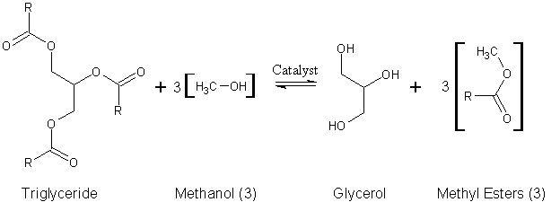
Select the best answer:
  - Methanol acts as a solvent in the above reaction.
  - Methanol acts as a transesterification agent in the synthesis of biodiesel.
  - The role of the catalyst is to increase the activation energy of the reaction and thus speed up the reaction.
  - Two statements are true.
  - Three statements are true.
[0.5 mark]
Letter of answer: _D_______

8. South Africa has a total land area of 122.3 million hectares (1.0 hectare = 0.01 km²), and approximately 13% of this land can be used to grow crops. Castor oil seeds can be used as a food crop or as a source of biodiesel. Assuming castor oil seeds are 85% oil, converting castor oil to biodiesel gives a 95% yield, and one square kilometre of farm land can produce 180000 kg of seeds per year. Given this information, answer the following questions:
a. How much biodiesel can be produced per year from 1 acre (1 acre = 0.00405 km²) of farm land? Give your answer in mass units per land area. Show all your calculations.

Mass seeds per land area (from the question) = 180000/km²
Convert to mass seeds per acre
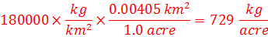
Convert mass seeds to mass castor oil produced
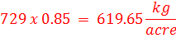
Convert mass oil to mass biodiesel
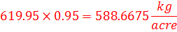
Answer = 5.9 x10² kg/acre

[0.75 marks]

- South Africa uses approximately 10 billion litres of diesel per year, how much land is needed to make enough biodiesel to meet this demand (density of biodiesel ~ 0.85 g/mL)?
Unit Conversion of mass biodiesel
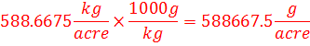
Conversion from mass to volume
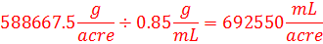
Conversion of mL to L
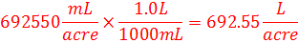
Calculation of acres needed
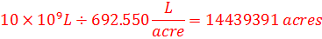
Answer = 1.44 x 10⁷ acres (Land needed)

[1.0 marks]
- B20 is a blend of 20% biodiesel and regular petrol diesel, calculate whether there is enough land to grow and eventually produce enough biodiesel for a B5 blend?

Litres needed for a B5 blend = 10 x10⁹ x (5/100) = 500000000 Litres
Land needed for a B5 blend
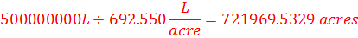
Land needed for a B5 blend in square kilometres
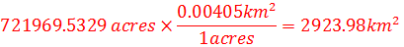
South Africa Farmland available
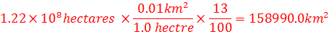
Answer = Yes

[ 0.75 marks]

