Physics Theoretical Question Marking Scheme

=0.5 point
Question 1
- (i)
(0.5 point)

real | virtual | magnified | diminished
 |  | 

(ii) (0.5 point)
There will be no image | You will only see the bottom half of the filament | You will only see the top half of the filament | You will still see the full image of the filament
 |  |  | 

- (0.5 point)
There will be no image of the filament | You will see a larger image of the filament | You will see an upright image of the filament | You will see a faint image of the filament


(b)
30 cm
50 cm
16 cm

for diverging lens.
Using the thin lens equation, we have
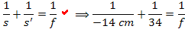
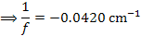

(2 points)

Question 2
(1.5 points)
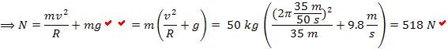
(b)
(2 point)
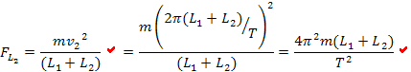
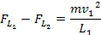
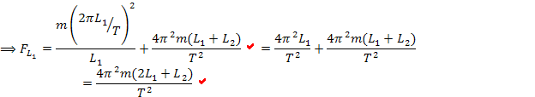

Question 3
(a)
(1 point)
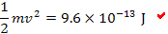

(2 point)
Consider part of the beam as a cylinder with cross section area A.
