EXAMINATION RULES
- All competitors must be present at the front of examination room ten minutes before the examination starts.
- No competitors are allowed to bring any tools except his/her personal medicine or any personal medical equipment.
- Each competitor has to sit according to his or her designated desk.
- Before the examination starts, each competitor has to check the stationary and any tools (pen, ruler, calculator) provided by the organizer.
- Each competitor has to check the question and answer sheets. Raise your hand, if you find any missing sheets. Start after the bell rings.
- During the examination, competitors are not allowed to leave the examination room except for emergency case and for that the examination supervisor will accompany them.
- The competitors are not allowed to bother other competitor and disturb the examination. In case any assistance is needed, a competitor may raise his/her hand and the nearest supervisor will come to help.
- There will be no question or discussion about the examination problems. The competitor must stay at their desk until the time allocated for the examination is over, although he/she has finished the examination earlier or does not want to continue working.
- At the end of the examination time there will be a signal (the ringing of a bell). You are not allowed to write anything on the answer sheet, after the allocated time is over. All competitors must leave the room quietly. The question and answer sheets must be put neatly on your desk.

Read the following instructions carefully:
- The time available is 3 hours.
- The total number of the questions is 3. Check that you have a complete set of theoretical questions and the answer sheet.
- Use only the pen provided.
- Write down your name, code, country and signature in the first page of your answer sheet. You will only need to write down your name and code in the next pages of your answer sheet.
- Read carefully each problem and write the complete correct answer in the answer sheet.
- All competitors are not allowed to bring any stationary and tools provided from outside. After completing your answers, all of the question and answer sheets should be put neatly on your desk.
- Grading rules: According with each question marking.

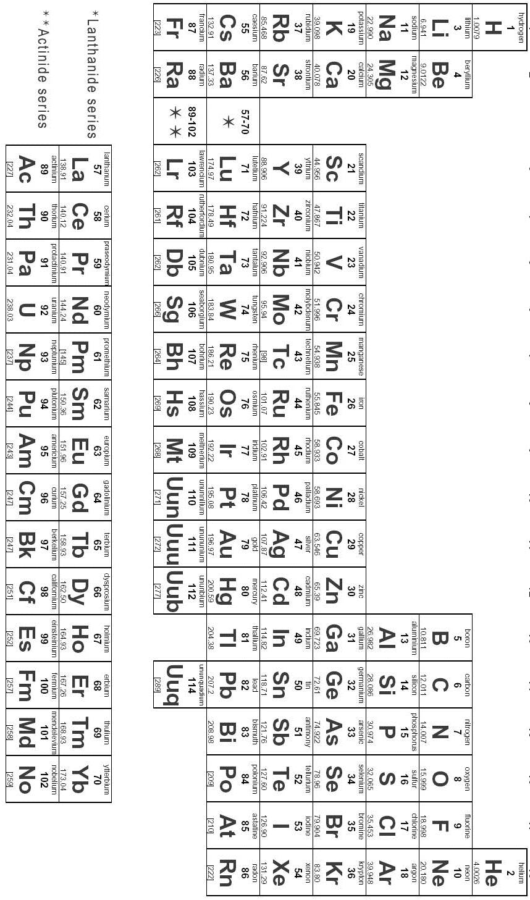

PHYSICS

Iran is connected to the free waters by the Persian Gulf. This Gulf is located in Western Asia between Iran and the Arabian Peninsula. Its area and the average depth are 240,000 km² and 50 m respectively. It is the largest Gulf after the Gulf of Mexico, and Hudson Bay , rich in oil and gas resources. Sailing in this region has a long history,and the first conclusive evidence can be traced to the fourth century BCE. In this problem take g=10 m/s².

Part A)
$C_{\text{water}}=\text{4200}\frac{J}{\text{kg}\text{.}K}$$ρ_{\text{water}}=\text{1000}\frac{\text{kg}}{m^{3}}$ How much energy is required to raise the temperature of water by 1°C. Consider the Gulf in the form of a box. The specific heat capacity of water is
and the density of this is
(1)

Part B)
Fishing and pearling is one of the main sources of income for the people of this region. Local people build small wooden boats. The small boat is built entirely from a kind of local wood. What is the density of the wood if about 0.186 m of the boat’s height goes below the water surface? For simplicity consider the boat like a cuboid as in the figure below. The thickness is 10cm and 20cm at the walls and the bottom respectively. ( 1)
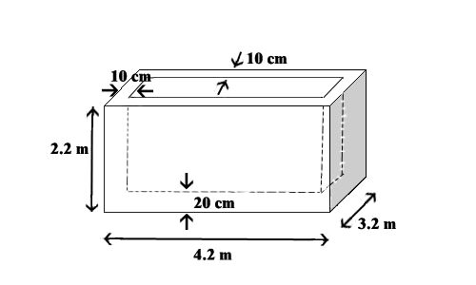

Part C)
I- Part B was theoretical , when people use this boat it needs interiors, equipment , material and so on. The additional mass inside the boat is 1.99*10⁴ kg .
What is the maximum number of divers that can be loaded in the boat, if we want not more than 80% of the height of the boat to be below the water surface? Consider the mass of each diver to be 80 kg.
(1.5)

II- In hot summer days the temperature goes up to 50 ⁰ C and the salty water evaporates intensively. Which statement is true assuming that not more than 80% of the height of the boat to be below the water surface? Neglect thermal expansion. The maximum number of divers who can be loaded in the boat

1) increases.
2) decreases.
3)remains the same.
(0. 5)

Part D)
The divers realize that water has entered inboard due to a leak and has covered the bottom of the boat in a thin layer. A suction pump is used to eject this water. It has a uniform plastic pipe with the inner radius of 1cm leading the water out of the edge of boat with the velocity of 3 m/s. What is the output power of this pump?
(2.5)

Part E)
Centuries before the discovery of oil, pearling and its trading, had been the most important economic activity in the Persian Gulf as a source of wealth for the south shore dwellers. In addition to white pearls , pink, yellow, green, blue, brown and black ones are found in this Gulf.
One of the divers has gone down to a depth of 15 m for pearling. What is the pressure on the diver at that depth (in Pascal)?
(1)
PartF)
A 2.0 kW pump is powered by a solar panel. Given efficiency of conversion of light energy into electrical is 12 %. Find the minimum area of the solar panels required if the intensity of solar radiation received by the solar panels is 1100 W/m².
(1.5)

Part G)
Given that the speeds of sound (ultrasonic waves) in air and in water are 340 m/s and 1440 m/s respectively.
I- Calculate the refractive index for sound waves in water with respect to that in air.
II- An aircraft at a height of 1 km from the ocean surface, directs a beam of ultrasonic waves to the bottom of the ocean and receives an echo from the bottom of the ocean in 7 s. Estimate the depth of the ocean.
(1)

CHEMISTRY

Chemical Analysis of a sample of Persian Gulf Water
Chemical analysis has many applications in different industries. It also plays an important role in other sciences than chemistry. For example, chemical analysis may help biologists to characterize and maintain the properties of water that certain plants grow in.
A biology team working on Mangrove forests near Persian Gulf, was concerned about the composition of chemicals in water. A sample of the water was given to an analysis laboratory to determine the chemical species present in the water and their concentrations. Certain qualitative tests were applied to reveal that the species present in the sample are :
Cl⁻ , I⁻ , HCO₃⁻ , HSO₃⁻ , Fe²⁺
To determine the concentrations of chloride and iodide ions, 20.0 mL of the sample solution was treated with an excess of AgNO₃ solution and 2.93 g of precipitate was obtained. In another experiment, an excess of Pb(NO₃)₂ solution was added to 30.0 mL of the sample solution and resulted 4.30 g of precipitate. Assume that both ions precipitated completely in each case.
Note : Use precise atomic masses from the given periodic table in all your calculations.
1) Write down the balanced chemical equations for all the reactions involved. (2 marks)
2) Calculate the concentrations of Cl⁻ and I⁻ in the sample. (3 marks)
After that, the concentrations of HCO₃⁻ and HSO₃⁻ were to be measured. For this purpose an excess of a 5.0 M sulfuric acid was added to 100 mL of the sample and the gas evolved was collected and its volume was measured.
3) What volume, in millilitres, of concentrated H₂SO₄ (98% by mass, density=1.83 g/mL) is needed to make 1000 mL of 5.0 M H₂SO₄? (1 mark)
4) Which gases are evolved during the reaction? Write down the balanced chemical equations. (1.5 marks)
The volume of the gas obtained was 2.5 mL at 298K and 1.0 atm [101325 Pa]. The gas mixture was passed through an acidic bromine solution. Only one of the gases dissolved.
5) Draw the Lewis structure of both gas molecules. Show the oxidation state of the central atom. Indicate which of the two gases can be oxidized further by circling it. (2 marks)
The volume of the gas collected after passing through the acidic bromine solution was 2.0 mL at 298K and 1.0 atm [101325 Pa]. The value of the gas constant, R, is 0.0821 atm.L/(mol.K) [8.314 J/(mol.K)]. Ignore any water vapour that may be present. Assume that the gases behave ideally.
6) Calculate the concentrations of HCO₃⁻ and HSO₃⁻ in the sample. (2 marks)
To find the concentration of Fe²⁺, 100 mL of sample was first treated with suitable reagents to remove other ions present in the solution and then was titrated with Permanganate ion and required 9.3 mL of 1.0x10⁻³ M KMnO₄ solution to reach the equivalent point. The reaction of titration is :
MnO₄⁻ + Fe²⁺ + H⁺ Mn²⁺ + Fe³⁺ + H₂O
7) Balance the chemical equation of titration. (1 mark)
8) Calculate the concentration of Fe²⁺ ions in the sample. (1.5 mark)

BIOLOGY

Mangrove forest or mangals include trees and shrubs that grow in tropical and subtropical latitudes (coastal and intertidal zones) adjacent to the equator. Mangrove plants need a number of morphological and physiological adaptations to overcome unfavorable conditions such as anoxia (lack of oxygen), high level salinity and frequent tidal inundation.
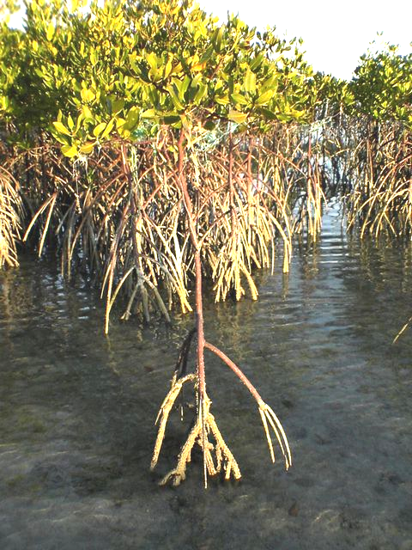
Avicennia marina is the famous mangal plant in Iran which is viviparous (seeds germinate while still attached to the parent tree).

Mangrove tree
Iran

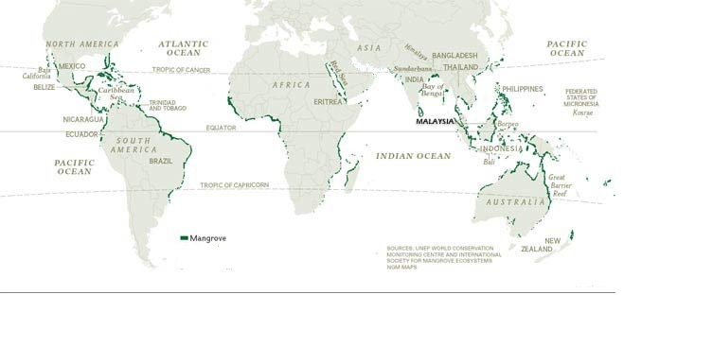

Distribution of mangrove forests around the world
- According to the text and the map above, determine the distribution of mangrove forest in Iran (shown by a thick curve).

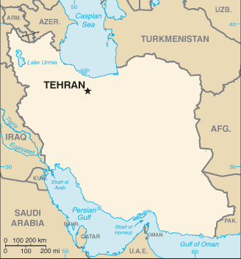
- Caspian Sea B) Persian Gulf & Gulf of Oman

- Urmia Lake D) Caspian Sea & The straits of Hormuz
(1 point)
- Match the problem encountered and corresponding adaptation(s) for the mangrove plants to cope with (one or more answers may apply).
Problem encountered |  | Adaptations
A | Intertidal currents | i | Viviparity
B | Anoxia | ii | Reduced surface area of leaves
C | High concentration of Salt | iii | Leaves with glands that excrete salt
D | Reproduction in unsuitable condition | iv | Larger extension of root in seabed
E | High temperature and evaporation | v | Breathing roots
 |  | vi | Reduced opening of the stomata
(0.5 X 6 = 3 points)

- Benthic invertebrates that live in a mangrove habitat are exposed to air during low tide. During that period, the concentration of lactic acid in the body of benthic invertebrates will increase. State whether the following statements are true or false by ticking the appropriate box in the answer sheet.

Statement | True | False
These invertebrates will change their respiration mode from aerobic to anaerobic pathway during the low tide.
These invertebrates will slow down their metabolism during the low tide.
(0.5 X 2 = 1 point)

- Identify which of the cross-sections of leaves shown in figure 1, 2 and 3 belong to:
- Mesophytic plant (adapted to grow in moderate amount of water)
- Hydrophytic plant (adapted to grow in water)
- Xerophytic plant (adapted to grow in dry conditions)
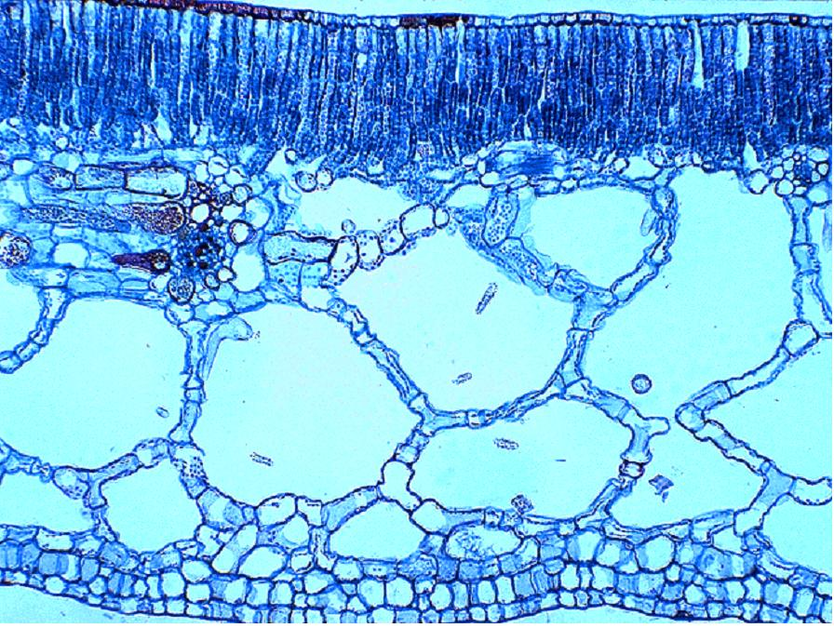
Y

X

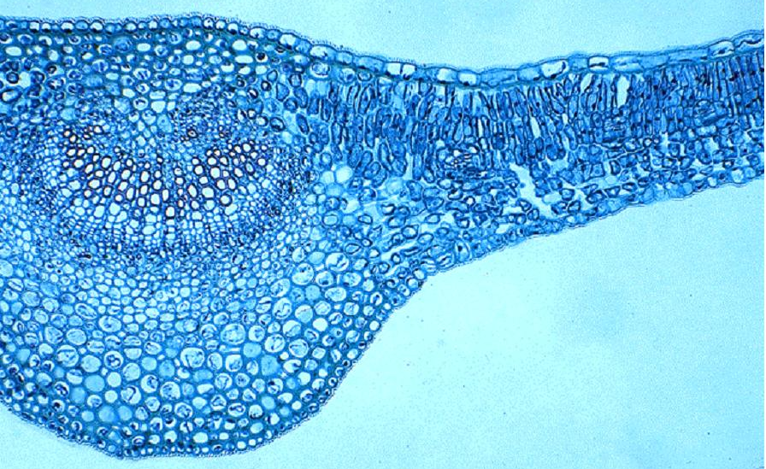
Figure 1

Y

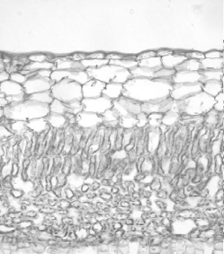
Figure 2
Z
Y

Legend:
X. Air containing tissue
Y. Photosynthetic tissue
Z. Water containing tissue

Figure 3
(0.5 X 3 = 1.5 points)
- Read the following passage and complete the blank spaces with the correct word. Choose the words from the table below and write the corresponding number on the answer sheet

A xerophyte is a plant that has adapted to survive in an environment that lacks sufficient a)…., such as a desert. Xerophytic plants may have adapted shapes and forms or internal functions that reduce their water loss or store water during long periods of dryness. Plants with such morphological adaptations are called xeromorphic. Xerophytic plants have less overall b)… than other plants in order to reduce water loss by c).…. Xerophytes have d)… leaves than other plants. An example of a xerophytes is a e)….
Hydrophytes are plants that have adapted to living in aquatic environments. These plants require special adaptations. The most common adaptation is the possession of f)… storage tissue. The stomata of hydrophytes are located on the g)… surface of the leaves. An example of a hydrophyte is a h)….
Letter in text | Answer
a. | I | air
 | II | salt
 | III | water
 | IV | light
b. | I | height
 | II | mass
 | III | volume
 | IV | surface area
c. | I | osmosis
 | II | evaporation
 | III | diffusion
 | IV | active transport
d. | I | lighter
 | II | larger
 | III | darker
 | IV | smaller
e. | I | cactus
 | II | water lily
 | III | rose
f. | I | glycogen
 | II | starch
 | III | air
g. | I | upper
 | II | lower
h. | I | cactus
 | II | water lily
 | III | rose
(0.25 X 8 = 2 points)
- Mangroves have xerophytic adaptations.
Which of the following statements are true? Tick the appropriate box on the answer sheet.

Statement | True | False
- The air roots of mangroves directly absorb air from the atmosphere.
- Mangroves store salt in their vacuoles and use osmosis to take up water.
- Mangroves use osmosis to excrete salt into the environment.
(0.5 X 3 = 1.5 points)

