EXAMINATION RULES
- All competitors must be present at the front of examination room ten minutes before the examination starts.
- No competitors are allowed to bring any tools except his/her personal medicine or any personal medical equipment.
- Each competitor has to sit according to his or her designated desk.
- Before the examination starts, each competitor has to check the stationary and any tools (pen, ruler, calculator) provided by the organizer.
- Each competitor has to check the question and answer sheets. Raise your hand, if you find any missing sheets. Start after the bell rings.
- During the examination, competitors are not allowed to leave the examination room except for emergency case and for that the examination supervisor will accompany them.
- The competitors are not allowed to bother other competitor and disturb the examination. In case any assistance is needed, a competitor may raise his/her hand and the nearest supervisor will come to help.
- There will be no question or discussion about the examination problems. The competitor must stay at their desk until the time allocated for the examination is over, although he/she has finished the examination earlier or does not want to continue working.
- At the end of the examination time there will be a signal (the ringing of a bell). You are not allowed to write anything on the answer sheet, after the allocated time is over. All competitors must leave the room quietly. The question and answer sheets must be put neatly on your desk.

Read the following instructions carefully:
- The time available is 3 hours.
- The total number of the questions is 30. Check that you have a complete set of the test questions and the answer sheet.
- Use only the pen provided.
- Write down your name, code, country and signature in your answer sheet.
- Read carefully each problem and choose your correct answer by crossing one of the capital letters in your answer sheet. There is only one right answer for each problem.
Example:
1 | A | B | C | D
- If you want to change your answer, you have to circle the first answer and then cross a new letter as your correct answer. You are only allowed to make one correction.
Example:
1 | A | B | C | D
A is the first answer and D is the corrected answer
- All competitors are not allowed to bring any stationary and tools provided from outside. After completing your answers, all of the question and answer sheets should be put neatly on your desk.
- Grading rules:
- Correct answer : + 1.00 point
- Wrong answer : : - 0.25 point
- No answer : 0 point
1. A block of 0ºC ice with the mass of 50 kg slides on a horizontal surface. The initial velocity of ice is 6.0 m/s and it stops after a distance of 28.3 m. How much ice melts due to the friction? (specific latent heat of fusion of ice, L_{f} = 80 cal/g and 1 cal = 4.18 J and neglect the heat transfers to the environment)

(a) 47 g | (b) 2.7 g | (c) 4.7 g | (d) 11.2 g

2. Why does the Moon always show its same face to Earth? Because:

(a) it rotates about its axis almost once per day
(b) it rotates about its axis almost once per month
(c) it rotates about its axis almost once per year
(d) it does not rotate about its axis

3. The following diagram shows changing force which is applied to a body with a mass of 5 kg in the same direction. The body is initially at rest. What is the final speed in m/s after 2.5 s?

(a) 4 | (b) 6 | (c) 8 | (d) 10

4. A light beam from a laser source which is parallel to the horizontal surface, hits an equilateral prism as shown in the figure below. What is the angle α (between AB and the horizontal surface) if the emergent beam is perpendicular to the face AB? (Refractive index of the prism is 2)
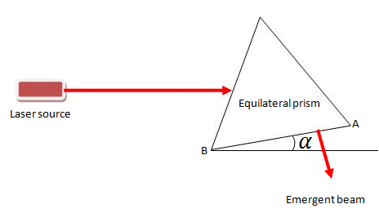

(a) 24.5º | (b) 42.5º | (c) 15º | (d) 30º

5. An ambulance moves through a street along the positive X direction and a person who stands beside the street hears the sound of the ambulance siren. Which option represents the frequency(f) received by the person? X is the position of the ambulance; the person stands at the origin.

f  X  (a) | f  X  (b)
f  X  (c)  (c) | f  X  (d)  (d)
6. In the Track and Field World Championships, the world record in the 100-m dash was as shown in the table. Which of the following graphs best represents the time variation of velocity?

t (s) | 1.88 | 2.96 | 3.88 | 4.77 | 5.61 | 6.46 | 7.30 | 8.13 | 9.0 | 9.87
x (m) | 10 | 20 | 30 | 40 | 50 | 60 | 70 | 80 | 90 | 100

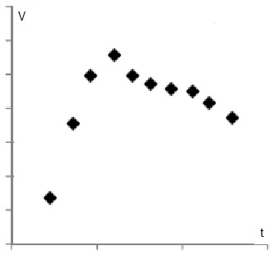  (a) | `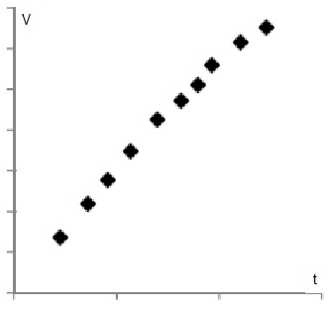  (b)
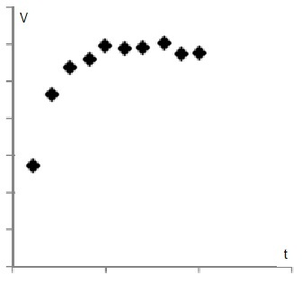  (c) | 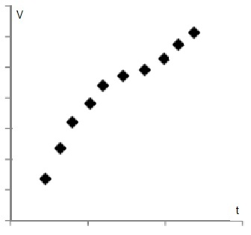  (d)
7. The vertical surfaces of a frustum (as shown below) are connected to two thermal reservoirs at different temperatures. The material is solid and uniform. Which diagram shows the temperature variation along the frustum axis after temperature stabilization?

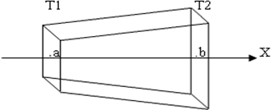

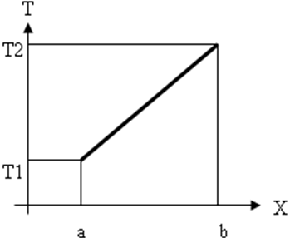  (a) | 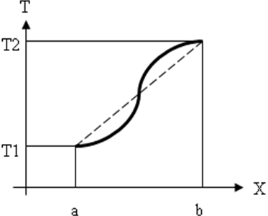  (b)
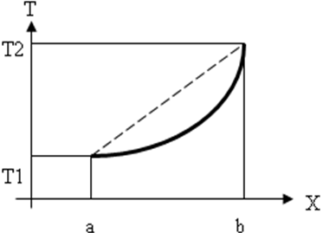  (c) | 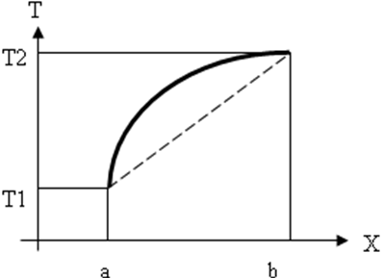  (d)

8. The following figure shows a barometer, the cross section area of each pipe is 1.8 cm². The barometer contains the fluid with density of 8 g/cm³.
The barometer is connected to a gas tank. The right pipe is closed and above the fluid is vacuum.The height difference between the liquid levels in the two pipes equals to 0.25 m.
What is the weight of liquid (between the two AB & CD levels)? What is the ratio of the gas pressure to the atmosphere pressure? g= 10 m/s²

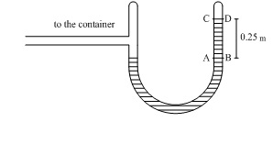

(a) $3\text{.}6N, 2$ | (b) $3\text{.}6N, 0\text{.}2$ | (c) $\text{36}N, 2$ | (d) $\text{36}N, 0\text{.}2$

9. A word is written in blue ink on a white sheet paper. A red light illuminates this paper and

(A) The word is seen red
(B) The word is not seen
(C) The word is seen black
(D) The word is seen blue

10) In the following circuit, what is the ratio of equivalent resistance when the switch (k) is closed to switch (k) is open? If the total current through the circuit is” I”, when the switch is opened, what fraction of “I” is shown by the Ammeter (A)?

(A) $0 , \frac{\text{12}}{\text{50}}I$ | (B) $0 , \frac{2}{\text{19}}I$ | (C) $\frac{\text{12}}{\text{50}} , \frac{\text{12}}{\text{25}}I$ | (D) $0 , \frac{\text{12}}{\text{25}}I$

11. The density of hot and cold water are different mainly because:
(a) The molecules in hot water are slightly larger than in cold water.
(b) The bond between hydrogen and oxygen atoms in a single water molecule is stronger in cold water.
(c) The molecules in hot water move faster and are slightly further apart.
(d) Intermolecular forces in cold water are weaker.

12. When certain substances dissolve, the solution gets colder. This type of dissolving process is endothermic. In endothermic dissolving:
(a) More energy is released when solvent molecules bond to the solute than is used to pull the solute particles apart.
(b) More energy is used to pull the solute particles apart than is released when solvent molecules bond to the solute.
(c) More energy is used when the solute molecules get apart than to pull the solvent molecules apart.
(d) The energy released when solvent molecules get apart is more than the energy released when solute molecules bond to solvent.

13. Consider the following aqueous equilibrium ;
HF_{(aq)} H⁺_{(aq)} + F⁻_{(aq)}
In which of the following answers would both of the compounds decrease the amount of HF in equilibrium, when added to the solution ?
(a) NaCl , CaCl₂
(b) NaF, NaOH
(c) H₂O, NH₃
(d) CaF₂ , H₂SO₄

14. In four containers with equal volume and temperature, equal masses of the gas mixtures below is confined. Which container would have the highest pressure? The compositions are given in mole percent.
(a) 50% He, 50% Ne
(b) 50% He, 50% Ar
(c) 70% Xe, 30% Ne
(d) 90% Xe, 10% Kr

15. 50 ml of 0.1 M Ammonia solution is being titrated with a standard 0.1 M HCl solution. Which of the following acid-base indicators is the most accurate to reveal the equivalent point ( pKa of NH₄⁺ ion is 9.2)?
(a) Phenolphthalein which changes color between pH=8.2 to 10.0
(b) Methyl Red which changes color between pH=4.8 to 6.0
(c) Bromothymol Blue which changes color between pH=6.0 to 7.6
(d) Methyl Orange which changes color between pH=3.2 to 4.4

16. Carbon monoxide and chlorine react to form Phosgene, COCl₂. A mixture was prepared containing 0.20 mole of CO and 0.10 mole of Cl₂ in a 3.0 dm³ vessel at 400K. The equilibrium constant for the reaction in these conditions, K_{c}=0.41.
What would be the number of moles of COCl₂ at equilibrium ?
(a) 8.75x10⁻⁴ mol
(b) 2.92x10⁻⁴ mol
(c) 2.63x10⁻⁴ mol
(d) 2.63x10⁻³ mol

17. What is the correct order for the bond energy in the following molecules ?
(a) CO₂ > CCl₄ > N₂ > CH₄
(b) N₂ > CO₂ > CCl₄ > CH₄
(c) CO₂ > N₂ > CCl₄ > CH₄
(d) N₂ > CO₂ > CH₄ > CCl₄
18. Assuming that all reactions go to completion, which of the compounds below would release more CO₂ molecules if we heat the amount indicated in parentheses ?
(a) BaCO₃ (1.0 g)
(b) Li₂CO₃ (2.0 g)
(c) Ce(CO₃)₂ (3.0 g)
(d) Fe₂(CO₃)₃ (2.0 g)

19. Which of the following statements about a sample of N₂ at room temperature and 1 atm pressure, is wrong?
(a) All of the N₂ molecules do not have the same kinetic energy.
(b) The molecules collide elastically with the container’s walls.
(c) The mean potential energy of the molecules does not change over time.
(d) If we double the absolute temperature, the mean speed of molecules doubles.

20. The rate of which of the elementary reactions below, would increase more if the pressure rises by reducing the volume of the container? All reactions take place in the gas phase.

(a) H + Cl₂ HCl + Cl
(b) Br₂ 2Br
(c) 2H + H⁺ H₃⁺
(d) Br + H₂ HBr + H

21. According to the following figures, a cow uses plant leaves as a nutrition source. As we know, the energy of sunlight is absorbed by plant leaves (Photosynthesis process). So, calculate the percentage of the sun's light energy assimilated by a cow.
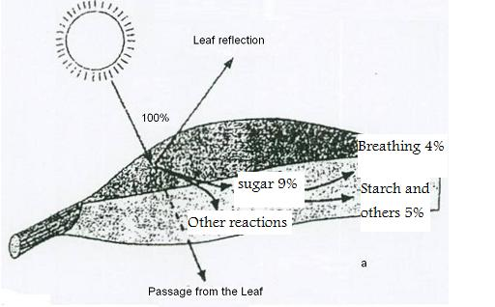
- 2%
- 0.2%
- 4%
- 5%

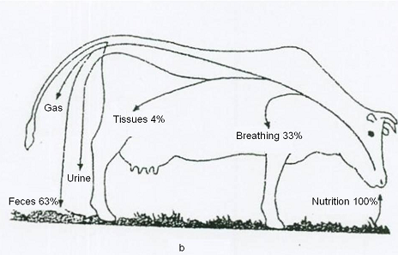

22. The Karyotype shown below belongs to a …….

- normal woman
- normal man
- woman with Trisomy 18
- man with Trisomy 18
.

23. The diagrams show vertical sections of kidneys of a freshwater seal, Northern Three-toed Jerboa (a species of rodent living in arid deserts of Northeastern Iran) and Persian fallow deer (a rare ruminant mammal inhabiting in Khuzestan, Southern Iran, and in Mazandaran, Northern Iran, and in an island in Lake Urmia in Northwestern Iran), showing the relative size of cortex and medulla. Which kidney belongs to which animal? Assume that the majority of Henle loops are located in the medulla.
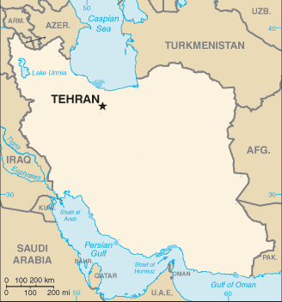
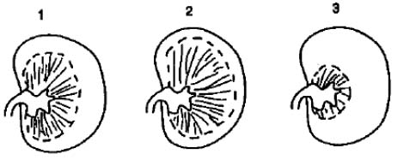
- 1:Persian fallow deer 2: Seal 3: Jerboa
- 1: Jerboa 2: Persian fallow deer 3: Seal
- 1: Jerboa 2: Seal 3: Persian fallow Deer
- 1: Persian fallow deer 2: Jerboa 3: Seal

24. A musician suffering a stroke has lost his coordination and accuracy in playing piano. Which part of his brain may be damaged?

a- Cerebellum
b- Medulla oblongata
c- Hypothalamus
d- Limbic system

25. There is a receptor on the antennae of the male silkworm moth that plays a role in the recognition of a female silkworm moth at a distance. What type of the following receptor is it?

a) Photoreceptor
b) Thermoreceptor
c) Chemoreceptor
d) Mechanoreceptor

26. Which teeth patterns belong to carnivores and which ones to herbivores?
- 1 and 2: carnivores
3 and 4: herbivores
- 1 and 3: carnivores
2 and 4: herbivores
- 1 and 2: herbivores
3 and 4: carnivores
- 1 and 3: herbivores
and 4: carnivores

27. According to the figure below, which pair is closer evolutionarily to each other?
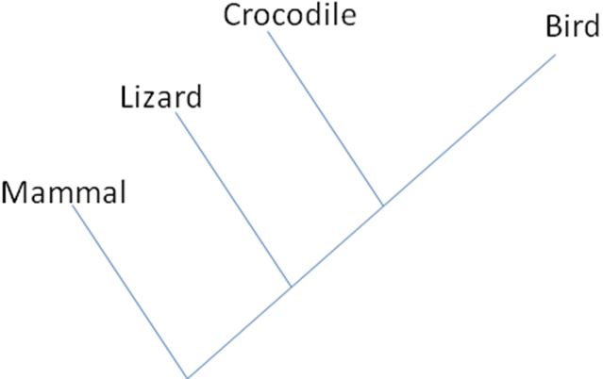
- Crocodile-bird
- Crocodile-lizard
- Mammal-bird
- Lizard-bird

28. Which one shows the ascending order in the relative lengths of the caecum to the whole alimentary canal of the following animals?

- Rabbits→ dogs→humans
- Rabbits→humans→dogs
- Dogs→humans→rabbits
- Humans→rabbits→dogs

29. There are many migrating birds which go across the Iranian Plateau during the migration season. Which of the following factors is the most effective in triggering their migration?

- Change in temperature
- Change in food available
- Change in behavior of predators
- Change in daylight time

30. A precipitation resulted from blood sample and antibody A. Which one of the following choices is definitely incorrect?

- Only gives blood to anybody with blood group B.
- Cannot take blood from anybody with blood group AB.
- Can give blood to anybody with blood group A.
- Can take blood from anybody with blood group O.

