8th International Junior Science Olympiad
Durban, South Africa

Theoretical Examination: Part 2 - Chemistry

5 December 2011

Duration: 3 hours Total Marks: 30

EXAMINATION RULES
- All competitors must be present at the front of examination room 15 minutes before the examination starts.
- No competitors are allowed to bring any stationery and tools except his/her personal medicine or any personal medical equipment.
- Each competitor has to sit at his or her designated desk.
- Before the examination starts, each competitor has to check the stationery and any tools (pen and calculator) provided by the organiser.
- Each competitor has to check the question and answer sheets. Raise your hand, if you find any missing sheets. Start after the bell rings.
- During the examination, competitors are not allowed to leave the examination room.
- If a competitor needs to use the bathroom he/she must raise his/her hand and an examination supervisor will escort you.
- The competitors are not allowed to communicate with other competitors and disturb the examination. In case any assistance is needed, a competitor may raise his/her hand and the nearest supervisor will come to help.
- There will be no questions or discussion about the examination problems. The competitor must stay at his/her desk until the time allocated for the examination is over, although he/she has finished the examination earlier or does not want to continue working.
- At the end of the examination time there will be a signal (the ringing of a bell). You are not allowed to write anything on the answer sheet, after the allocated time is over. All competitors must leave the room quietly. The answer sheets must be left on your desk.
Read the following instructions carefully:
- The time available is 3 hours.
- The theoretical examination question paper is in 3 parts. Check that you have a complete set of theoretical questions and the corresponding answer sheets. The question paper consists of 21 pages.
- Use only the pen provided.
- Write down your name, seat number, country and signature on the first page of your answer sheet. You will only need to write down your name and seat number on the next pages of your answer sheet.
- Carefully read each problem and write the correct answer and show all your working (calculations) on the answer sheet.
- Full marks will only be awarded if all your calculations are shown on the answer sheet.
- After completing your answers, your answer sheet should be left on your desk.

Grading rules: According to the marks shown for each question.

ПОДАЦИ:
Aвогадров број = 6.022 × 10²³ mol⁻¹
Фарадејева константа = 96485 C mol⁻¹
R = 8.314 J mol⁻¹ K⁻¹
1.0 l = 1.0 dm³
1.0 atm = 101 325 Pa

Периодни систем елемената се налази на последњој страни

QUESTION 1
Advancements in medical technology have made it possible for doctors to determine whether the baby has abnormal chromosomes before birth. An example of such technology is amniocentesis, represented in Figure 1, which is done during the 18th week of pregnancy.
Study Figure 1 below and answer the following questions.
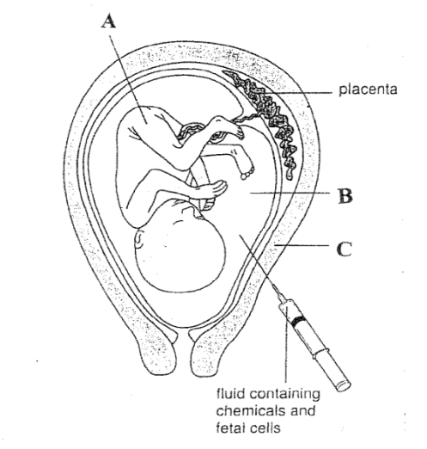
Courtesy: Department of Basic Education
Figure 1
(a) Match the parts indicated by A, B and C (from Figure 1) in Column X with one corresponding structure or part indicated by numerals in Column Y on the answer sheet.
Column X | Column Y
- ….  - ….  - …. | - Liquid which serves as shock absorber.  - Liquid which contains red blood cells to carry oxygen.  - Structure which represents the stage of human development from 3-9 months during pregnancy.  - A structure which represents the stage of human development from 1-2 months during pregnancy.  - Structure which dilates during first stage of birth/parturition.  - Site where fertilization takes place.  - Structure which is shed during menstruation.  - Myometrium (Muscular wall).
(1.5 marks)
(b) State whether the following is true or false by placing a tick (√) in the appropriate box on the answer sheet.

Amniocentesis cannot be carried out during the 36th week of pregnancy because…
 | True | False
(i) … the amniotic fluid will not contain cells.
(0.25 mark)
(ii) …there is a greater possibility of injuring the foetus.
(0.25 mark)
(0.5 mark)

(c) Study the following chromosomal map (Figure 2).

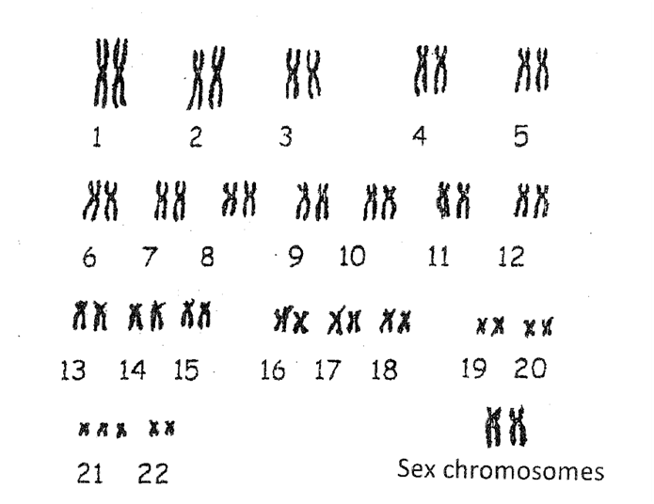
Figure 2

(i) Circle the letter in the answer sheet which corresponds to the symptom(s) of the genetic disorder which can be detected using the chromosomal map in Figure 2.
A. Lacks or has inadequate presence of clotting factor VIII.
B. Low muscle tone, intellectual disability and short stature.
C. Sticky mucus blocks air passages in lungs.
(0.5 mark)
(ii) The genetic disorder shown in the chromosomal map in Figure 2 is autosomal. State whether this is true or false by placing a tick in the appropriate box on the answer sheet.
(0.25 mark)
(iii) Circle the correct letter in your answer sheet to complete the following statement.
The sex of the child shown by the chromosomal map in Figure 2 is…
- female because it has 23 pairs of chromosomes.
- male because it has 23 pairs of chromosomes.
- male because it has identical sex chromosomes.
- female because it has identical sex chromosomes.
(0.5 mark)
(d) Many hormones play a vital role during pregnancy. Study the following list of hormones.
M. Oxytocin
N. Prolactin
O. Oestrogen
P. Progesterone

Complete the sentences below by placing a tick (√) in the most appropriate box in the answer sheet.
 |  | M | N | O | P
(i) | The hormone which is released in large quantities by the pituitary gland to facilitate the process of child birth/parturition is…
(ii) | The hormone which is produced in large quantities by the placenta and helps to maintain the endometrium is …
(0.5 x 2= 1 mark)

QUESTION 2
Study the flow chart which is based on excretion of nitrogenous wastes in animals.
Protein
Amino acids

-NH₂

Ammonia
Urea
Uric acid
A

The following are the explanations for arrow A.

- Arrow A represents a decreasing amount of water needed for the process of excretion.
- Arrow A represents a decreasing amount of energy required for the formation of the nitrogenous waste.
- Arrow A represents an increasing amount of water needed for the process of excretion.
- Arrow A represents an increasing amount of energy required for the formation of the nitrogenous waste.

Choose the two correct statements and write the corresponding letters on the answer sheet.
(0.75 mark x 2 = 1.5 mark)

QUESTION 3 - Photosynthesis
Study the following graphs showing the effect of environmental factors on the rate of photosynthesis and answer the questions that follow.
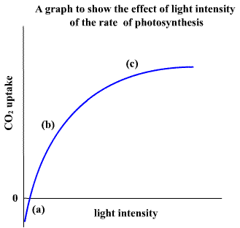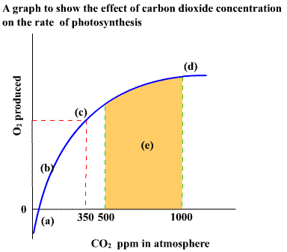
Figure 3a Figure 3b

Indicate whether the following statements are true or false by placing a tick in the appropriate box in the answer sheet.

 | True | False
A. A further increase in light intensity beyond point (c) in Figure 3a will significantly increase the rate of photosynthesis.
(0.25 mark)
B. In Figure 3a, beyond point (c) light intensity is the limiting factor on the rate of photosynthesis.
(0.25 mark)

C. In both figures, the plant is only respiring and not photosynthesizing at point (a). (0.25 mark)

D. The plant has reached maximum rate of O₂ production at point (d) in Figure 3b and the rate of photosynthesis may remain at a constant level.
(0.25 mark)

(1 mark)

QUESTION 4 Renewable energy: Biofuel production
Energy crops, such as wheat, maize, rape seed, sugarbeet, ley crops and willow, are being investigated for their potential use as alternative fuel sources to fossil fuels. These crops are grown at a low cost, have a high energy yield and can be used to make various kinds of biofuels such as biogas, biodiesel, and ethanol. Table 1 below shows data comparing the production of different biofuels from selected energy crops.

Table 1
Type of crop | Gross energy yield (GJ/hectare/year) |  |  | Energy input in production and conversion (GJ/hectare/year)
Type of crop | I. Ethanol | II. Biogas | III. Biodiesel | I. Ethanol | II. Biogas | III. Biodiesel
A. Wheat | 65 | 85 | - | 40 | 30 | -
B. Sugarbeet | 115 | 130 | - | 60 | 65 | -
C. Rape seed | - | - | 30 | - | - | 10
D. Ley crops | - | 75 | - | - | 25 | -
E. Maize | - | 125 | - | - | 35 | -
F. Willow | 65 | - | - | 30 | - | -
Adapted from: Borjesson and Mattiasson (2007)
- Calculate the net energy yield of biogas for the crops A, B, D and E in GJ/hect/year. Show all your calculations. (0.25 x 4 = 1 mark)
- Write the letter which corresponds to the crop that produces the highest net energy yield in biogas. (0.25 mark)
- From the non-gas biofuels, select the letter which corresponds to the crop which yields the highest net energy in GJ/hect/year. (0.5 mark)
- Replacing fossil fuels with biofuels will potentially reduce greenhouse gas emissions. Figure 4 below shows the average carbon dioxide (CO₂) emissions from fossil fuels and biofuels.
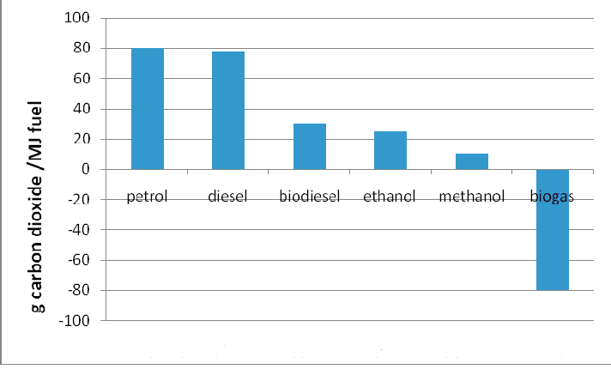
Fossil fuels and biofuels
Adapted from: Borjesson & Mattiasson (2007)
Figure 4: Average net yield of CO₂ emissions from production and combustion of fossil fuels and biofuels

Answer the following questions by referring to Figure 4.
(i) If diesel is replaced with biodiesel, what is the estimated percentage reduction in CO₂ emissions? Show your calculation.
(1 mark)

(ii) Which biofuel is most favourable in reducing the release of carbon dioxide?
Biodiesel | Biogas | Ethanol | Methanol
(0.5 mark)
End of Biology Questions

Acids form an important part of our lives; they give Gummy Bears their sour taste, and are the cause of acid rain which corrodes important statues and damages historic buildings. A recent and famous example is the 30 million US$ project to restore the Statue of Liberty. Acids have been made famous in numerous James Bond movies, since he carries an acid-filled gold pen. When Bond is captured and imprisoned, he squirts some acid out of his pen and onto the iron bars of his cell. The acid dissolves the metal and Bond manages to escape.

QUESTION 1
1.1
Hydrogen chloride can be conveniently prepared by the action of concentrated H₂SO₄ on solid NaCl. Give a balanced equation for this process.
(0.5 mark)
1.2
Match the statement in Table 1 with a letter from Table 2 that corresponds to a reasonable explanation for the observation.
(0.25 mark)
Table 1:
NaCl is a solid at room temperature which melts at 804 °C.
Table 2:
 | Reasons for NaCl
A | Covalent attraction of Na⁺ and Clˉ that results in an ionic intramolecular force of attraction.
B | Electrostatic attraction of Na⁺ and Clˉ that results in an ionic intramolecular force of attraction.
C | Electrostatic attraction of Na⁺ and Clˉ that results in an ionic intermolecular force of attraction.
D | Covalent attraction of Na and Cl atoms results in a neutral salt.
1.3
(i) Chlorine and fluorine are in the same group within the periodic table. When their hydrogen compounds are dissolved in water, one is considered a strong acid, whilst the other is weak. Give the formula for the weak acid, and the formula for the strong acid, and clearly indicate which one is weak or strong.
(0.25 mark)
(ii) State whether each of these statements are true or false.

- The hydrogen compound of fluorine has a higher bond dissociation energy than that of chlorine.
- Chlorine has a higher electronegativity than fluorine.
- The intermolecular forces in the hydrogen compound of fluorine are greater than those that occur in the hydrogen compound of chlorine.
- The hydrogen compound of fluorine has a higher boiling point than the hydrogen compound of chlorine.
- The hydrogen compound of fluorine is hydrogen bonded in both the liquid and vapour states.
(1.25 marks)
1.4
In South Africa, hydrofluoric acid is produced as a by-product of the wet process for the production of phosphoric acid from phosphate bearing rocks; specifically fluoroapatite. The volatile by-product, hydrogen fluoride, is converted into a useful product used in water purification via the following unbalanced reaction
SiO₂(s) + HF → A(g) + B(l)
Give the chemical formulae for A, B and a balanced equation.
(0.75 mark)
1.5
State whether each of the following mixtures of solutions are buffers or not.

 | Mixtures of Solutions | Yes | No
A | HCl + H₂SO₄
B | HF + H₂O
C | HF + NaF
D | HF + excess NaOH
E | HCl + excess NaOH
(0.5 mark)
1.6
How many H⁺ ions are present in one drop (0.050 cm³) of pure water at 25 °C? (Density of water = 1.0 g cm⁻³.) Show all your calculations.
(1.0 mark)

QUESTION 2
Man-made sources of various inorganic pollutants can react in the atmosphere to generate acidic precipitation. One of the most well-known examples is the release of oxides of sulfur from the combustion of hydrocarbon fuels. Another source of these oxides is from industrial processes such as the Contact Process for the production of sulfuric acid.

In Stage 2 of the Contact Process the following reaction occurs:
2SO₂(g) + O₂(g) ⇌ 2SO₃(g) ΔH = -197 kJ mol⁻¹
2.1
For parts (i) – (iii) choose the statement which correctly completes the given sentences.

(i) According to le Chatelier’s Principle the forward reaction is favoured by:
- low temperature and high pressure
- low temperature and low pressure
- high temperature and high pressure
- high temperature and low pressure
(0.25 mark)

(ii) In reality these conditions are not applied due to the following reasons:
A. | At low temperature the reaction will slow down and it is not economically viable to wait for true equilibrium. At high pressure unwanted side reactions occur.
B. | At high temperature the reaction is so fast that it is difficult to control the formation of product. At low pressure unwanted side reactions occur.
C. | At low temperature the reaction will slow down and it is not economically viable to wait for true equilibrium. At high pressure it will be costly to build a chemical plant to withstand such high pressures.
D. | At high temperature the reaction is so fast that it is difficult to control the formation of product. At high pressure it will be costly to build a chemical plant to withstand such high pressures.
(0.5 mark)

(iii) The problem described in (ii) can be overcome by:
A. fabricating the reaction vessel with strong nanomaterials.
B. performing the reaction in an inert atmosphere.
C. using supercritical fluids instead of gaseous reactants.
D. catalytic conversion.
(0.25 mark)
2.2
Calculate the pH of a 0.25 mol dm⁻³ H₂SO₄(aq) solution at 25 °C. Assume complete dissociation.
(0.5 marks)
2.3
To what final volume should you dilute 75.0 cm³ of a 10.0 mol dm⁻³ H₂SO₄ solution to obtain a 1.75 mol dm⁻³ H₂SO₄ solution? Show all calculation steps.
(0.5 mark)
2.4
What volume in cm³ of a 0.101 mol dm⁻³ NaOH solution is required to reach the end point in the complete titration of a 10.0 cm³ sample of 0.138 mol dm⁻³ H₂SO₄? Show all calculation steps.
(0.75 mark)
2.5
What reaction occurs at each electrode in the electrolysis of dilute H₂SO₄?
(1.0 mark)

2.6
A volume of 500 dm³ of SO₂ is released from a factory in the port city of Richards Bay, located in KwaZulu-Natal, South Africa. Assume the sea level pressure is 1.20 atm, and the temperature at the time of release is 31.2 °C. Calculate the density of this sample of gas if it is transported in a balloon to the mesosphere, at an altitude of 51.2 km, at a temperature of -81.2 °C and the pressure is 0.0122 % the sea level pressure.
(1.75 mark)

End of Chemistry Questions

QUESTION 1
An optical bench is set up with the following components:
- A light bulb with a filament in it which serves as the object.
- A white screen on a movable stand.
- A converging lens of focal length 10 cm mounted on a movable holder.
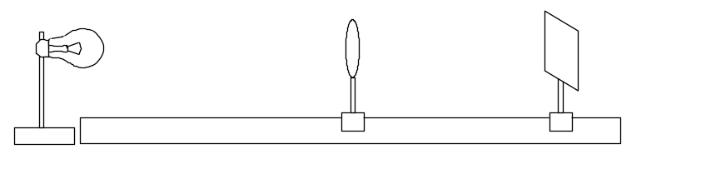
- The distance between the lens and filament is kept fixed at 12 cm, and the screen is adjusted until a clearly focused image of the filament is formed on the screen.
Answer the following questions by placing a cross in the relevant box/boxes on the answer sheet:
- Which of the following terms can be used to describe the nature of the image of the filament?
(0.5 mark)
Real | Virtual | Magnified | Diminished

- If the top half of the lens was covered with black paper, what will happen to the image of the filament?
(0.5 mark)
There will be no image | You will only see the bottom half of the filament | You will only see the top half of the filament | You will still see the full image of the filament

- The lens is then removed from the holder. What will happen to the image of the filament?
(0.5 mark)
There will be no image of the filament | You will see a larger image of the filament | You will see an upright image of the filament | You will see a faint image of the filament

- The original converging lens is removed and replaced by a second converging lens of unknown focal length. The positions of the lens and screen are adjusted until a clearly focused image of the filament is formed on the screen. The distance between the lens and screen is found to be 30 cm. A diverging lens is now placed 16 cm to the right of converging lens. The screen has to be moved a further 20 cm away from the converging lens in order to form a clearly focused image of the filament.
Calculate the focal length of the diverging lens.
(2 marks)
QUESTION 2
- A passenger of mass 50 kg on a Ferris wheel moves in a vertical circle of radius 35 m. The Ferris wheel rotates at constant speed and makes one complete revolution every 50 s. Calculate the magnitude of the force exerted by the seat on the passenger when the seat is at the bottom of the circle. Take acceleration due to gravity on Earth as 9.8 m s⁻².
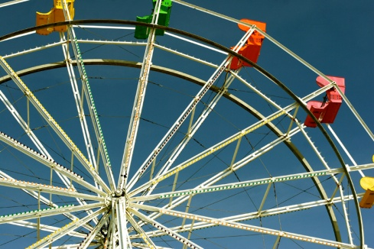
(1.5 marks)
- The diagram shows a small block of mass m attached to a cord of length L₁, which is fixed at one end. The block moves uniformly in a horizontal circle on a frictionless table. A second small block of the same mass m is attached to the first by a cord of length L₂ and also moves uniformly in a circle as shown.
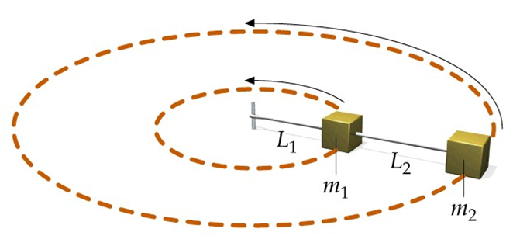

If the period of motion is T, derive an expression for the tension, F_{T1}, in the cord L₁, in terms of the given quantities.
(2 marks)

QUESTION 3
In a certain particle accelerator, a current of 600 μA is carried by a proton beam in which each proton has a kinetic energy of 9.6 × 10⁻¹³ J. The cross-sectional radius of the beam is 1.50 mm. The mass of a proton is 1.67 × 10⁻²⁷ kg and its charge is 1.6 × 10⁻¹⁹ C.

- Calculate the speed of the protons.
(1 mark)
- Determine how many protons per unit volume are in this beam.
(2 marks)

End of Physics Questions

1 |  |  |  |  |  |  |  |  |  |  |  |  |  |  |  |  | 18
1  H  1.008 | 2 | Periodic Table |  |  |  |  |  |  |  |  |  | 13 | 14 | 15 | 16 | 17 | 2  He  4.003
3  Li  6.941 | 4  Be  9.012 |  |  |  |  |  |  |  |  |  |  | 5  B  10.81 | 6  C  12.01 | 7  N  14.01 | 8  O  16.00 | 9  F  19.00 | 10  Ne  20.18
11  Na  22.99 | 12  Mg  24.31 | 3 | 4 | 5 | 6 | 7 | 8 | 9 | 10 | 11 | 12 | 13  Al  26.98 | 14  Si  28.09 | 15  P  30.97 | 16  S  32.07 | 17  Cl  35.45 | 18  Ar  39.95
19  K  39.10 | 20  Ca  40.08 | 21  Sc  44.96 | 22  Ti  47.88 | 23  V  50.94 | 24  Cr  52.00 | 25  Mn  54.94 | 26  Fe  55.85 | 27  Co  58.93 | 28  Ni  58.69 | 29  Cu  63.55 | 30  Zn  65.39 | 31  Ga  69.72 | 32  Ge  72.61 | 33  As  74.92 | 34  Se  78.96 | 35  Br  79.90 | 36  Kr  83.80
37  Rb  85.47 | 38  Sr  87.62 | 39  Y  88.91 | 40  Zr  91.22 | 41  Nb  92.91 | 42  Mo  95.94 | 43  Tc  98.91 | 44  Ru  101.1 | 45  Rh  102.9 | 46  Pd  106.4 | 47  Ag  107.9 | 48  Cd  112.4 | 49  In  114.8 | 50  Sn  118.7 | 51  Sb  121.8 | 52  Te  127.6 | 53  I  126.9 | 54  Xe  131.3
55  Cs  132.9 | 56  Ba  137.3 | 57*  La  138.9 | 72  Hf  178.5 | 73  Ta  180.9 | 74  W  183.8 | 75  Re  186.2 | 76  Os  190.2 | 77  Ir  192.2 | 78  Pt  195.1 | 79  Au  197.0 | 80  Hg  200.6 | 81  Tl  204.4 | 82  Pb  207.2 | 83  Bi  209.0 | 84  Po  (209) | 85  At  (210) | 86  Rn  (222)
87  Fr  (223) | 88  Ra  (226) | 89**  Ac  (227) | 104  Db  (261) | 105  Jl  (262) | 106  Rf  (263) | 107  Bh  (262) | 108  Hn  (?) | 109  Mt  (?)

*Lanthanide Series | 58  Ce  140.1 | 59  Pr  140.9 | 60  Nd  144.2 | 61  Pm  (147) | 62  Sm  150.4 | 63  Eu  152.0 | 64  Gd  157.2 | 65  Tb  158.9 | 66  Dy  162.5 | 67  Ho  164.9 | 68  Er  167.3 | 69  Tm  168.9 | 70  Yb  173.0 | 71  Lu  175.0
*Actinide Series | 90  Th  (232) | 91  Pa  (231) | 92  U  (238) | 93  Np  (237) | 94  Pu  (239) | 95  Am  (243) | 96  Cm  (247) | 97  Bk  (247) | 98  Cf  (252) | 99  Es  (252) | 100  Fm  (257) | 101  Md  (256) | 102  No  (259) | 103  Lr  (260)

