

Water and sustainability

Theoretical Test
Marking scheme
December, 7th 2017







Biology questions
Plants in floodplains
- Maximum score 1.2
An example of a correct calculation is:
The slope of the initial decline of the curve describes the maximum respiration rate per liter per minute. This slope is 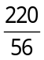 µmol/(L min) (see figure).
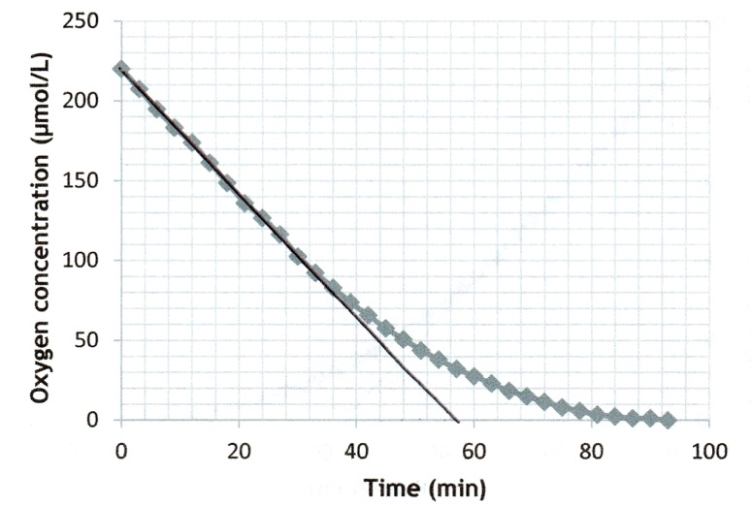

The volume of the box is 1.2 L, so the maximum respiration rate of the submerged plant is × 1.2 = 4.7 µmol/min (range: ± 0.2 µmol/min).
- notion that the slope of the initial decline of the curve describes the maximum respiration rate per liter per minute 0.4
- calculation of the slope 0.4
- multiplying the slope by 1.2 (L) 0.4
- Maximum score 0.4
4.7 µmol/min
Remark
The answer should be the same as the result of the calculation of question 1.

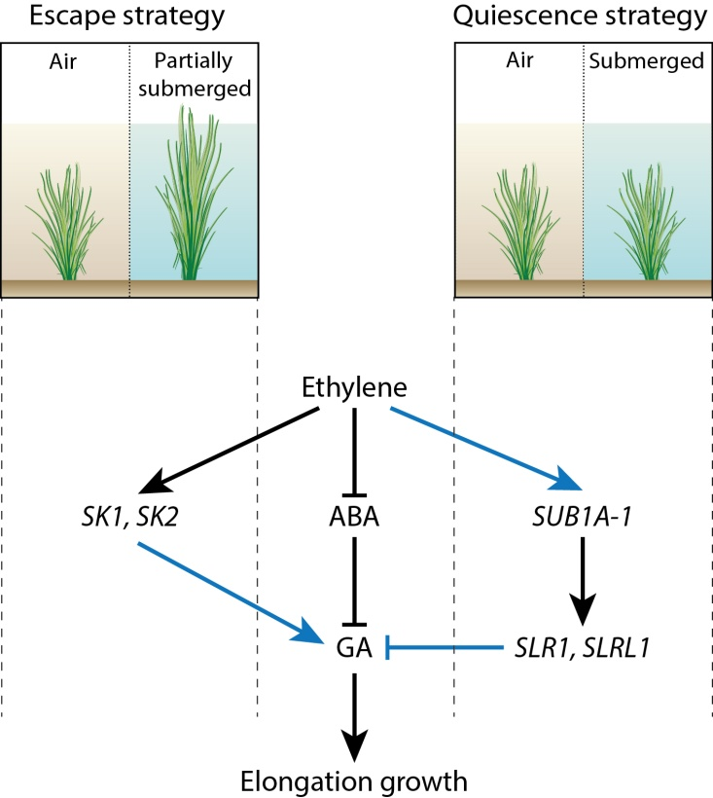
- Maximum score 1.2

per correct interaction 0.4

Oysters
- Maximum score 1.2
A correct answer may look as follows:
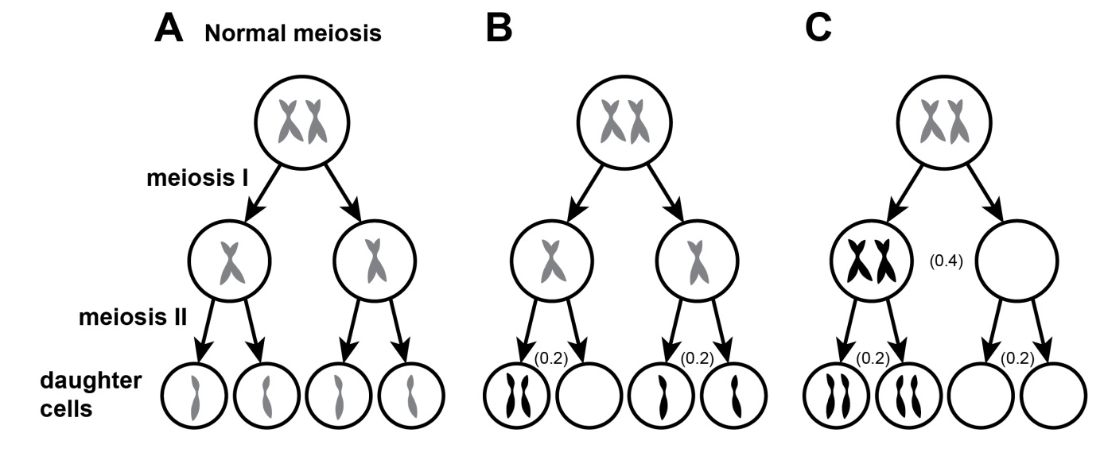
correct meiosis I step (from first to second row of C) 0.4
per correct meiosis II step (second to third row of B and C) 0.2
scores are also indicated in the figure above (in brackets).
Remark
Cells derived from the same cell can be permuted.
If in B the student gives a faulty meiosis II for all four daughter cells, he/she also receives full points.
If nothing is filled in on the second row of C, the student does not receive points for the empty cells on the third row.
- Maximum score 0.8
Species | O. edulis (oyster) | B. ostreae (protist)
Role | III | IV
per correct answer 0.4
- Maximum score 0.8
Parameter | p | q
Description | IV | VI
per correct answer 0.4

- Maximum score 1.2
Parameter | $$a$$ | $$b$$ | $$c$$
Triploid vs. diploid | + | o | ‒
Explanation:
$a$: birth/growth rate of oyster: ‘[triploid oysters] grow and mature faster’.
$b$: death rate of oyster: no info provided
$c$: infection parameter: ‘[triploid oysters] are more resistant to infections’.
per correct cell 0.4
Remark
No points for empty cells.

Osmosis in fish
- Maximum score 1.2
at location 1: → (arrow to the right)
at location 2: ← (arrow to the left)
at location 3: H (low % O₂)
at location 4: L (high % O₂)
- directions of both arrows at locations 1 and 2 are opposite 0.4
- if arrows are opposite and direction at locations 1 and 2 correct 0.4
- both indications at locations 3 and 4 correct 0.4
- Maximum score 0.8
I swell up
II very little
III large
IV diluted
per correct answer 0.2
Anammox
- Maximum score 1.2
Hypothesis |  | Experiment |  |  |  |  | Prediction
 | I |  | A | B | C |  | 1 | 2
 | II |  | A | B | C |  | 1  OR | 2
 | III |  | A | B | C |  | 1 | 2

- all pairings of I – III with A – C are correct 0.8
if two pairing of I – III with A – C are correct 0.4
if two pairing of I – III with A – C are correct 0.2
- all predictions correct 0.4
if one or two pairing(s) of I – III with A – C is/are correct and the corresponding prediction correct 0.4
if all pairings correct, but one prediction incorrect 0.2
if no pairing is correct or no prediction is correct 0

Chemistry questions
Water and the fight against Legionella
- Maximum score 1.2
An example of a correct answer is:
After x D-values the concentration is decreased to 0.10^{x} × 1 200 cfu/L. So to reach a level of 100 cfu/L: 0.10^{x} × 1 200 = 100. This gives x = 1.08.
So after heating during 1.08 × 5 = 5.4 min the concentration of Legionella in the water is below the level that is regarded as safe.
- after x D-values the concentration is decreased to 0.10^{x} × 1 200 cfu/L 0.4
- calculation of x 0.4
- rest of the calculation 0.4
- Maximum score 1.6
An example of a correct answer is:
The equilibrium is: HClO + H₂O H₃O⁺ + ClO‒
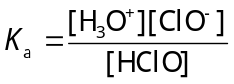 or 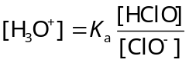
So when [H₃O⁺] > K_{a} then [HClO] > [ClO‒] or pH < pK_{a}. pK_{a} = - log4.0·10^{—8} = 7.40.
In the pH region below 7.40 [HClO] > [ClO‒].
- correct expression for K_{a} 0.4
- when [H₃O⁺] > K_{a} then [HClO] > [ClO‒] 0.4
- calculation of the pH value 0.4
- this is a maximum pH 0.4
Remark
If the student gives the wrong number of significant figures, no points will be subtracted.
- Maximum score 1.2
- half-reaction of the reducing agent: Cu(s) → Cu²⁺(aq) + 2 e— 0.4
- half-reaction of the oxidizing agent: 2 HClO + 2 H⁺(aq) + 2 e— → Cl₂(aq) + 2 H₂O 0.4
- overall reaction equation: Cu(s) + 2 HClO(aq) + 2 H⁺(aq) → Cu²⁺(aq) + 2 H₂O(l) + Cl₂(aq) 0.4
If the following answer is given: 0.8
half-reaction of the reducing agent: 2 HClO + 2 H⁺(aq) + 2 e— → Cl₂(aq) + 2 H₂O
half-reaction of the oxidizing agent: Cu(s) → Cu²⁺(aq) + 2 e—
overall reaction equation: Cu(s) + 2 HClO(aq) + 2 H⁺(aq) → Cu²⁺(aq) + 2 H₂O(l) + Cl₂(aq)
Remarks:
- When the student gives an equation like
Cu(s) — 2 e— → Cu²⁺(aq)
no points will be subtracted.
- No points will be subtracted for missing or incorrect state indications.

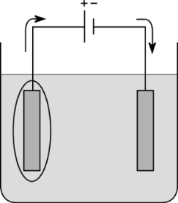
- Maximum score 0.8
A correct answer may look as follows:
- correct electrode indicated 0.4
- flow of the electrons correct in relation to indicated electrode 0.4
- Maximum score 0.8
2 ~ S ‒ H + 2 Ag⁺ → ~ S ‒ S ~ + 2 Ag + 2 H⁺
- 2 ~ S ‒ H left and 2 H⁺ right 0.4
- 2 Ag⁺ left and 2 Ag right 0.4
- Maximum score 0.4
The reaction of silver ions with ~ S ‒ H groups in one protein chain results in a change of the tertiary structure of the protein.

Wastewater treatment
- Maximum score 1.2
An example of a correct answer is:
0.632 × 2 × 32.00 × 10^{—3} × 175 000 × 365 × 3 × 0.19 = 1.5·10⁶ euros
- calculating the number of moles of oxygen needed per inhabitant per day: multiplying 0.632 (moles) by 2 0.4
- converting the number of moles of oxygen needed into kg oxygen needed per inhabitant per day: multiplying by the molar mass of oxygen (= 32.00 g/mol) and by 10^{—3} (kg/g) 0.4
- converting the amount of kg oxygen needed per inhabitant per day into kg oxygen per year for the population of Nijmegen: multiplying by 175 000 (inhabitants) and by 365 (days per year) 0.2
- converting the amount of kg oxygen per year for the population of Nijmegen into the costs per year: multiplying by 3 (kWh per kg oxygen) and by 0.19 (€ per kWh) and the answer lies in between 1.47·10⁶ euros and 1.5·10⁶ euros 0.2
Remark
If the answer is given as 1 470 000 euros or 1 500 000 euros no points are subtracted.
- Maximum score 1.6
An example of a correct answer is:
$\frac{2-0.75}{2}$ × 100% = 63%.
- oxidizing one mole of NH₄⁺ to NO₃— in the conventional process requires 2 moles of oxygen 0.4
- oxidizing one mole of NH₄⁺ to NO₂— in the anammox process requires 1.5 moles of oxygen 0.4
- only half of the amount of NH₄⁺ has to be oxidized 0.4
- calculation of the percentage reduction 0.4
If the answer $\frac{2-1.5}{2}$ × 100% = 25% is given: 1.2
If the answer $\frac{3-1}{3}$ × 100% = 67% is given 0.8
If the answer $\frac{3-2}{3}$ × 100% = 33% is given 0.4
- Maximum score 1.2
A correct answer may look as follows:
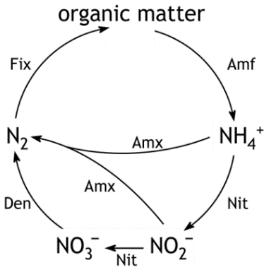

- NH₄⁺ connected with N₂ via NO₂— and NO₃— 0.4
- ‘Nit’ and ‘Den’ in the right place 0.4
- shortcut ‘Amx’ from NH₄⁺ to N₂ and shortcut ‘Amx’ from NO₂— to N₂ 0.4

Physics questions
Wind energy
- Maximum score 0.4
P = 8$P_{0}$ (W)
- Maximum score 1.6
An example of a correct answer is:
P = ½ × π × ${\left(\frac{80}{2}\right)}^{2}$ × 1.2 × ${\left(\frac{36×{10}^{3}}{3600}\right)}^{3}$ × 0.70 × 0.59 = 1.2·10⁶ W
- calculation of the area that is covered by the sails: π × ${\left(\frac{80}{2}\right)}^{2}$ 0.4
- calculation of the wind speed in m/s: multiplying 36 (km/h) by 10³ (m/km) and dividing by 3600 (s/h) 0.4
- applying the factor 0.70 × 0.59 0.4
- completion of the calculation 0.2
- answer in 2 or 3 significant figures 0.2
- Maximum score 1.2
An example of a correct answer is:
The volume of water that has to be pumped is V = $\frac{m}{ρ}$ = $\frac{3.3∙{10}^{11}}{1.03∙{10}^{3}}$ = 3.2·10⁸ m³.
The height difference is h = 40.0 ‒ 32.0 = 8.0 m.
So the area of the reservoir is A = $\frac{V}{h}$ = $\frac{3.2∙{10}^{8}}{8.0}$ = 4.0·10⁷ m².
- use of A = $\frac{V}{h}$ 0.4
- use of V = $\frac{m}{ρ}$ 0.4
- completion of the calculation 0.2
- answer in 2 or 3 significant figures 0.2
- Maximum score 2.0
An example of a correct answer is:
The increase in potential energy is: ΔE_{p} = mgΔh = 3.3·10¹¹ × 9.81 × ½ × (40.0 + 32.0) = 1.17·10¹⁴ J.
The total average power of the wind turbines is 75 × 5.0·10⁶ = 375·10⁶ W.
Since E = Pt, and E = ΔE_{p}, it follows that t = $\frac{∆E_{p}}{P}$ = $\frac{1.17∙{10}^{14}}{375∙{10}^{6}}$ = 3.11·10⁵ s or $\frac{3.11∙{10}^{5}}{3600}$ = 86 h.
- insight that ΔE_{p} = mgΔh 0.4
- insight that Δh = ½ × (40.0 + 32.0) m 0.4
- calculation of ΔE_{p} 0.4
- use of E = Pt 0.4
- completion of the calculation 0.2
- answer in 2 or 3 significant figures 0.2

- Maximum score 1.2
Yes | No | Question
 | $$√$$ | Because of its location at sea, nobody is annoyed by this plant.
$$√$$ |  | In this plant, energy can be stored and subsequently be used in the absence of wind.
$$√$$ |  | In this plant, energy can be stored and subsequently be used whenever necessary.
 | $$√$$ | This plant is a cheap way of generating electricity.
$$√$$ |  | This plant can supply a constant power.
$$√$$ |  | The power supply of this plant can be adapted to the demand.
 | $$√$$ | This plant can replace a number of coal-fired power stations.
 | $$√$$ | This plant does not expel CO₂.

Per correct answer 0.15
Remark:
For every wrong argument 0.15 points deduction. The total score for this question cannot be less than 0 points.

Room for the river
- Maximum score 0.8
An example of a correct derivation is:
For n holds: n = $\frac{A}{Q}D^{2/3}S^{1/2}$
So the unit of n is: $\frac{m^{2}}{m^{3}/s}m^{2/3}$ or s/m^{1/3}.
- all units correctly used 0.4
- rest of the derivation 0.4
- Maximum score 1.2
An example of a correct calculation is:
D = ${\left(\frac{0.10×1.4∙{10}^{4}×0.018}{200×{\left(5.0∙{10}^{-4}\right)}^{1/2}}\right)}^{3/5}$ = 2.8 m.
- multiplying 1.4·10⁴ (m³/s) by 0.10 0.4
- use of the correct values of D, W and S 0.4
- completion of the calculation 0.2
- answer in 2 or 3 significant figures 0.2
- Maximum score 1.6
An example of a correct calculation is:
0.99 × 0.99^{2/3} × $\frac{0.018}{0.022}$ × 10% = 8.0%.
- insight that A decreases by 1% 0.4
- insight that because of the decrease in D of 1%, the drain decreases by a factor 0.99 × 0.99^{2/3} 0.4
- insight that when n increases by a factor $\frac{0.022}{0.018}$, the drain decreases by a factor $\frac{0.018}{0.022}$ 0.4
- completion of the calculation 0.2
- answer in 2 or 3 significant figures 0.2
Remark
If D of previous question is used, correct calculation gives the same answer and same amount of marks.

