15TH INTERNATIONAL JUNIOR SCIENCE OLYMPIAD
IJSO-2018

Discovery, Innovation and Environment
Theory Competition
MARKING GUIDE
– Exam Sheet –
December 6, 2018
Do NOT turn to next page
before a whistle is blown.
Otherwise, you will receive a penalty.

1. You have 10 minutes to read “EXAMINATION RULES”, “EXAM INSTRUCTIONS”, and “CALCULATOR INSTRUCTIONS” on pages 1 - 3.

2. Do NOT start answering the questions before the“START”whistle! Otherwise, you will receive a penalty.

EXAMINATION RULES

1. You are NOT allowed to bring any personal items into the examination room, except for personal medicine or approved personal medical equipment.
2. You must sit at your designated desk.
3. Check the stationery items (pen, calculator, and rough book) provided by the organizers.
4. Do NOT start answering the questions before the “START” whistle.
5. You are NOT allowed to leave the examination room during the examination except in an emergency in which case you will be accompanied by a supervisor/volunteer/invigilator.
6. Do NOT disturb other competitors. If you need any assistance, you may raise your hand and wait for a supervisor to come.
7. Do NOT discuss the examination questions. You must stay at your desk until the end of the examination time, even if you have finished the exam.
8. At the end of the examination time you will hear the “STOP” whistle. Do NOT write anything more on the answer sheet after this stop whistle. Arrange the exam, answer sheets, and the stationary items (pen, calculator, and rough book) neatly on your desk. Do NOT leave the room before all the answer sheets have been collected.

INSTRUCTIONS FOR CALCULATOR
1. Turning on: Press .
2. Turning off: Press  .
3. Clearing data: Press .
4. Addition, subtraction, multiplication, and division
Example 1) $45+\frac{285}{3}$
45  285  3 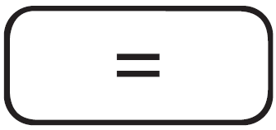 140.
Example 2) $\frac{18+6}{15-8}$
 18 6  15  8 3.428571429
Example 3) $42×\left(-5\right)+120$
42  5  120 -90.
42 5 120 -90.
5. Exponential
Example 1) ${8.6}^{-2}$
8.6  2 0.013520822
Example 2) ${6.1 × 10}^{23}$
6.1 10 23 6.1 x 10²³
6. To delete a number/function, move the cursor to the number/function you wish to delete, then press . If the cursor is located at the right end of a number/function, the key will function as a back space key.

Do NOT turn to next page
Before the“START”whistle is blown.
Otherwise, you will receive a penalty.

Biology

Q1
- Choose two (2) of the gases listed, which are the major constituents of the gas in the bubbles. Write the appropriate letters into the boxes below. [0.3 marks, 0.15 for each correct answer]

B | D

- What are the beneficial uses of biogas to man? Write three (3) letters corresponding to uses in the boxes below. [0.3 marks, 0.1 for each correct answer]
A | C | D

- Decide, whether the following statements regarding that decomposition process are true or false by marking the appropriate box with a cross (X). [0.4 marks, 0.1 for each correct answer]
Statement | True | False
The decomposition of plant and animal tissue at the bottom of the swamps is an aerobic process. |  | X
The gases produced as a result of the degradation are metabolic waste products of bacterial metabolism. | X
The biochemical decomposition processes of plant and animal matter by bacteria do not require water molecules. |  | X
Bacteria that degrade plant and animal matter at the bottom of the swamp receive more energy from the degradation compared to bacteria decomposing the same plant and animal matter on the surface. |  | X

- What could be the explanation of the observation described? Indicate, which of these options could be true and which ones false by marking the appropriate box with a cross (X). [0.25 marks, 0.05 for each correct answer]
Possible explanation | True | False
The bacteria are able to multiply more rapidly due to the higher temperatures. | X
The enzymes in the bacteria are working at close to their optimum rate. | X
More enzyme-substrate complexes are being formed, so more biogas can be made. | X
The kinetic energy of the enzyme and substrate molecules has decreased. |  | X
The enzymes in the bacteria have begun to denature. |  | X

- What is the most likely explanation for the observation described? Write the corresponding letter in the box below. [0.25 marks]

B

Q2
- Use the space given below to calculate the frequencies of the genotypes AA, Aa and aa. [0.75 marks, 0.25 for each correct answer]
Calculations

[AA] = (350/600) = 0.583

[Aa] = (100/600) = 0.167

[aa] = (150/600) = 0.250

Frequency of genotype AA:  0.583 [0.25 marks] | Frequency of genotype Aa:  0.167 [0.25 marks] | Frequency of genotype aa:  0.250 [0.25 marks]

- Use the space given below to calculate the frequencies of alleles A and a. [1.0 mark, 0.5 for each correct answer]

Calculations

[A] = ((700+ 100)/1200) = 0.6667 or [350 + 50 /600]

[a] = ((100 + 300)/ 1200) = 0.3333 [150+50/600]

Frequency of allele A: 0.6667 [0.5 marks] | Frequency of allele a: 0.3333 [0.5 marks]

- Use the space given below to calculate the expected frequencies of the genotypes AA, Aa and aa if the population was in a genetic equilibrium. [1.5 marks, 0.5 for each correct answer]
Calculations

[AA] = p² = (0.67*0.67) = 0.449

[Aa] =2pq = 2*0.67 *0.33 = 0.442

[aa] = q² = 0.33*0.33 = 0.109

Frequency of genotype AA:  0.449 [0.5 marks] | Frequency of genotype Aa:  0.442 [0.5 marks] | Frequency of genotype aa:  0.109 [0.5 marks]

Q3
a-1) Plot a graph of population size against year using the graph paper provided [1.0 marks]

Marks are as follows: 0.6 correct plotting of points (0.1 for each)
0.2 labelled axes [0.1 for each correctly labelled axis]
0.2 scale

a-2) Draw a linear trendline of your data, determine the equation of the line and write the equation in the box below. [0.5 marks]
Calculations
Example of ideal graph line equation calculation:
$$slope =\frac{y_{2}-y_{1}}{x_{2}-x_{1}} =286.87$$
Where $(x_{1},y_{1})$ and $(x_{2},y_{2})$ are coordinates of any two points on the trend line

To find the intercept, substitute $(x_{1},y_{1})$ or $(x_{2},y_{2})$ in $y=mx+c$ and solve for c. note that c is the intercept and m is the slope

[0.25] for correct trend line on student’s graph

Line equation: [0.25 marks for correct equation based on the student’s graph]

a-3) Use the space given below to calculate the average growth rate of the elephant population size from 1990 to 2010. [0.25 marks]
Calculations
Growth rate is the slope of the trendline or fitted linear line, which is 287 for the ideal graph.

Students need to take the slope from their equation.

Average growth rate:
[0.25 marks if they have taken the correct value and added the correct unit]

a-4) Use the space given below to calculate the projected elephant population size in 2019. [0.5 marks]
Calculations
Solved using the ideal trendline equation:
y = mx + c which is in this case, y = 287x – 545902
Therefore y = 287 × 2019 – 545902 = 33551

- Students may use their line equation to calculate the value in the way above.
- Students may take the value for 2010 and add 9 × the annual growth rate.
- Student may decide to extend the trendline to 2019 then extrapolate the answer for elephant population from the graph.

The value should be higher than the value for 2010.
Projected population size:

- Use the space given below to calculate the difference in the density of the elephant population size in 1995 and 2010 in the Chobe National Park. [0.5 marks]
Calculations

$Density =\frac{number of animals}{area }$

$Density =\frac{31000-26650}{11700}$

=0.372 elephants/km²

Difference in density: 0.372 elephants/km²
[0.25 marks for correct answer + 0.25 marks for correct units

- Use the space given below to calculate the total amount of bark that was stripped in 1995. [0.5 marks]
Calculations
Total food consumed in 1995

= 28650 × 200 kg/day [0.125]
= 5730000 kg/day × 365 days [0.125]

=2.09145 x 10⁹ kg [0.125]

The total bark portion of the consumed food is 35%

Therefore 35% of that number is: $\frac{35}{100}$ x 2.09145 x 10⁹ kg
= 732007500 kg [0.125]

Total amount of bark stripped: 7,3 × 10⁸ kg
- Use the space given below to calculate the percentage of the actual material utilized by the elephant per day. [0.5 marks]
Calculations
Actual material utilized = 200kg – 136kg = 64kg [0.2 marks for correct kg value, 0.05 marks for units]

% of the actual material utilized= $\frac{64}{200}$ x 100 =32% [0.2 marks for correct kg value, 0.05 marks for units]

Percentage of actual material utilized: 32%

Q4
Decide, whether each of the terms listed below corresponds to the interior of the membrane (within the membrane) or the exterior surfaces of the membrane and fill in the table. Use „+“ if the term applies and „0“ if the term does not apply. [1.5 marks, 0.125 for each correct answer]
 | Interior | Exterior
Hydrophobic | + | 0
Hydrophilic | 0 | +
Fatty acid tails | + | 0
Ribosomes | 0 | 0
Ion channels | + | +
Oligosaccharides | 0 | +

Chemistry
Q5 Chemistry: Acid mine drainage and air pollution at a nickel mine
Q5a | (0.5) | Write the balanced equations for the neutralization and precipitation reactions  Neutralisation Ca(OH)₂ _{(aq)} + H₂SO₄ _{(aq)} → CaSO₄ _{(s)} + 2H₂O _{(l)}  [0.25; if not balanced substract 0.1, don’t penalize for state symbols]  Precipitation Fe₂(SO₄)₃ _{(s)} + 3Ca(OH)₂ (aq) → 2Fe(OH)₃ _{(s)} + 3CaSO₄ _{(s)}  [0.25; if not balanced substract 0.1, don’t penalize for state symbols]
Q5b | (1.75) | What mass in kilogram of Fe(OH)₃ will be produced due to oxidation of pyrites?  Molar mass of FeS₂ = 119.97 g/mol [0.25]  Molar mass of Fe(OH)₃ is 106.85 g/mol [0.25]  % of pyrite in solid waste = 5/100 x 10⁶ =5 x 10⁴g [0.25]  Mole of FeS₂ 5x10⁴/119.97 = 416.78 mol; mole ratio is 1:1 [0.25]  Mole of Fe(OH)₃ is 416.78 mol [0.25]  Mass of Fe(OH)₃ is then 5x10⁴/119.97 x 106.85 =44533.08 g = 44.5 kg [0.5]  [Final answer should be given to the correct significant figure, if not substract 0.1]  Fe(OH)₃ mass …………44.5…………kg
5c  5d | (0.5) | How much iron (II) (in grams) is pumped into the chemical neutralization plant in 2 hours at the stated flow rate using red lake water as feed?  Volume of iron(II) pumped in two hours = 50.0 m³/h x 2 hours = 100 m³ [0.25]  Iron(II) mass 100mg/L x 100 m³ x 1000L/1m³  = 10 000 000 mg  = 10 000 g  Or =1.00 x 10⁴ g [0.25]
5c  5d | (0.5) | Iron (II) …………………………. g
5c  5d | (1.0) | How many moles of H⁺ ions were neutralized in one liter of solution?  pH= -Log [H⁺] [0.25]  At pH 6.0 concentration = -Log [H⁺]; [H⁺] = 1.00 x 10⁻⁶ [0.25]  At pH 1.9 concentration = -Log [H⁺]; [H⁺] = 1.26 x 10⁻² [0.25]  Concentration = 1.26 x 10⁻² mol/L  Moles of H⁺ = 1.26 x 10⁻² mol [0.25]
5c  5d | (1.0) | Moles of acid =
Q5e | 5e-1 (0.15) | What is the order of the reaction with respect to iron(II) expressed as a number?  1 [0.15]
Q5e | e-2 (0.25)  e-3 (0.5) | What is the rate of reaction when the surface area of the reactor is doubled at constant volume?  Rate = 16.1x2 = 32.2 molL⁻¹s⁻¹ [0.25]  What is the rate of reaction when the pressure of oxygen gas is doubled?  Pressure is 2^{0.5} = 1.41 [0.25]  Rate = 16.1x1.41 = 22.7 molL⁻¹s⁻¹ [0.25]
Q5f | (2.0) | What mass in tons of calcium carbonate is needed to remove one ton of sulphur dioxide if the removal process is 90.0% efficient?  Moles of 10⁶ / 64.06 = 15610.37 mol [0.25]  Mol ratio CaCO₃:SO₂ = 1:1 [0.25]  Mol of CaCO₃ = 15610.37 mol [0.25]  Mass of CaCO₃ = 15610.37 x 100.09 = 1562441.93 g [0.25]  Mass in ton = 1562441.93 / 10⁶ = 1.56 t (for 100 % efficiency) [0.5]  - 90% = 1.56 t / 0.9 = 1.73 t [0.25]  - Total amount of CaCO₃ needed = 1.73 / 0.65 = 2.66 t [0.25]
Q5g | (0.6) | Calculate the number of moles of CO₂ gas present in the container after 20 minutes of heating  (R= 0.082 L.atm mol⁻¹ K⁻¹; R= 8.314 J.mol⁻¹ K⁻¹), 1 atm = 101325 Pa.  $$PV=nRT$$  $n=\frac{PV}{RT}$ [0.1]  $n=\frac{1.04atm×1.00L}{0.082\frac{L atm}{mol K}×1100K}$ [0.25]  $=0.0115 mol$ [0.25]
Q5h | h-1(0.25)  h-2 (0.25) | What will be the final pressure inside the container?  Tick the correct answer  Where will the equilibrium shift to in the reaction equation below?  Tick the correct answer
  Less than 1.04 atm
  greater than 1.04 atm
  Equal to 1.04 atm | √
  Right (product side)
  Left (reactant side) | √
  No change
Q5i
Q5i | (0.25) | Calculate the value of the equilibrium constant, K_{p}, for the decomposition of CaCO₃ at 1100 K.  $K_{p}=P_{{CO}_{2}}=1.04$ atm (or 105378 Pa)  [award 0.1 for the Kp expression and 0.15 for the answer]
6 | (1.5) | What mass in kilogram of sodium carbonate can be formed from 0.850 ton of trona?  Molar mass of trona = 332 g/mol [0.25]  Moles of trona = 0.85 x 10⁶ g / 332 g/mol = 2.56 x 10³ moles [0.25]  5 moles of Na₂CO₃ : 2 moles of Trona [0.25]  Moles of Na₂CO₃ = 2.56 x 10³ x 5/2 = 6.4 x 10³ moles [0.25]  Molar mass of Na₂CO₃ = 106 g/mol [0.25]  Mass of Na₂CO₃ ₌ 6.4 x 10³ moles x 106 g/mol = 6.78 x 10⁵ g = 678 kg [0.25]

7 | (0.5) | What is the concentration of carbonic acid in air saturated with water vapour at 25 °C?  Henry’s law is Conc = KP  = 2.3x10⁻² mol/L.atm x 3.04 x 10⁻⁴ atm [0.25]  =7.0 x 10⁻⁶ mol/L [0.25]

Total points for question Q5a
Total points for question Q5b
Total points for question Q5c
Total points for question Q5d
Total points for question Q5e
Total points for question Q5f
Total points for question Q5g
Total points for question Q5h
Total points for question Q5i
Total points for question Q6
Total points for question Q7
Total marks

Physics Theory answer sheet

No unit in final answer: -0.1
Questions | Points | Waves: Doppler effect: Answers (show your working)
Q6 | (1.40) | Calculation of frequency as the ambulance approaches the observer  Step 1: calculate $v_{s}$ (note speed of sound increases as temperature increases)  $v_{s}=331.3+0.606*T_{C}=331.3+0.606*38=354.328 m/s$ [0.20]  ambulance approaching the observer  convert 90 km/h = 25 m/s [0.25]  $f_{o}=f_{s}\left(\frac{v_{s}}{v_{s}-v_{o}}\right)$ correct equation!! [0.45]  $f_{o}=300.0*\left(\frac{354.328}{354.328-25}\right)$ [0.25]
Q6 | (1.40) | Approaching ambulance $f_{o}=$322.77 Hz [0.25]
Q7 | (1.55) | (Show your working)  Kinematics  During reaction time:  Calculation of the acceleration of the car if it stops just before hitting the cow.  Initial velocity u  $u=33.2m/s, a=0, t=0.20s$ [0.20]  $s=ut+\frac{1}{2}at^{2}$ [0.25]  $s=33.2m/s*0.2s+0=6.64m$ = distance covered during the reaction time  For acceleration;  $s=60m-6.64m=53.36m$ [0.25]  $note that v=0m/s, u=33.2m/s$  $v^{2}=u^{2}+2as$ [0.25]  $a=\frac{v^{2}-u^{2}}{2s}$ [0.20]  $a=\frac{0-{33.2}^{2}}{2*53.36}$ [0.20]  $a=-10.3 m/s^{2}$  In case of missing “-“ sign: -0.10
Q7 | (1.55) | acceleration of the car = $a=-10.3 m/s^{2}$ [0.20]

Fluid flow: conservation of energy and continuity principles
Questions | Points | Answers ( show your working)
Q8 (a) | (0.85) | Calculate the velocity of water through the pipe at the farm  $from the continuity equation Q=A_{1}v_{1}=A_{2}v_{2}$  Note $A=πR^{2}= π\frac{D^{2}}{4}$ [0.20]  $v_{2}=\frac{A_{1}v_{1}}{A_{2}}= \frac{{{πD}_{1}^{2}}/4}{{{πD}_{2}^{2}}/4}* v_{1}$ [0.25]  $v_{2 }= \frac{{π*0.35}^{2}}{{π*0.25}^{2}}*1.30$ [0.20]
Q8 (a) | (0.85) | $v_{2}=2.55 m/s$ [0.20]
Q8 (b) | (0.9)
Q8 (b) | (0.9) | Calculation of the pressure of water at the farm  Consider Bernoulli’s equation  $$\frac{P}{ρ}+\frac{1}{2}v^{2}+gy=constant$$  Or $P_{1}+\frac{1}{2}{ρv}_{1}^{2}+ρgy_{1}=P_{2}+\frac{1}{2}{ρv}_{2}^{2}+ρgy_{2}$ [0.20]  $P_{2}=P_{1}+\frac{1}{2}{ρ(v}_{1}^{2}-v_{2}^{2})+ρg(y_{1}-y_{2})$ [0.25]  $P_{2}=670000+\frac{1}{2}\left(1000\right)*\left({1.30}^{2}-{2.55}^{2}\right)+1000*9.8*(940-960)$  $P_{2}=670000-2401.152-196000$ [0.25]
Q8 (b) | (0.9) | Pressure P₂ at the farm =471598.8 Pa = 471598.8 N/m² [0.20]
Q8 (c) | (0.8) | Flow rate at the farm $Q=A_{2}v_{2}=\frac{πD_{2}^{2}}{4}v_{2}$ [0.20]  $Q=\frac{π{0.25}^{2}}{4}2.55=0.125 m^{3}/s$ [0.10]  Calculation of time it takes to fill a 50000L reservoir  Convert L m³  50000L = 50m³ [0.10]  Time taken = $\frac{50m^{3}}{0.125{m^{3}}/s}$ [0.20]
Q8 (c) | (0.8) | $t=$400 sec [0.20]
Q9 | (1.9)
Q9 | (1.9) | ELASTIC COLLISIONS  Momentum before collision = momentum after collision  $m_{A}u_{A}=m_{A}v_{A}+m_{B}v_{B}$ [0.25]  After collision: $x=v_{x}t$; horizontal distance  $x_{A}=1m=v_{xA}t$ distance travelled by ball A [0.20]  $x_{B}=2m=v_{xB}t$ distance travelled by ball B [0.20]  Vertical Motion:  $y=u_{y}t-\frac{1}{2}gt^{2}$ [0.20]  $$u_{y}=0 hence$$  $$-1.225=-\frac{1}{2}*9.8*t^{2}$$  $t=\sqrt{\frac{1.225}{4.9}}=0.50s$ [0.25]  $$x_{A}=1=v_{xA}t=0.5v_{xA}$$  ${ v}_{xA}=2.0 ms^{-1}$ [0.20]  $$x_{B}=2=v_{xB}t=0.5v_{xB}$$  $v_{xB}=4.0 ms^{-1}$ [0.20]  $$m_{A}u_{A}=m_{A}v_{A}+m_{B}v_{B}$$  $u_{A}=\frac{m_{A}v_{A} +m_{B}v_{B}}{m_{A}}$ [0.20]
Q9 | (1.9) | Mass can be used in g or kg:  $$u_{A}=\frac{0.060*2+0.020*4}{0.060}=3.33 m/s$$  Velocity before impact= 3.33 m/s [0.20]
Q10a | 1.1 | 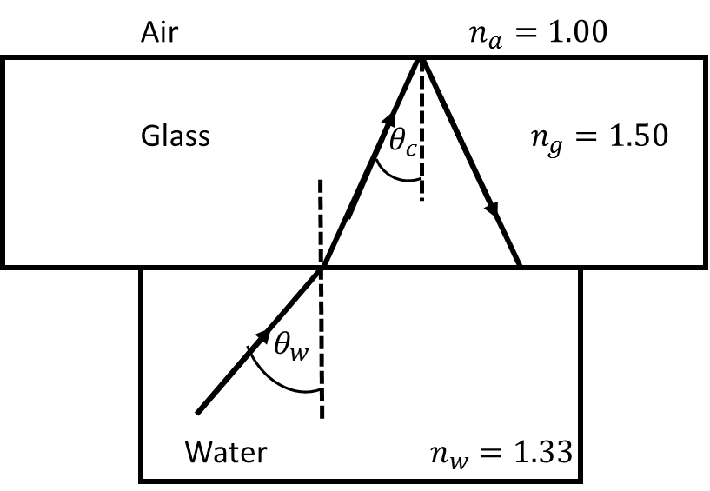  For minimum angle $θ_{w}$, angle of incidence at the glass- air boundary is the critical angle $θ_{c}$.  From Snell’s law (steps 1-3):  $n_{g}\sin{θ_{c}= n_{a}\sin{90}}$ [0.20]  ${sinθ}_{c}= \frac{n_{a}}{n_{g}}= \frac{1}{1.5}$ [0.10]  $θ_{c}= \sin^{-1}\left(\frac{1}{1.5}\right)=41.8°$ [0.20]  At water- glass surface interface  $n_{w}\sin{θ_{w}= n_{g}\sin{θ_{c}}}$ [0.20]  ${sinθ}_{w}= \frac{n_{g}\sin{θ_{c}}}{n_{w}}= \frac{n_{g}}{n_{w}}*\frac{n_{a}}{n_{g}}$  $θ_{w}=\sin^{-1}\left(\frac{n_{g}}{n_{w}}*\frac{n_{a}}{n_{g}}\right) = \sin^{-1}\left(\frac{n_{a}}{n_{w}}\right)= \sin^{-1}\left(\frac{1}{1.33}\right)$ [0.20]  Students will not be penalized for not using step 1-3 when final answer is correct  Final answer:  $θ_{w}=48.8°$ [0.20]  Illustration showing incident, transmitted and emergent ray and labelling of slab thickness [0.4]  Correct labelling of angles $θ_{1}$ and $θ_{2}$ [0.2]  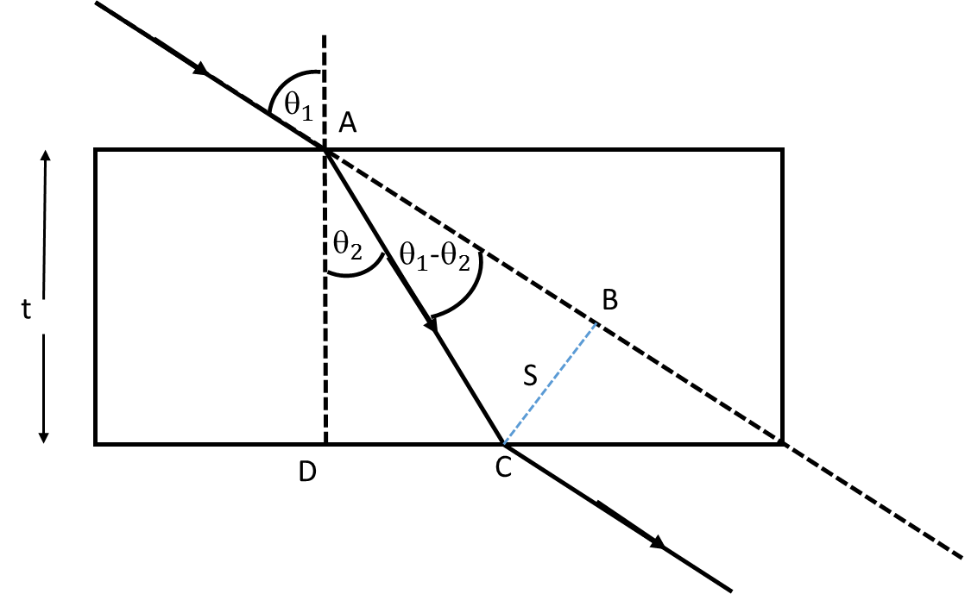  From triangle ABC, $\frac{BC}{AC}=sin\left(θ_{1}-θ_{2}\right)$ [0.20]  From triangle ADC, $\frac{AD}{AC}=cos\left(θ_{2}\right)$ [0.20]  Therefore $AC=\frac{AD}{cos\left(θ_{2}\right)}= \frac{t}{cos\left(θ_{2}\right)}$ [0.20]  $sin\left(θ_{1}-θ_{2}\right)=\frac{BC}{AC}= \frac{BC*cos\left(θ_{2}\right)}{t}$  That is:  $BC*cos\left(θ_{2}\right)=t*sin\left(θ_{1}-θ_{2}\right)$ [0.20]  $BC=s=\frac{t*sin\left(θ_{1}-θ_{2}\right)}{cos\left(θ_{2}\right)}$ [0.10]
Q10b | 1.5
------------------------------------ DO NOT WRITE BELOW ------------------------------------
Total points for question Q6
Total points for question Q7
Total points for question Q8
Total points for question Q9
Total points for question Q10
Total marks

